We make playable stories

Akibabus Ltd is a game publishing company with a unique (Pat. Pend) and interactive gaming concept that re-defines creative craft gaming.

Our Boxitale™ brand represents a series of crafty adventure games that take children on an adventure into an original and animated escapade where they act as the heroes of the story.

Boxitale™ gaming concept is about kids playing in Epic stories.

Our original stories can be viewed on a smartphone/tablet, but the game itself will be played on a board.
The kids will build, design, and solve challenges and even play in mini games to solve the challenges presented to them in the story and eventually save the day!
Once the kid’s design is ready on the board, they will take a picture of their design using our App. The picture will then be embedded in the next scenes of the story, which nhances the interactivity level of the game and makes it even more FUN.

Boxitale ™ is the perfect combination of an App and a board game
The kids get to enjoy a high-tech game while playing a craft game on the board 80% of the game time.

There is no rule book!

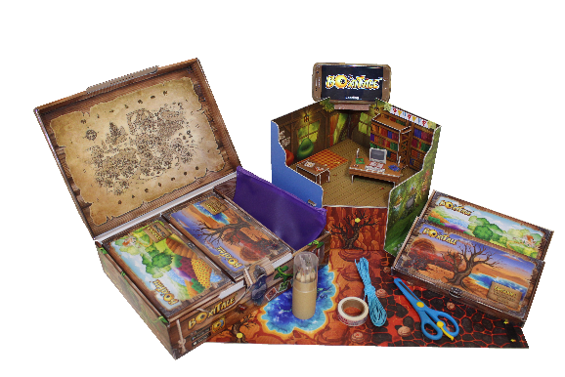
Video links
https://youtu.be/UsDbod1ayNw
https://youtu.be/KvWnzhEKWa0 - Nuremberg toy fair
More info on the web site
akibabus.com

