Amloid 2018 Toy Fair Product Fact Sheet

Aqua Kidz - Aqua Creatures Swim Masks
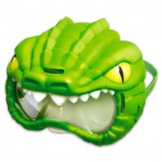
Take a dive on the wild side and discover the underwater world in a whole new way with the Aqua Creatures Swim Masks from Amloid! Kids can explore their animal alter-egos with a quality mask that will keep their eyes protected and will surely bring loads of fun to pool and water activities. Each version features unique creature characteristics as the shark mask comes complete with a fin on top, realistic eyes and jagged teeth over the lens, while the crocodile mask is decked out in reptile scales, spooky yellow eyes and spikey teeth. The one-size-fits-all mask features an adjustable strap to fit kids ages 5-and-up along with a durable, high-quality kid-safe lens.
Available in 3 styles: Crocodile (green), Shark (pink) and Shark (blue)
Ages: 5+
MSRP: $9.97
Available: Spring 2018 @ Walmart

Aqua Kidz - Aqua Creatures Water Squirterz

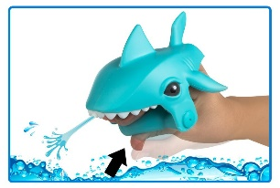
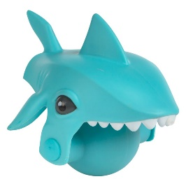
Talk about a wet and wild sneak attack! With Amloid’s Aqua Creatures Water Squirterz, kids will have a blast battling each other to see whose predator is the pack leader. Just place the hand-held launcher under water and squeeze the compression pump to fill it up, then squeeze again to soak your target. Available in ferociously playful shark and crocodile editions, each squirterz can launch a steady stream of water up to 10 feet! Whether outside in a pool or inside in a bath, the Aqua Creatures Squirterz will take the fun to a whole new level. The one-size-fits-all squirterz are the perfect accessory to add to any water toy box this spring.
Available in 3 styles: Crocodile (green), Shark (pink) and Shark (blue)

Ages: 5+
MSRP: $7.68
Available: Spring 2018 @ Walmart

NextWave™ – Jumbo Beach Basket
Get ready to have tons of fun in the sun with the all-new, totally redesigned NextWave™ Jumbo Beach Basket! This bright and colorful activity set is packed with play value with all the accessories kids need to spend hours at the beach or in the sand box with new sand forms and a collection of multifunctional sand tools. New features include a sturdy nylon shoulder strap along with a comfort grip handle for easy on-the-go portability. And the collapsible folding case makes clean up a breeze by shaking out water and sand when its time to go. Plus, the cover detaches from the basket to double as a super-sized animal sand form! Whether little ones are creating cool castles or sculpting masterpieces in the sand, parents will love the quality and value of this Jumbo Beach Basket set from a trusted brand name in Amloid. The 15-piece set comes complete with assorted sea creatures and nautical forms, bucket with handle, castle molds, rake, roller, sand spinner, sifter and shovels in a variety of sizes. Available in 3 styles: Flamingo (pink), Whale (purple) and Shark (teal).
Ages: 2+
MSRP: $14.99
Available: Now @ Sam’s Club

Tonka Mighty Builders Next Step™ Construction Truck Assortment Playset
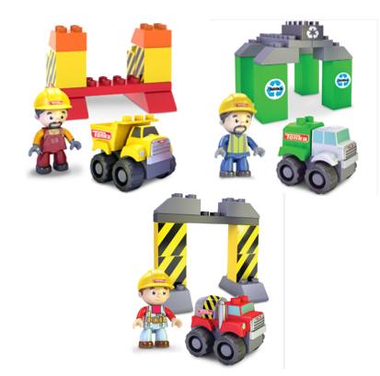
Ready to report for duty is the new line of Tonka Mighty Builders Next Step™ Construction Truck Assortment Playsets from Amloid! Little builders can get any project started with their choice of a three-piece, take-apart and build Cement Truck, Dump Truck or Recycle Truck, that comes with a block-fit figure in working uniform and matching Kids@Work medium-sized building blocks. Children can mix and match parts with other Tonka Mighty Builders Next Step™ vehicle and construction playsets to create their own Tonka Tough worksites. This 15-piece playset includes 1 three-piece construction vehicle, 1 block-fit figure and 11 bright and durable Tonka Kids@Work medium-sized building blocks. Available in Cement Truck (red), Dump Truck (yellow) and Recycle Truck (green) playset assortments.
Ages: 2+
MSRP: $9.99
Available: Fall 2018

Tonka Mighty Builders Next Step™ Tire Track Playset
Ready, Set, Roll! Kids can be in charge of their own construction zone with the new Tonka Mighty Builders Next Step™ Tire Track Playset from Amloid. Get the fun started by opening the multifunctional tire carry case, which also doubles as a foundation for blocks to build away. Watch as the trucks cruise along the connecting rolling track ramps and over the colorful collection of Kids@Work medium-sized bricks. And when play time is over, all the pieces conveniently fit back in the tire carrying case with a handle for easy on-the-go portability for playdates and travel. Children can mix and match parts with other Tonka Mighty Builders Next Step™ playsets to create their own custom vehicles and track designs. The 35-piece playset includes 1 three-piece Cement Truck (yellow), 1 three-piece Recycling Truck (green), 5 rolling block-fit ramps, 1 construction block-fit figure, 1 Tire Play Storage Case and 22 bright and durable Kids@Work medium-sized building blocks.
Ages: 2+
MSRP: $24.99
Available: Fall 2018

Tonka Mighty Builders Next Step™ Operational Crane Playset
Little workers can take their construction creations to new heights with the Tonka Mighty Builders Next Step™ Operational Crane Playset! This massive 40-piece playset from Amloid comes with all the accessories and riggings to keep little ones busy and entertained for hours during their construction play time. The operational crane features a real-working crank to raise and lower building blocks and 360-degree mobility to get the job done from any angle. And with 2 three-piece, take-apart and build Dump and Recycle Trucks, and an assortment of bricks and ramps, children can play with a building buddy to create anything their Tonka Tough imaginations come up with. Mix and match parts with other Tonka Mighty Builders Next Step™ playsets to create custom vehicles and construction sites. The 35 piece playset features 1 three-piece Cement Truck (yellow), 1 three-piece Recycle Truck (green), 1 block-fit working crane, 8 crane building blocks, 1 construction block-fit figure and 24 bright and durable Kids@Work medium-sized building blocks.
Ages: 2+
MSRP: $24.99
Available: Fall 2018

