Baby Tooth Album Debuts New Eli the Firefly at the NY Toy Fair – Booth #4316

For parents who cherish their children’s baby teeth, the Baby Tooth Album brand makes keepsake products that allow parents to treasure memories of their children, celebrate the tooth fairy tradition, and inspire kids to take proper care of their teeth. As the creators of the world’s first and only baby tooth organizer, the brand’s scrapbooks, kits, and accessories are popular amongst both kids and parents. Now they are launching their biggest product yet – Eli the Firefly! Come meet the founders and Eli at the Toy Fair in NYC at the Javits Center from February 18-21! They will be at Booth #4316 and offering a show special – free shipping with all US orders!

California mom Lala Sarkissian and her husband, a dentist, started the company after they designed and patented a baby tooth organizer to save, organize, and cherish your child’s baby teeth in a memory book. The Sarkissians were overjoyed by the birth of their daughter after six years of trying to have children, so for them every milestone of their young daughter’s life was monumental. When she lost her first baby tooth, the proud parents wanted to keep it safe and celebrate her toothless smile with a keepsake they could cherish forever. Their original baby tooth organizer then expanded into a scrapbook with memory pages, a tooth guide, stickers and a kit full of tooth fairy accessories to gift to children.

Their newest product coming to market is Eli the Firefly – a plush toy and illustrated storybook set that kids and parents will love! It is the first of its kind to tie together the tooth fairy tradition with the importance of oral hygiene.

Baby Tooth Album Products:

Eli the Firefly

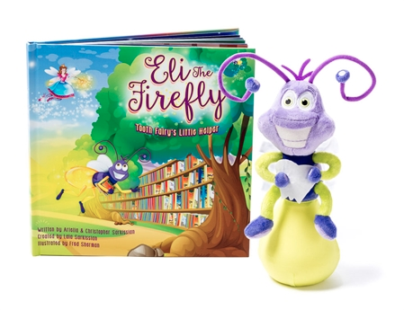

The whimsically rhyming storybook, written by the Sarkissian children, ages 16 and 14, and beautifully illustrated by Fred Sherman, answers the age-old questions of where the tooth fairy keeps all of those baby teeth and why she needs them in the first place! One day when there weren’t enough clean, white teeth in tooth fairyland, Eli the Firefly, the hero of the story, comes to the rescue with a brilliant idea.

As an adorable plush toy, Eli comes to life to motivate kids all around the world to help the tooth fairy, by taking great care of their teeth. Eli’s tail will glow on and off for a full two minutes to keep count as kids brush and on that special night, when there is a clean, bright baby tooth under the pillow, his glowing tail will serve as a beacon for the tooth fairy.

$39.99

Baby Tooth Flapbook

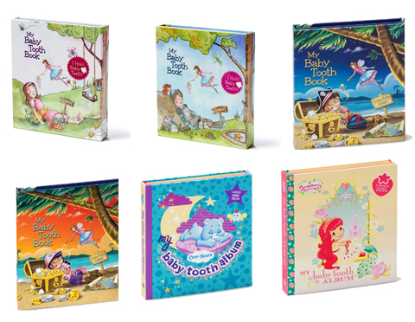

Tri-fold flapbook complete with Baby Tooth Organizer, guide, hand painted cover and magnetic flap. Care Bears, Strawberry Shortcake, and more!

$15.95

Complete Tooth Fairy Kit

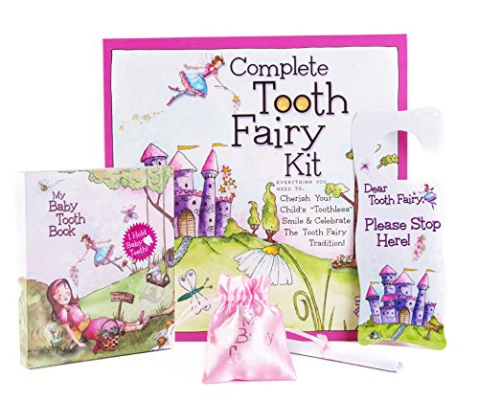

In this kit you will find everything a parent and child need to celebrate those precious "toothless" smiles.

$25.95

Baby Tooth Scrapbook

Just add Photos and Baby Teeth! Save, organize and cherish your child’s precious baby teeth in this one-of-a-kind memory book and baby tooth organizer.

$19.95

Tooth Fairy Door Hanger

Make the Tooth Fairy tradition even more magical for your child as he or she hangs this whimsical door hanger from the door.

$3.49

Baby Tooth Pouch

Keep baby tooth and coins safe under the pillow with this beautifully printed satin pouch.

$1.49

For more information on Baby Tooth Album and to browse the collection, visit www.babytoothalbum.com!

Visit www.elithefireflystory.com for more info and to purchase Eli the Firefly!

What Parents Are Saying About Baby Tooth Album:

"I love your products and would like to share it with my club of moms... Thank you so much for coming out with such a great product."
- Channon H., Surprise, AZ

"I really wanted to give my sister something truly special and unique for her baby shower. Something she would cherish for years. When I saw the Baby Tooth Album Memory Book, I knew I had to get it. I bought several items for her shower, but the Baby Tooth Album was the one everyone was talking about!"
- J.T., Rockville, MD

"I saved all of my children’s teeth in small jars. The Baby Tooth Album is the perfect way to save your child’s teeth in a photo album. I bought one for all of my grandchildren."
- N.C., Natick, MA

"I had a lot of fun embellishing my child’s Baby Tooth Keepsake. It really was a unique and enjoyable craft project that is useful too."
- K.L., Arlington, VA

Note to the Media

To arrange an interview with the Lala Sarkissian prior to, during, or after the show, please contact Tasha Mayberry, Director Public Relations at tasha@socialmedia22.com or call 207.317.6099.

Contact Information:

Tasha Mayberry
Director Public Relations
tasha@socialmedia22.com

Baby Tooth Album
16661 Ventura Blvd., Suite 800
Encino, CA 91436

www.babytoothalbum.com
Facebook: https://www.facebook.com/BabyToothAlbum
Twitter: @babytoothalbum

###

