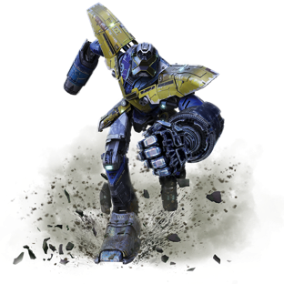

BRAND OVERVIEW
Mech-X4 is a serialized live-action sci-fi adventure series that follows Ryan Walker, a freshman at Bay City High who has technopathy – the extraordinary ability to control technology with his mind. His talent mysteriously awakens MECH-X4, a giant 150-foot robot built by an elusive genius-in-hiding to defend their town against impending doom. Ryan recruits his two best friends and his older brother to help him operate MECH-X4. When monsters suddenly begin to descend upon their city, the four must quickly learn to work as a team in order to pilot the robot that is their only hope of saving their town, and ultimately the world, from mass destruction. Mech-X4 premiered last fall in the United States on Disney Channel and Disney XD and continues to build a strong audience base. Mech-Execute!

PRODUCT LINE OVERVIEW
The Mech-X4 toy product line targets boys 5-9 years old and includes action figures, feature figures and tech-action role play items. The line delivers on the themes central to the success of the show: controlling a giant robot, never before seen monsters, and aspirational high-tech gadgets that allow the boy to be the hero and be in control of the action. The line launches in the United States in August 2017.

PRODUCT LINE DETAILS:

ACTION FIGURES
With a line of highly detailed Action and Monster figures, boys can recreate the amazing battle action scenes from the show. Ages 4+
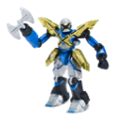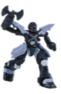  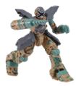 | 5” Mech-X4 Assortment  - Key Features  - 9 points of articulation  - Outfitted with extra weapon attachment  - Includes the original Mech-X4, Stealth, Camo & Invisible mode robots | SRP $9.99  Each sold separately
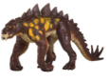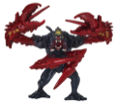  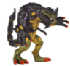 | 5” Monster Assortment  - Key Features  - 3-4 points of articulation  - Constructed with soft PVC material  - Includes Jaguasaur, Claw-Boon, Cameleo-Wasp & Harper’s Beast | SRP $9.99  Each sold separately
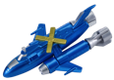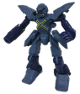  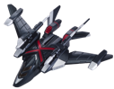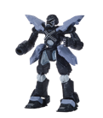 | 5” Mech-X4 + Vehicle Assortment  - Key Features  - Distinct Mech-X4 deco  - 9 points of articulation on figure  - 2 Modes of play: standalone vehicle or armored up robot  - Each vehicle shoots 2 missiles  - Includes Mech-X4 + Submarine, Mech-X4 +Jet | SRP $19.99  Each sold separately

FEATURE FIGURES
Mech-X4 feature robots bring the exciting battle action from the show to life and allow boys to recreate their favorite scenes. Ages 4+
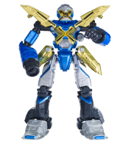 | 10” Mech-X4  - Key Features  - 6 points of articulation  - Press the button at the waist to activate light up visor & “X” on chest  - Includes 10+ battle sounds and character phrases from the show  - Requires 3xLR44 batteries, included | SRP $24.99
ROLE PLAY
Boys can “Mech-execute” and play out all the action and pretend they possess the Technopathy ability just like Ryan discovers he has in the show! Ages 4+
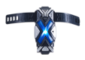  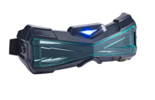 | Tech Action Role Play Assortment  - Key Features  - Mech Link Communicators feature 2.4GHz Technology to allow for 60+ ft. communication range and light up when in use  - "X" Vision Goggles feature motion sensor activated Blue LED light up to recreate Ryan's Technopathy vision and provides enhanced night vision!  - Assortment Includes “X” Vision Goggles and Mech-Link Communicators  - Mech Link Communicators require 4xAAA batteries; X-Vision Goggles require 3xLR41 batteries, not included | $19.99 SRP  Each sold separately
SOCIAL MEDIA AND MEDIA ASSETS:
DISNEY
Website: http://disneychannel.disney.com/mech-x4
Facebook: http://www.facebook.com/MechX4
Twitter: https://twitter.com/ #mechx4
Instagram: https://www.instagram.com/mechx4

About Bandai America Incorporated

Bandai builds on dreams, adds to the fun, and strives to inspire kids of all ages around the world, every day! A leader in developing engaging, quality toys that capture children’s imaginative spirit and provide endless “Fun For The Future,” Bandai America Incorporated is the manufacturer and master toy licensee of some of the most popular brands in children’s toys and interactive entertainment today. The Bandai America brand family includes Power Rangers®, Dragon Ball®, Miraculous™ and Zak Storm™, among other boys, girls, preschool and hobby product lines. Bandai America Incorporated is a subsidiary of BANDAI NAMCO Holdings USA Inc., an entity that resulted from the integration of Namco Ltd. and Bandai Co. Ltd. of Japan. Global interests encompass three strategic business units: Toys and Hobby, Video Games and Online Entertainment and Film and Music. The company is headquartered in El Segundo, California. Find out more about our expertise in connecting with kids in fun and fresh ways at www.Bandai.com.

Bandai logo: ® and © 2017 Bandai.
© Disney 2017
All other trademarks are the property of their respective owners.

# # #

