Ryan’s World™ Spring 2019 Product Descriptions

Ryan Toys Review is the most popular kids and family YouTube channel on the planet! Ryan’s channels have 30+ Billion video views, 18+ million subscribers and counting. Bonkers Toys has partnered with pocket.watch™ to create Ryan’s very first toy line under the brand, Ryan’s World™. The flagship toy in the Ryan’s World toy line, the Giant Mystery Egg, was one of the most highly sought after toys of the holiday season and has been featured by national media and received numerous awards.

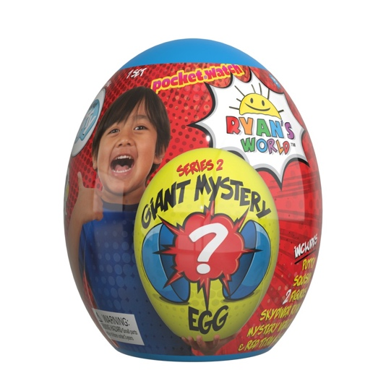 | Ryan’s World™ Giant Mystery Egg - Series 2  The award-winning Ryan’s World Giant Mystery Eggs created a frenzy at retail with Ryan’s fans. New for 2019, the highly anticipated Series 2 Giant Mystery Egg hits shelves. Kids can be just like Ryan from Ryan Toys Review when they unbox their Giant Mystery Egg from Bonkers Toys! The action-packed Series 2 Egg features an exclusive pull-back vehicle, ultra-rare figures, a new skydiver Ryan with a working parachute, special putty, a limited edition squishy, and a Red Titan mask. The flagship toy in the Ryan’s World line, stands at almost a foot tall and has been selling out at retailers across the country.  - Based on Ryan Toys Review, the most popular kids YouTube channel on the planet  - Giant egg is filled with surprises including an exclusive pull-back vehicle, ultra-rare figures, a new skydiver Ryan with a working parachute, special putty, limited edition squishy and Red Titan mask.  MSRP $39.99 - $49.99 | Ages 3+
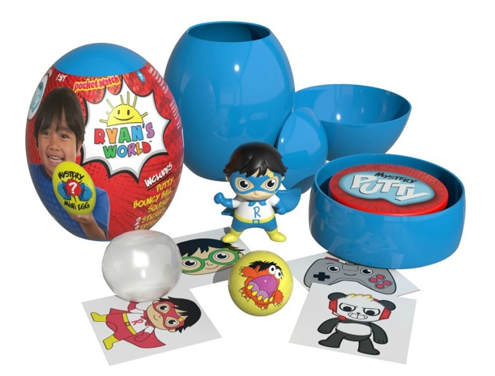 | Ryan’s World™ Mini Mystery Egg  Great things come in smaller packages! Based the success of the award-winning Ryan’s World Giant Mystery Egg, Bonkers Toys has created the Mini Mystery Egg for Spring 2019. The 5 inch tall egg is filled with fun including a surprise Mystery Figure, Squishy or new Build-a-Ryan Figure, exclusive putty, bouncy ball, stickers and Ryan’s World tattoos. The Mini Mystery Egg is the ideal unboxing experience at an affordable price.  - Based on Ryan Toys Review, the most popular kids YouTube channel on the planet  - Mini Mystery Egg is filled with surprises including a Mystery Figure, Squishy or new Build-a-Ryan Figure, exclusive putty, bouncy ball, stickers and Ryan’s World tattoos.  - The ideal addition to Easter baskets for Ryan’s fans  MSRP $12.99 - $14.99 | Ages 3+
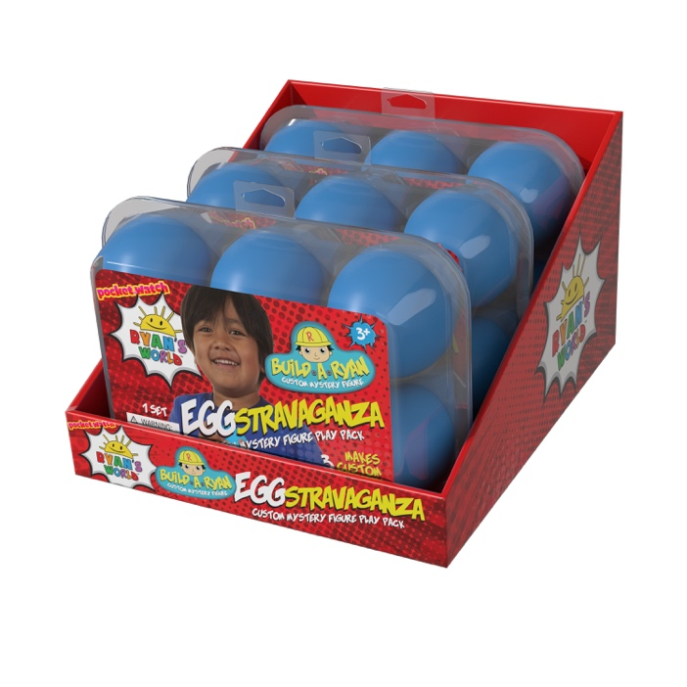 | Ryan’s World™ Build-a-Ryan EGGstravaganza  This egg-ceptional new addition to the Ryan’s World toy line allows kids to build and create their very own Ryan’s World figures. The cleverly packaged egg crate is filled with Build-a-Ryan components so fans can mix and match. Each set includes pieces to make three complete figures that may include Red Titan, Robo Ryan, Alien Ryan and even Combo Panda. Available exclusively at Target for Spring 2019.  - Based on Ryan Toys Review, the most popular kids YouTube channel on the planet  - EGGstravaganza includes components to make three complete figures.  - Kids can mix and match to make their own crazy characters  MSRP $12.99 - $14.99 | Ages 3+  Available exclusively at Target for Spring 2019
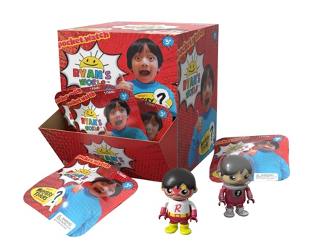 | Ryan’s World™ Mystery Blind Bag Figures – Series 2  An astronaut? A scientist? How about a superhero? Kids can be just like Ryan when they collect their very own mystery figures based on characters in Ryan’s videos. 12 figures in the series 2 assortment, each with their own accessory, including rare and ultra-rare versions.  - Based on RyanToysReview, the most popular kids YouTube channel on the planet  - 12 blind bag figures in the first assortment including rare and ultra-rare  MSRP $3.99 - 4.99 | Ages 3+
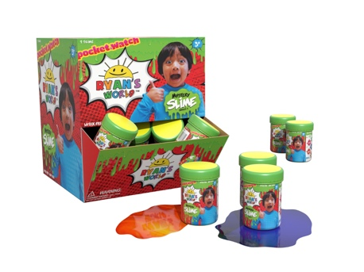 | Ryan’s World™ Mystery Goo  Get grossed out with ooey, gooey, Ryan’s World Mystery Goo. Featured in blind capsules, it combines the fun of goo with a blind unboxing experience. Will it be Bubble Blue? Rad Red? Or maybe the rare Blotchy Black. 7 different colors in the series 2 assortment.  - Based on Ryan Toys Review, the most popular kids YouTube channel on the planet  - Product comes in blind capsules - 7 different colors in the series 2 assortment  MSRP $3.99 - $4.99 | Ages 3+
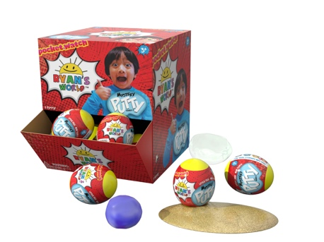 | Ryan’s World™ Mystery Putty – Series 2  Pull it, stretch it, and best of all, collect it. Ryan’s World Mystery Putty features 7 different cosmic colors, all in blind eggs. Including Wicked White, Brilliant Blue, and the very rare, Galactic Green.  - Based on Ryan Toys Review, the most popular kids YouTube channel on the planet  - Product comes in blind eggs - 7 different colors in the series 2 assortment  MSRP $3.99 - $4.99 | Ages 3+
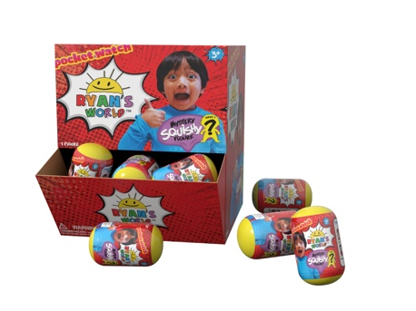 | Ryan’s World™ Mystery Squishy – Series 2  Squish, squish, hooray! Ryan’s World’s squishy figures are so soft and satisfying, kids can’t put them down. Based on Ryan’s most popular videos, the series 2 assortment includes Pilot Ryan, Robo Ryan, Karate Ryan, the rare Alien Ryan, and more.  - Based on Ryan Toys Review, the most popular kids YouTube channel on the planet  - Product comes in blind capsules - 6 different squishies in the first assortment including a rare  MSRP $3.99 - $4.99 | Ages 3+
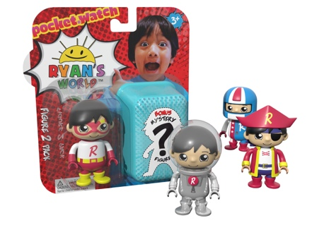 | Ryan’s World™ 2 Pack Figures  What could be better than one Ryan figure? Well two, of course! In the Ryan’s World 2 Pack Figures, one is shown and the other is completely blind, adding to the unboxing fun. Featuring the ultra-rare Steel Titan not available anywhere else.  - Based on Ryan Toys Review, the most popular kids YouTube channel on the planet  - 2 figures per package – one is seen and one is blind  - 12 figures in Series 2 including rare and ultra-rare  MSRP $7.99 - $9.99 | Ages 3+
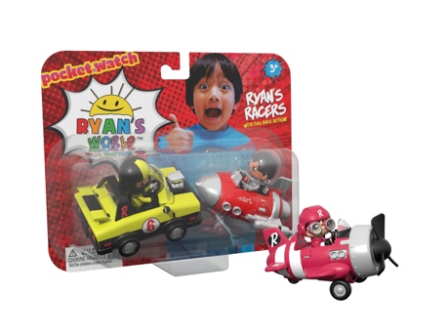 | Ryan’s World™ Ryan’s Racers 2 Pack  Ready to race? Ryan’s pull back vehicles are a super fun way for kids to play with their friends. Who will reach the finish line first? Featuring a variety of 2 pack combinations including race cars, emergency vehicles and rocket ships.  - Based on Ryan Toys Review, the most popular kids YouTube channel on the planet  - Includes 2 pull-back vehicles per package  - Eight different vehicle options including race cars, emergency vehicles, rocket ships and more.  MSRP $9.99 – $12.99 | Ages 3+
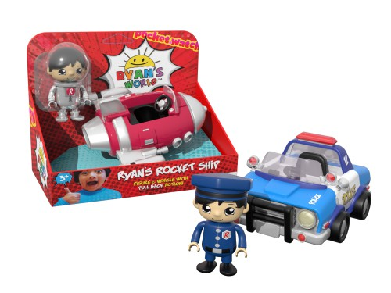 | Ryan’s World™ Medium Size Vehicle with Figure  Ryan’s World comes to life with real racing action. Six cool vehicles to choose from including Ryan’s Rocket Ship, Race Rod, Sky Fighter, Patrol Car, Off Road Vehicle and Tractor. Each vehicle features pull back action and a removable figure to collect.  - Based on Ryan Toys Review, the most popular kids YouTube channel on the planet  - Includes 1 mid-size vehicle with removable figure per package  - Six different vehicle options in the first assortment including Ryan’s Rocket Ship, Race Rod, Sky Fighter, Patrol Car, Off Road Vehicle and Tractor.  MSRP $12.99 – 14.99 | Ages 3+
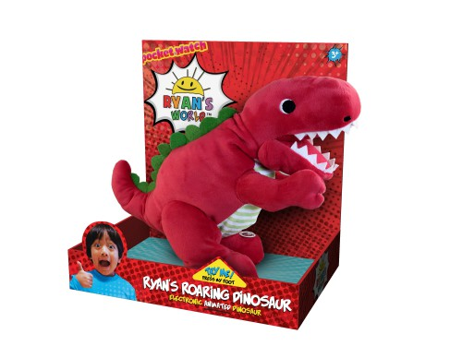 | Ryan’s World™ Roaring Dinosaur  Kids will have a roaring good time with the Ryan’s World Electronic Dinosaur. Featuring super soft plush, awesome animated action, and dinosaur sounds. Choose from the T-Rex or Triceratops.  - Based on Ryan Toys Review, the most popular kids YouTube channel on the planet  - Featuring super soft plush, awesome animated action, and dinosaur sounds.  - Choose from the T-Rex or Triceratops.  MSRP $24.99-29.99 | Ages 3+

