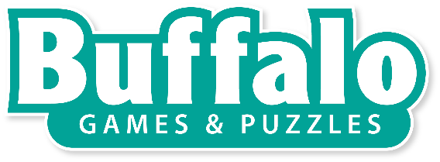
Contact Information:
Brent Feuz, 716-464-5246
Bfeuz@buffalogames.com

NEWS RELEASE
FOR IMMEDIATE RELEASE
BRING HOME THE WORLD’S MOST POPULAR ARCADE GAME WITH TABLETOP SKEE-BALL!
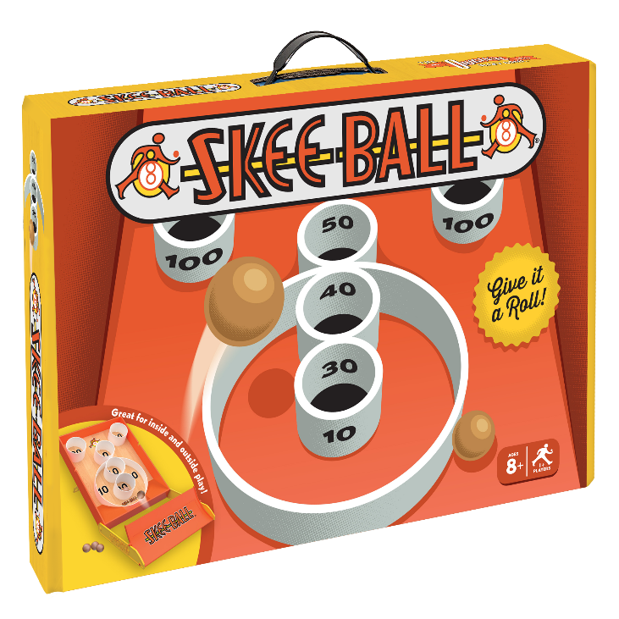
(Buffalo, New York) – Buffalo Games, industry-leading game and puzzle company, is partnering with Bay Tek Games, world-class developer of ticket redemption games, to release a portable tabletop version of the arcade classic, Skee-Ball.

In this new home version of Skee-Ball, players can play solo, head-to-head or in teams in an effort to score the most possible points over a 12-frame game. The gameplay of this new game is much like that of the full size original where players must launch balls off a ramp into rings of different point values. “We captured the fun and excitement of Skee-Ball in our version of the game, and now families can play together from the comfort of their own home,” said Buffalo Games Vice President of Sales and Marketing, Ben Jamesson.

The game can be played almost anywhere whether it is on a table or on the floor – inside or outside. Skee-Ball is perfect for ages 8+ and can accommodate any number of players making it a great game for family game night. When you are done playing, the game folds up for easy storage.

The Skee-Ball game will contain a board made from premium crafted wood, a plastic ramp, 5 authentic wooden balls, instructions and a score pad for tracking your points. The game will launch later this spring at most major retailers.

About Buffalo Games
Buffalo Games is an industry-leading jigsaw puzzle and party game manufacturer located in Buffalo, New York. Buffalo Games products are available at all major retailers in the U.S.A. and Canada. Over the company’s 30-year history, Buffalo Games has sold more than 40 million puzzles and party games. The company’s portfolio includes popular licenses such as Nat Geo’s Brain Games, Star Wars, the NFL, Charles Wysocki, Josephine Wall, Kim Norlien, Darrell Bush and The Hautman Brothers. All of Buffalo Game’s products are produced with a careful eye toward quality and sustainable practices. The company’s full line of party games are both fun to play and easy to learn. Their puzzles and games are made from high-quality paper board and precision cutting techniques and feature sought-after artwork from the industry’s top licensors. Find us at www.buffalogames.com or on Facebook at www.facebook.com/buffalogames.

About Bay Tek Games
Bay Tek Games was founded in 1977 and is a family owned and operated business that is driven to provide fun and profit through innovative ticket redemption games. Headquartered in the heart of the Midwest, Pulaski, Wisconsin is home to Bay Tek Games. The rural community in Northeast Wisconsin populates over 3,500 citizens where hard work, fun, and simplicity meet. The employees share one vision of becoming the best in the world at developing and manufacturing ticket redemption games. Dimensional Branding Group (DBG), licensing division of Bay Tek Games, grows and develops brand and licensing strategy for the entertainment industry and beyond. Find Bay Tek at www.baytekgames.com and DBG at dimensionalbranding.com

END

