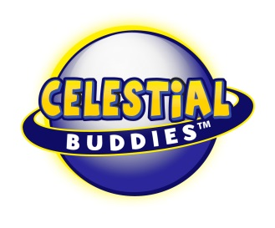

Press Release

Polaris Plush Lights Path for Celestial Buddies
NYTF Booth #6021
New York, NY - (February 12, 2019) – Lighting a path to fun! Just as the real North Star has lit the way for explorers for centuries, Celestial Buddies brings its plush version of Polaris to light the way for travelers to the 2019 New York Toy Fair.

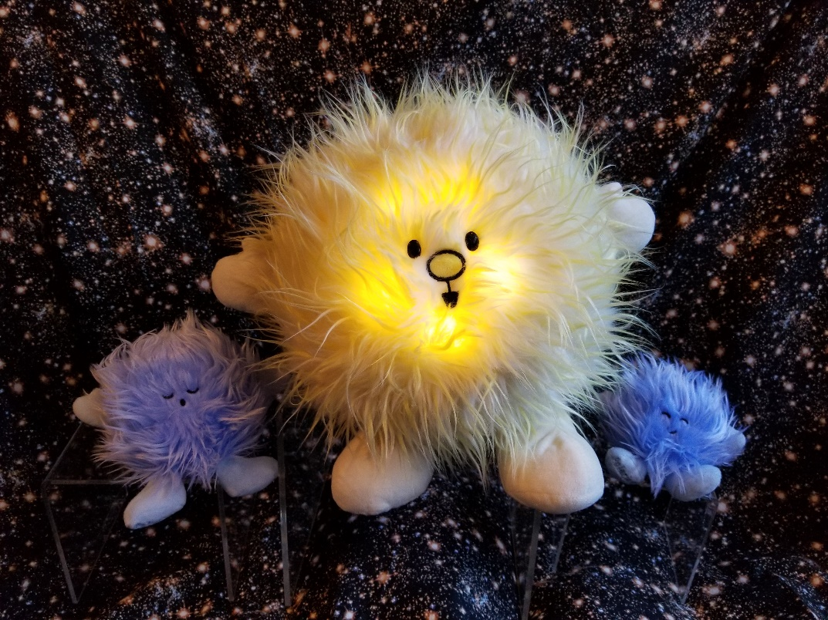
Celestial Buddies (Booth 6021) is pleased to en”light”en crowds with its first illuminating product.

Polaris (MSRP $39.99 for ages 3 and up), commonly referred to as The North Star or Pole Star, is the new Celestial Buddies product that is actually a group of three plush pals. As always, the company has been detail-oriented and true to the universe by creating Polaris as a “trinary”, or three-star system. Celestial Buddies included the small dwarf stars to attach magnetically to the Polaris center star, which twinkles thanks to safety-tested, battery-operated LED lights that are operated by squeezing the plush star’s left foot. (Polaris Buddy shuts off automatically after 20 minutes.)

Like all of the products from Celestial Buddies, Polaris comes with a hang tag that provides statistics and fun facts, including a guide to how to use the Big Dipper’s “pointer” stars to locate Polaris at night.

The Celestial Buddies collection now includes 15 different plush educational toys, including a Black Hole bag that carries all of the Buddies. Through both careful selection of fabrics and decisions regarding size, shape and features, the company designs each Buddy to stay true to its unique variations in order to create an artistic interpretation of each celestial body. The products are sold around the world online as well as in museums, gift shops, science centers, planetariums, and specialty stores in North America, Europe and Australia. For more information, visit www.celestialbuddies.com and interact with the company on Facebook and Instagram.

