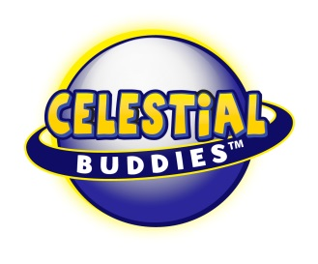

Press Release

Celestial Buddies Forge Even Younger Trend
Of S.T.E.M. Exploration
New York Toy Fair Booth #6021
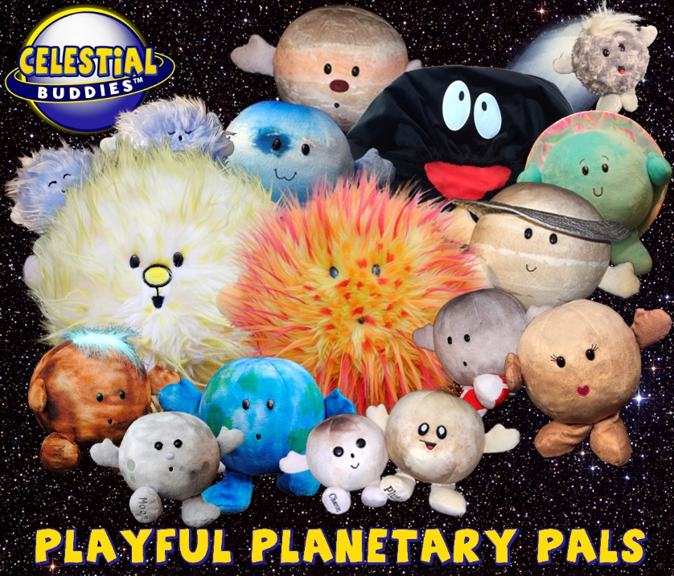
New York, NY – (February 16, 2019) - Celestial Buddies, the only manufacturer of educational plush toys that depict celestial bodies in our solar system and beyond, today announced its surge of sales specifically to cater to the science interest of toddlers and preschoolers.

“Our products are outstanding fun, quality plush pals and collectibles, and now we are seeing the science factor become a more dominant purchase intent,” Jon Silbert, VP Sales of Celestial Buddies, explains. “The trend in STEM is definitely showing in our sales. It’s more than just a casual fascination with the planets and solar system and it’s trending to a younger and younger age group all the time.”

From its beginnings in 2011, Celestial Buddies was heralded by parents, educators and organizations, which included Time Magazine naming the Buddies among “The Top Ten Toys for Young Geniuses”. Today, the product line has numerous accolades, including its most recent honor as The 2019 Mom’s Choice Gold Award for its My Precious Planet Plush.

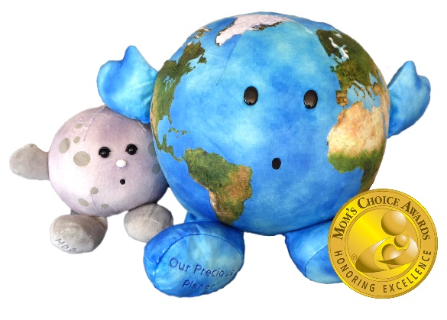
“We’ve been embraced by parents and children. Even professional astronomers love them, employing them in lectures for college students and for community outreach,” Silbert continued. “It’s very satisfying to see that our products can actually encourage future careers in science.”
According to The Toy Industry Association, the not-for-profit trade association representing all businesses involved in toys, a top trend is “Toys that Teach” and “Play with a Purpose.” The TIA recently published “…Though STEM/STEAM (an acronym for Science Technology Engineering Art Math) toys have been a mainstay the past few years, these toys are now engaging kids in several different ways and often incorporating new technologies and licenses to get kids excited about learning.” “…With the U.S. Bureau of Labor Statistics predicting that STEM jobs will increase to more than 9 million by 2022, parents are eager to get their children interested in these topics at a very young age. It's important to note that this trend also encompasses toys that teach kids how to make the world a better place – by being responsible citizens, kind to their friends, and open-minded about different cultures.” Looks like Celestial Buddies is on-point with its fun, educational products, and green messaging.
“Maybe we’re encouraging future astronauts, astrophysicists, and meteorologists, among so many other professions,” Silbert concluded.

Parents who have discovered the Celestial Buddies are finding a fun and healthy way to teach their kids about science. Professional educators on all levels, from elementary and middle school teachers, as well as museum and planetarium directors, and university professors utilize the Buddies in classes and community outreach with ongoing efforts to increase the knowledge of the amazing universe in which we live.

- A Planetarium Director: “Thank you for these wonderful Celestial Buddies! I find a daily use for them to help explain phenomena, update visitors on space missions & what we've discovered, and so much more. Because these are fun to work with, people tend to remember what it is we're trying to convey better. Thank you!"

- A mother: "I can't thank you enough. My son is 2 years old and is under assessment for autism. With these Celestial Buddies, my non-verbal son has a way to communicate with us about his passion…. He grabs the moon every night and sits by the window with him watching the moon. He takes all the planets and revolves them around the sun. I'm sure he even knows them by name at the age of 2. He now goes to sleep because he has the moon to cuddle up to while the rest live in his playroom in his cozy corner space for when he needs some quiet alone time…. I just want to say a massive thank you for your wonderful product which has given us a way to contact and engage my son. Celestial Buddies have changed the world from a lonely place for a little boy who just can't talk yet. Honestly, I can't thank you enough! "

- An Elementary School Teacher: "My students and I love our collection of Celestial Buddies and have collected them all. Thank you very much for creating these adorable plush planetary pals"
This year, Celestial Buddies enters the New York Toy Fair, the largest toy show in the Western Hemisphere, to present its full line of plush pals, including the all new Our Precious Planet plush and Polaris, the first illuminated Buddy. The company looks to add more distribution channels for consumers to purchase the products.
“Our products are now sold in museums, science centers, planetariums, and brick and mortar stores, as well as on-line, throughout North America, Europe and Australia, and we’re always looking to expand our retail universe,” Silbert said. “Look for us all over the galaxy.”
About Celestial Buddies:
The Celestial Buddies collection now includes 15 different plush educational toys, including a Black Hole bag that carries all of the Buddies. Through both careful selection of fabrics and decisions regarding size, shape and features, the company designs each Buddy to stay true to its unique variations in order to create an artistic interpretation of each celestial body. The products are sold around the world online as well as in museums, gift shops, science centers, planetariums, and specialty stores in North America, Europe and Australia. For more information, visit www.celestialbuddies.com and interact with the company on Facebook and Instagram.

