Press Release

For Immediate Release Media Contact: Greg Walsh, Walsh Public Relations
305 Knowlton Street, Bridgeport, CT 06608
greg@walshpr.com; 203-292-6280

The Most Famous Toy in the Universe
Profile of Celestial Buddies’ Little Earth and The Journey to Space
New York Toy Fair Booth #6117
New York, NY – (January 17, 2020) – Last Spring when SpaceX made history by sending its own spaceship to dock at the International Space Station (ISS), the toy industry also experienced a historic accomplishment.
A member of the SpaceX Crew Dragon was a plush toy. Celestial Buddies, makers of the Little Earth plush, didn’t realize its plush pal would become the most famous toy in the universe. The ISS crew quickly adopted a fondness to the cute Little Earth and made him a social media superstar. Twittered pictures by NASA astronaut Anne McClain and Canadian Space Agency astronaut David Saint-Jacques of Little Earth touring the space station, engaged the general public and a resurgence of interest in the space program emerged. When Crew Dragon was to return to Earth, Little Earth was kidnapped by the crew to stay aboard the ISS indefinitely.
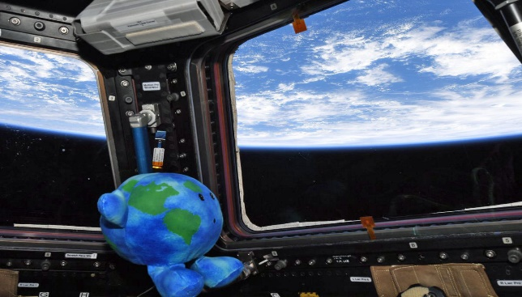
Since becoming an official astronaut in training, Little Earth has also enjoyed being a featured part of the NASA-SpaceX Emmy Award-Winning Outstanding Interactive Program.
The voyage of Little Earth catapulted Celestial Buddies to the forefront of toy industry news and now, less than a year later, Celestial Buddies will enter the International Toy Fair under a proclamation as the company with The Most Famous Toy in the Universe. In addition, Jessie Silbert, company founder and designer of the Celestial Buddies line, has been a named as finalist for The 2020 Women in Toys Rising Star!
Jon Silbert, VP Sales of Celestial Buddies, said, “The attention has been wonderful as we are able to share our company mission with many more people. When my daughter, Jessie, created the Celestial Buddies her aim was to create a line of superior quality products that would make science, and in particular, astronomy, fun and engaging for children.”
Celestial Buddies will be showing its full line of Buddies and accessories in a brand-new display booth at the Toy Fair this year.
About Celestial Buddies:
The Celestial Buddies collection now includes 15 different plush educational toys, including a Black Hole bag that carries all of the Buddies, and a new environmental-message Celestial Buddies t-shirt. Through both careful selection of fabrics and decisions regarding size, shape and features, the company designs each Buddy to stay true to its unique variations in order to create an artistic interpretation of each celestial body. The products are sold around the world online as well as in museums, gift shops, science centers, planetariums, and specialty stores in North America, Europe and Australia. For more information, visit www.celestialbuddies.com and interact with the company on Facebook, Twitter and Instagram.

Sales Inquiries:
Celestial Buddies LLC, 584 Towner Swamp Road, Guilford, Connecticut 06437
T: 203-415-0313; ​sales@celestialbuddies.com; www.celestialbuddies.com

