

***Press Release***

**Toy Fair 2019 Starring Our Precious Planet**

***Celestial Buddies New Plush Pal Opens Climate Discussion***

**NYTF Booth #6021**

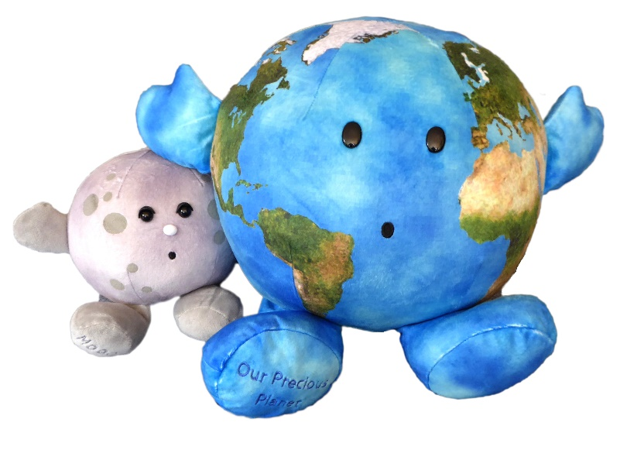New York, NY - (February 16, 2019) - The newest addition to the Celestial Buddies Galactic Gang is Our Precious Planet (MSRP $24.99)**,** a large (9” diameter) detailed version of Earth designed to help start a conversation about climate change and global warming.

Consistent with the Celestial Buddies mission to both enlighten and delight, this Special Edition Buddy is a gentle introduction to a very complicated but also very important subject.

Jon Silbert, VP Sales of Celestial Buddies, explains, "Our company understands that there are many factors that contribute to climate change. There is enough concern, however, about the human contribution to global warming that, as an educational toy company, we wanted to provide a way for families and educators to help promote healthy discussions with children about this important issue."

Like all of the Celestial Buddies, Our Precious Planet comes with an educational hang tag that provides useful information about its representation.

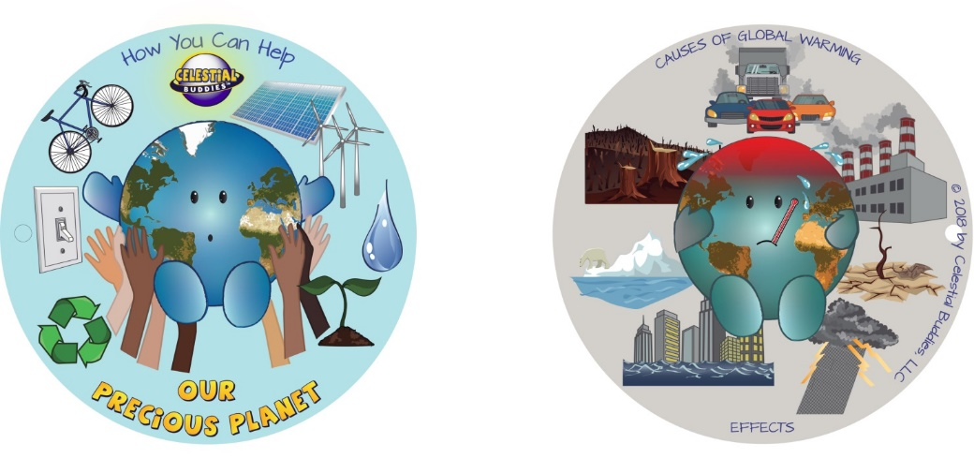Our Precious Planet includes a colorful supplemental tag that illustrates some of the causes and effects of global warming, as well as some suggestions about what individual human beings, including children and their parents, can do to help.

Our Precious Planet joins the line of 15 different Celestial Buddies plush educational toys, including a Black Hole bag that carries all of the Buddies. Through both careful selection of fabrics and decisions regarding size, shape and features, the company designs each Buddy to stay true to its unique variations. in order to create an artistic interpretation of each celestial body. The products are sold around the world online as well as in museums, gift shops, science centers, planetariums, and specialty stores in North America, Europe and Australia. For more information, visit [www.celestialbuddies.com](http://www.celestialbuddies.com)