PLUSH PLANET PLUTO PLUNGES INTO JAVITS CENTER!!! Huge Crowds Gather At Booth 5948 At International Toy Fair Plush Planetary Pals Continue to Delight . . . and Enlighten . . .Kids and Families
With Pluto and Charon having joined the ranks of the Celestial Buddies this year, we now have a Baker’s Dozen of Buddies to provide pleasure . . . and knowledge . . . to young audiences.
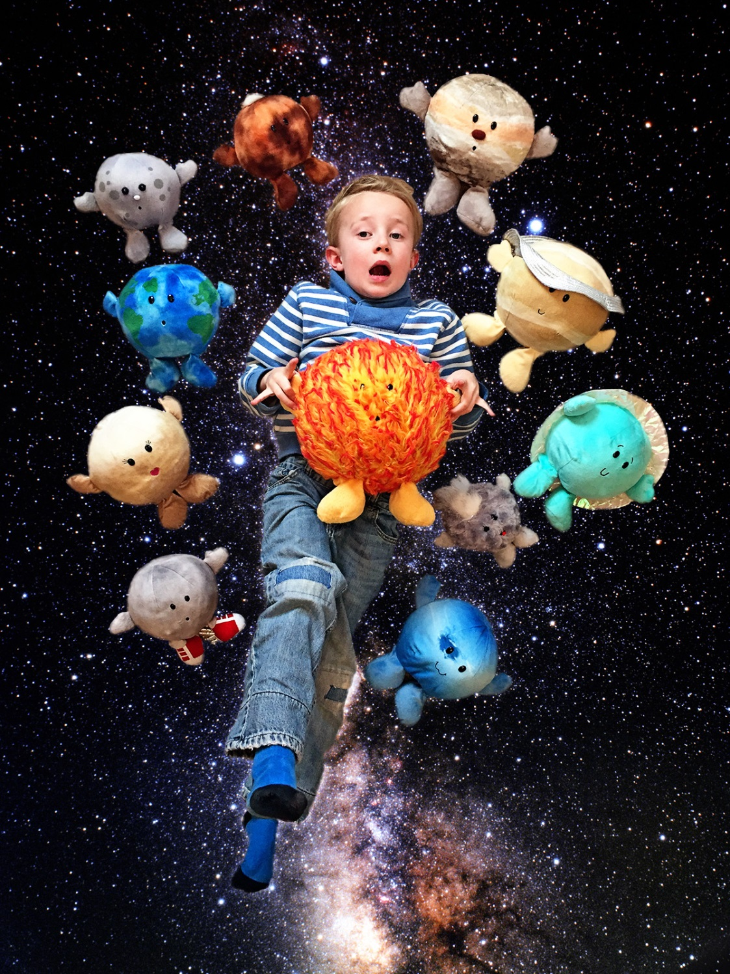
Beginning in 2011 with Sun, Moon, Earth and Mars, Celestial Buddies has been delighting eager children and grown-ups alike with thoughtful and educational depictions of objects in our solar system. Each Celestial Buddy has an educational hang tag that provides both vital statistics and fun facts about the object it represents.
Over the past several years, Celestial Buddies has had added to this miniature stuffed solar system . . .Jupiter and Saturn in 2012, Mercury and Venus in 2013, a Comet in 2014 and Uranus and Neptune in 2015.

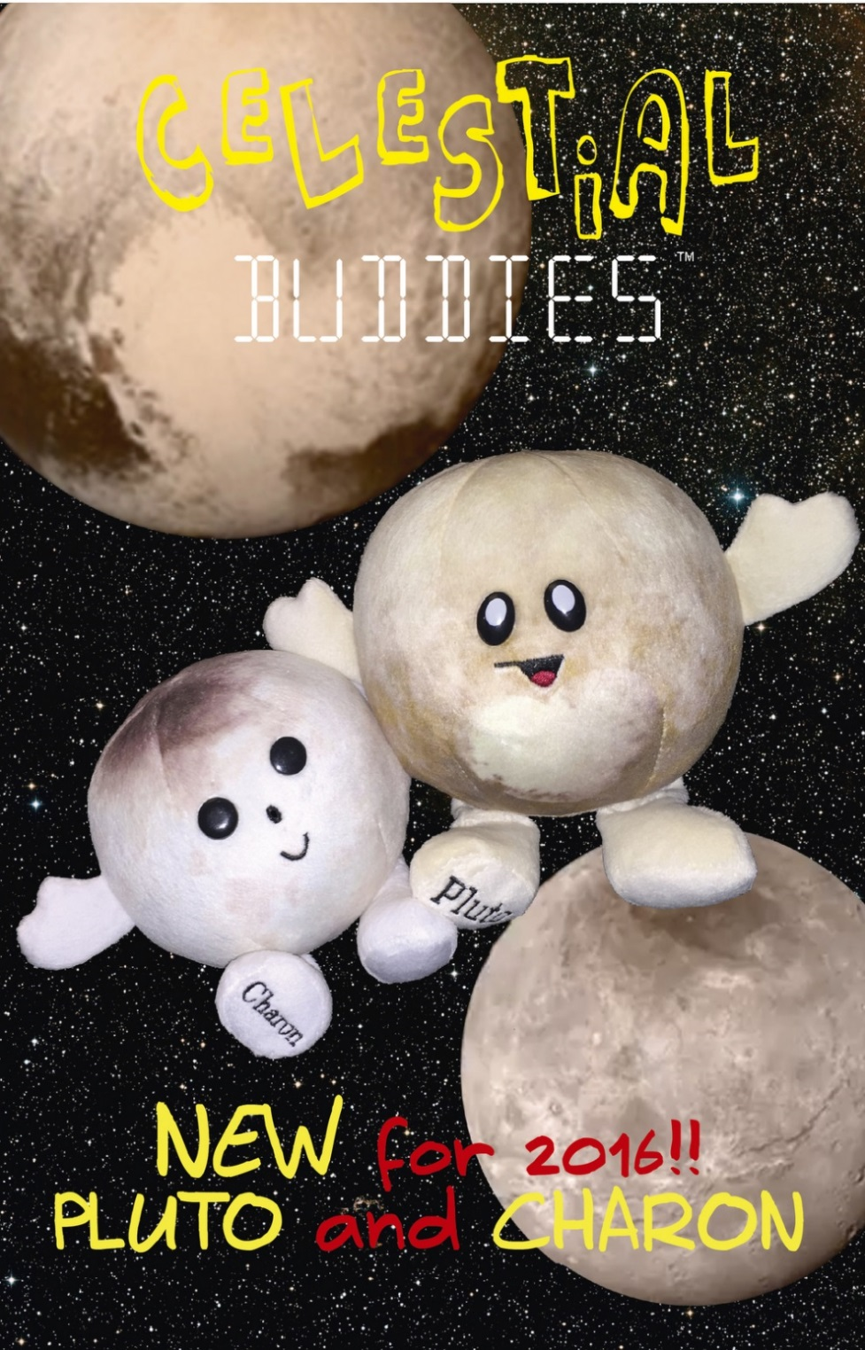
And now, in 2016, Pluto, accompanied by its largest moon, Charon, makes its Toy Fair debut. With designs inspired by the marvelous photos sent back to earth by the New Horizons Space Probe last summer, Pluto and Charon, like all the Celestial Buddies, come with an educational hang tag. Moreover, because of their binary characteristics, our Pluto and Charon are "joined at the hip" by hidden magnets and are being sold as a set at $13.99 wholesale with an MSRP of $27.99. Pluto, with a sideways "P" for a mouth and the heart-shaped "Tombaugh Regio" formation first seen in the New Horizons photos, and Charon, with its "Mordor" on top, are sure to be a hit with toddlers, astronomers and everyone in between.
Toy Fair attendees are invited to come and met the Designer and President of Celestial Buddies, Jessie Silbert, who will be at Toy Fair on Saturday, Sunday and Monday. All of us at Celestial Buddies look forward to welcoming you to Booth 5948.
Celestialbuddies.com Contact: Jon Silbert celestialbuddiesllc@gmail.com 203-415-0313

