Chalk of the Town chalkboard T-Shirts launch new products at Toy Fair 2019, Booth #4532

TEE-RIFFIC KIDS’ TEES -- & MORE!

NEW YORK, NY (February 12, 2019) - Chalk of the Town will display its revolutionary line of erasable kids’ chalkboard T-shirts at the 2019 New York Toy Fair and unveil two exciting new chalkboard products: a unicorn-patterned T-shirt and a canvas tote bag. Check them out at booth #4532, in the Launch Pad area.

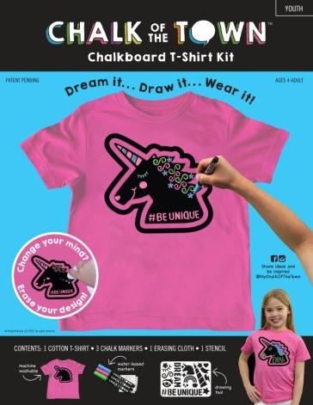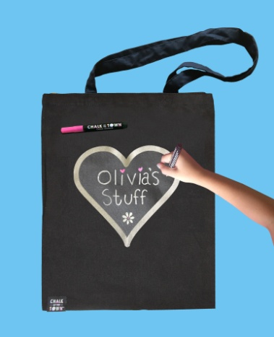

Chalk of the Town shirts, featured on the TODAY Show and carried by more than 150 stores including museums and the New York City Ballet boutique, are taking off. Why? They’re part DIY crafts project and part cool style statement. Kids can create custom designs with chalk markers and stencils on high-quality cotton T-shirts. Parents love that the shirts are machine washable and can be decorated over and over again. “There are a million ways to use these shirts,” one parent explained. “My daughter designed a T-shirt to wear at her birthday party and later decorated the same shirt for spirit day at school.”

About Chalk of the Town
Sisters Sondra Mansfield and Wendy Almasanu have always been crafty, so when they noticed chalkboard surfaces trending in interior design, a light bulb turned on. “We thought, ‘imagine if we could put a chalkboard on a shirt and let kids create a new shirt every day,’ “Mansfield reflects. “We were determined to create a chalkboard-like surface that could accept not only chalk but also bright, fun-to-use, chalk markers.”
The sisters’ combined years of experience in graphic design and engineering to come up with this unique patent-pending chalkboard for T-shirts and totes. Both product lines are sold as part of a kit. Stencils are available to guide designs, but kids can also create their own messages.
For more information visit https://www.chalk-of-the-town.com/
Contact: Sondra Mansfield, Chief Chalking Officer, Sondra@chalk-of-the-town.com

