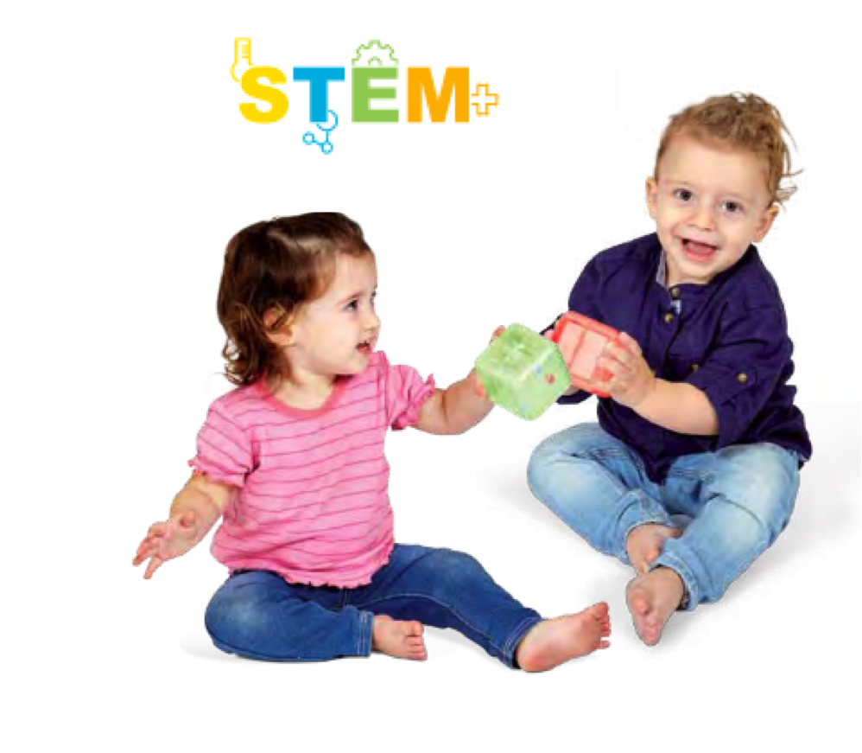 | 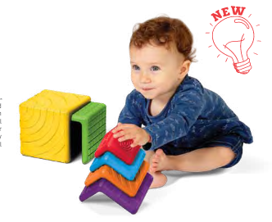 | 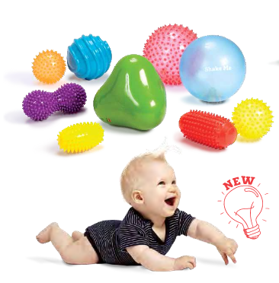
525020 Curiosity Cubes  Each candy-colored cube has a secret. Figure it out by moving it about. Look inside and find the beads. Maneuver the cube until the beads land where they belong. Four cubes, four skill levels.  MSRP: $19.99 | 525011 Stacks and Nesters  Toddlers love sorting, stacking and discovering new forms. Keep them happy and busy with these colorful textured shapes. Fitting them together is lots of fun because there are so many variations. Every creation is a small puzzle to solve and enjoy.  MSRP: $29.99 | 705199 Sensory ball 9pc  Mega Set Ball value pack. Includes: Small green Triangle ball: 5”, Sensory See-Me red ball 7”, two Sensory See-Me orange and yellow 4”, Peanut purple ball 2½”, two Massage Roll balls red and yellow ball 3”, Rainbow soft ball: 7”, Stripes ball 5”. MSRP: $49.99
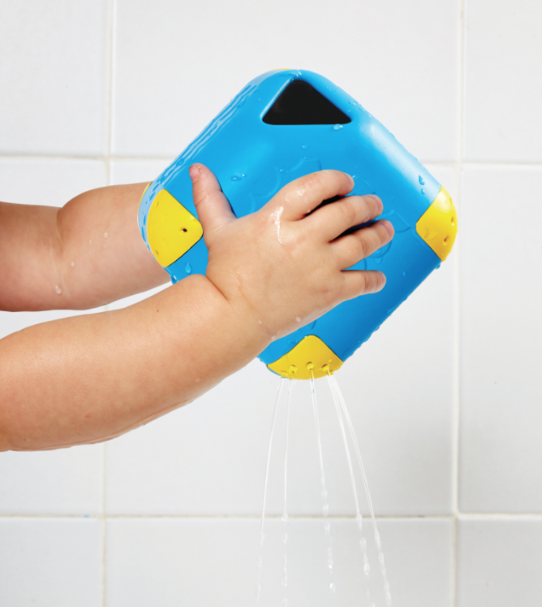 | 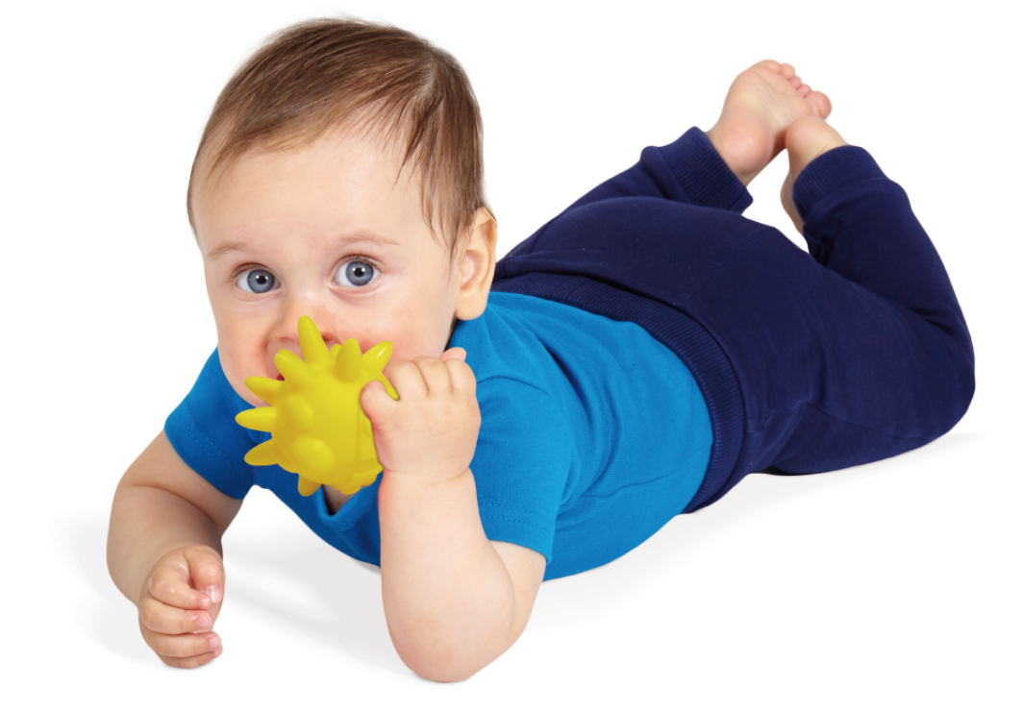 | 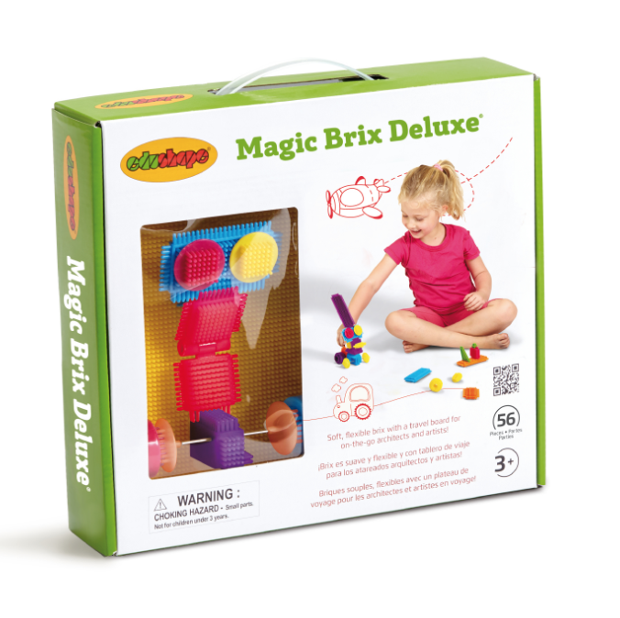
525010 Water Magic Cube  The artful cube has 6 different strainers. Fill it, rotate and pour, then see the water stream into unexpected shapes. Hands, eyes and minds are engaged and bath time is more fun.  MSRP: $9.99 | 865003 Dino Teether  This super-chewy, multi-featured creature soothes and satisfies sore gums as it distracts and entertains little ones. Soft, safe, durable, and fun.  MSRP: $ 35.99 | 925072 Magic Brix Deluxe  Magic Brix fans will be thrilled to add this set to their collection. Our flexibly soft and easy-to-handle brix snap together quickly. Young designers will make imaginative houses and forts, bridges and vehicles, artistic creations and cool sculptures. MSRP: $ 19.99
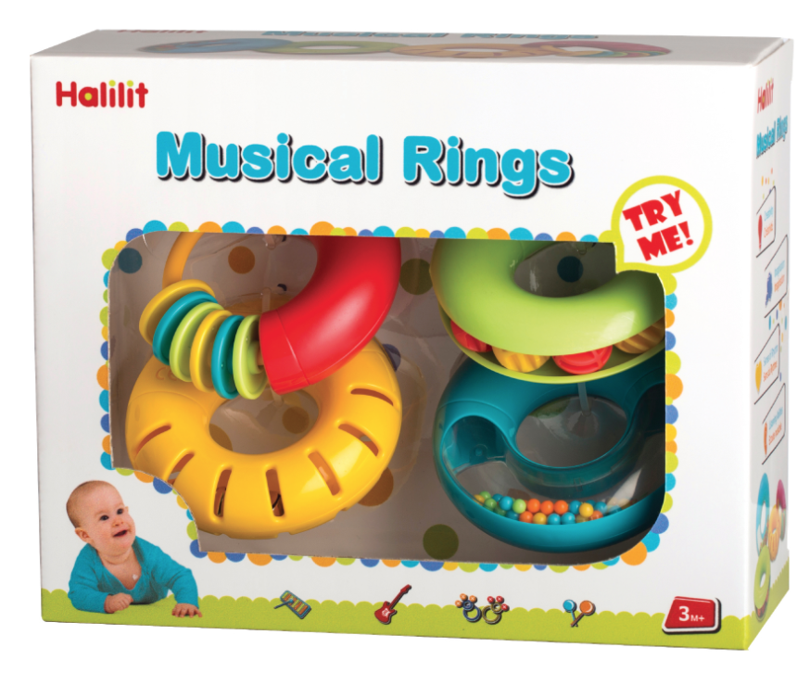 | 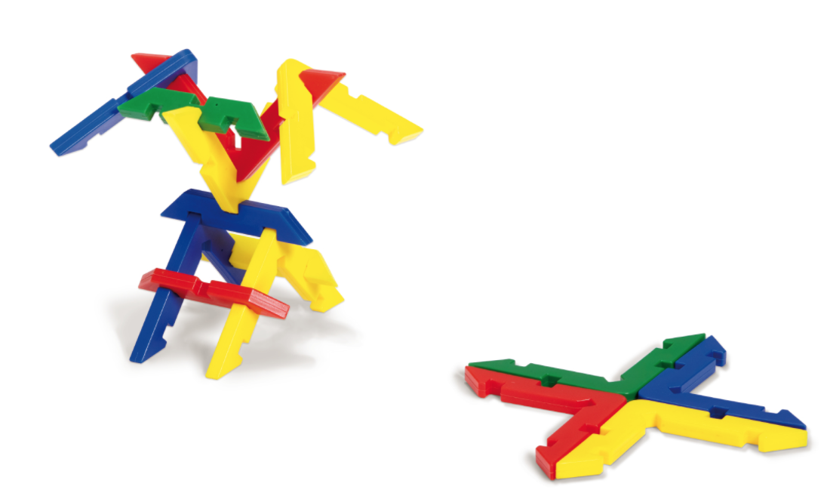 | 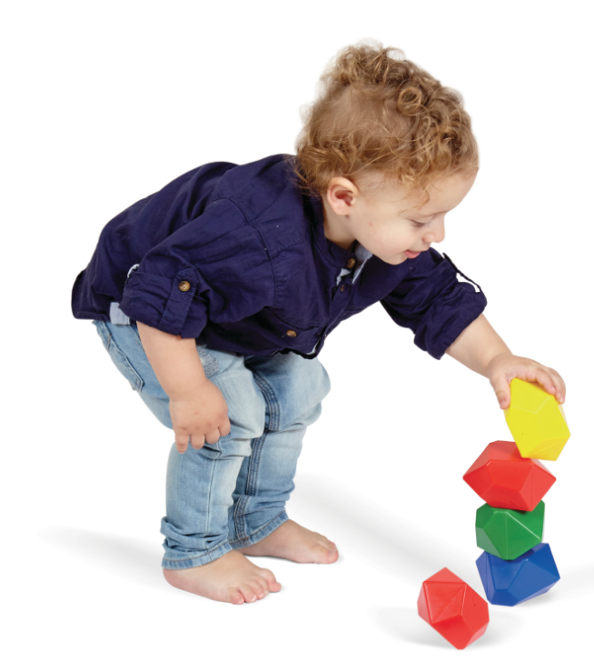
HL8888 Musical Rings  This unique, oversized and superior collection of 4 Musical Rings is ideal for early ages. A modern and innovative design Includes 4 different color rings with 4 different sounds. An early audio and visual sensory while being introduce to the world od sounds and music.  MSRP: $ 19.99 | 826092 Beam Builders  Imagine how many things you’ll make when you’re on the beam. Maybe a tower, maybe a bridge. Snap the pieces together, then add some more. Create a space creature or a robot. It’s up to you. 32 pieces.  MSRP: $ 29.99 | 826091 Gemblocks  If these rocks could talk, they would say “Stack me up, build me up, line me up.” Find the flat part of the facets and fit them together. Make a wall and knock it down. Irresistible! Four happy gemstone colors, 20 pieces.  MSRP: $29.99
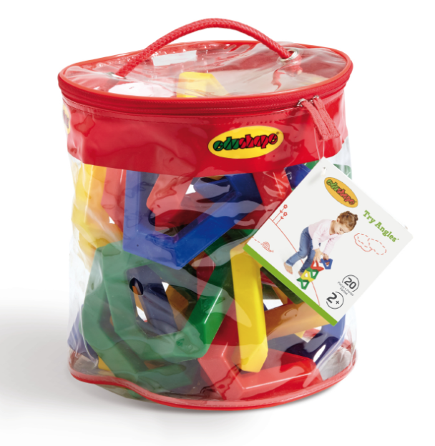
826090 Try Angles  Want to have some fun? Try angles. See how many ways they fit together, how many crazy shapes you can make. Stack them, balance them, interlock them. Kind of like puzzles, they make you think. Kind of arty, too. 20 pieces. MSRP: $29.99 |  | Media contact:  Alise Kreditor, KMC  alise@kmc-pr.com  516.482.4866

