PRESS RELEASE

For Immediate Release Media Contact: Greg Walsh, Walsh Public Relations
305 Knowlton Street, Bridgeport, CT 06608
endless@walshpr.com; 203-292-6280

Traffic Cop Positioned On Toy Fair Floor

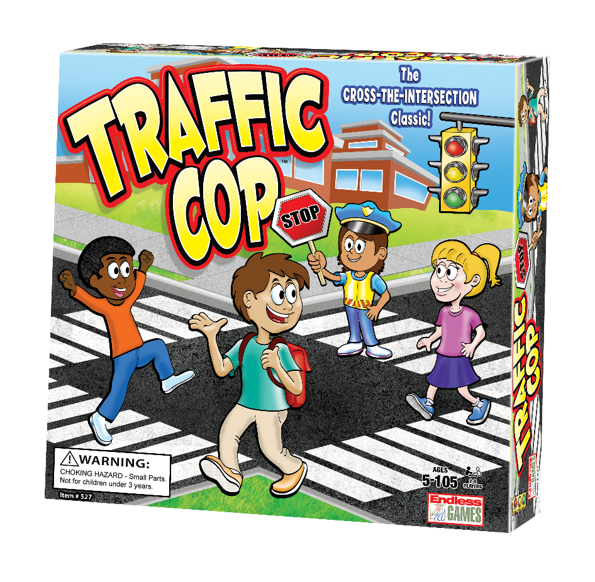
New York, NY - (February 12, 2019) – What’s the most popular intersection in New York City during Toy Fair? Ask the Traffic Cop at the corner of Endless Games Booth 119 in the Javits Convention Center.

Endless Games directs all Toy Fair attendees to a classic game of crossing the intersection with its new Traffic Cop game (MSRP $24.99 for ages 5 and up).

The new game, a follow up to Endless Games’ “hot” selling game, The Floor Is Lava, Traffic Cop is a fun interactive action game based on the classic schoolyard game where one player is the traffic cop and the other players try to cross the street safely.

Traffic Cop, The Floor Is Lava and the full catalog of Endless Games will be presented in booth 119 at the New York Toy Fair, held at the Jacob Javits Convention Center, February 16-19.

Other games from Endless Games include AKA, Jeopardy card game, Wheel of Fortune card game, Sleepover Party Game, Name 5, Everybody Knows, 60 Second Slam, HashTagIt, That Was Awkward, Horror Trivia, What Comes To Mind?, and Encore, among others.

About Endless Games: Founded in 1996 by industry veterans Mike Gasser, Kevin McNulty and game inventor Brian Turtle, Endless Games specializes in games that offer classic entertainment and hours of fun at affordable prices. The three have an uncanny ability for discovering and developing hit games, having been a part in past successes Trivial Pursuit™, Pictionary® and Six Degrees of Kevin Bacon™. The mission of Endless Games is to produce high quality entertainment in board games that are quick and easy to learn but offer “Endless” play value. For additional information, visit www.endlessgames.com and interact with the company on Facebook, Twitter, Pinterest, Instagram and YouTube.

