PRESS RELEASE
For Immediate Release Media Contact: Greg Walsh, Walsh Public Relations
305 Knowlton Street, Bridgeport, CT 06608
endless@walshpr.com; 203-292-6280

All-Time Classic TV Game Shows Come Home
Endless Games to Release Jeopardy, Password, and Wheel of Fortune Games This Spring

New York, NY - (February 15, 2019) – The Answer is: Best home game versions of game shows.
What are Endless Games’ new Wheel of Fortune, Password, and Jeopardy games.
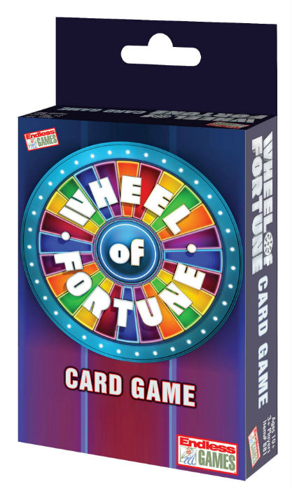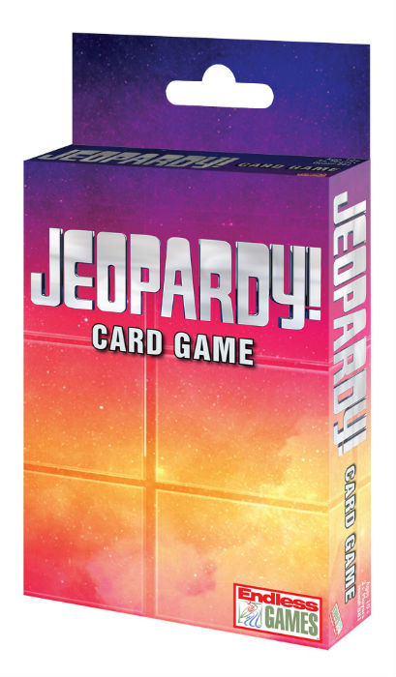
Jeopardy, TV’s most popular quiz show, which is now celebrating its 55th anniversary; Wheel of Fortune, America’s favorite word game show; and Password, the famous word association game show, are headed into homes this Spring when Endless Games releases its new set of game show games.

Debuting at the 2019 New York Toy Fair (Booth 119 in the Jacob Javits Convention Center), Endless Games will offer:
- Jeopardy Card Game (MSRP $6.99 for ages 12 and up);
- Wheel of Fortune Card Game (MSRP $6.99 for ages 12 and up);
- Password Home Game (MSRP $16.99 for ages 10+); and
- Jeopardy and Wheel of Fortune Junior edition card games (MSRP $6.99 each for ages 8-12)

The games feature all of the fun of the shows with easy scoring, bonus plays and final rounds just like the shows on TV.
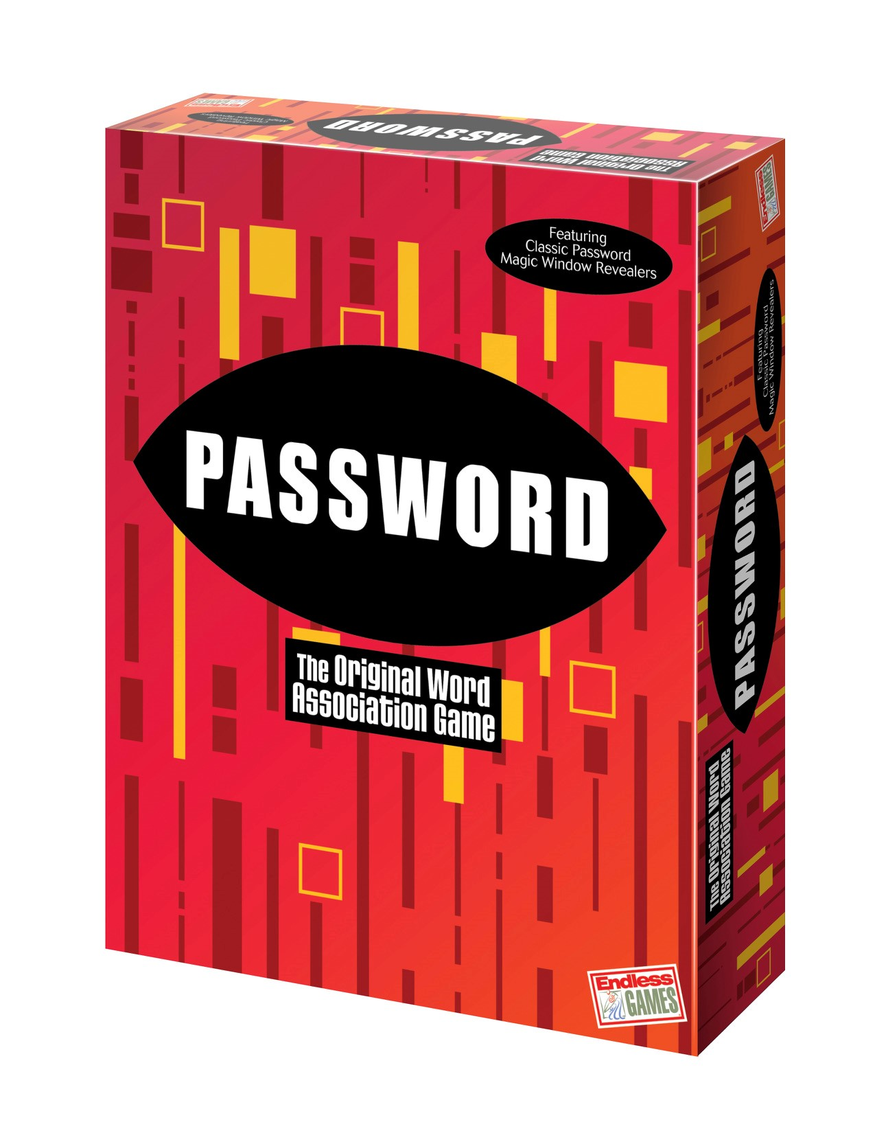
In the Wheel of Fortune card game, players shuffle the deck and flip their way through the Wheel trying to avoid the Bankrupt card. They call out a letter and try to solve the mystery phrase from the puzzle deck.

In the Jeopardy card game, players look to “answer correctly in the form of a question” to score points. The cards are played like a full episode of the TV game show complete with Jeopardy, Double Jeopardy, and Final Jeopardy Rounds.

For Password, players try to get each other to guess specific words based on the fewest single word clues.
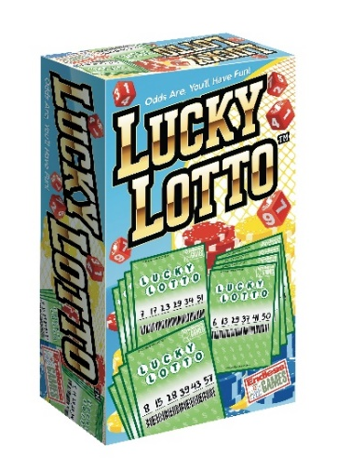
In addition to the wheel of cards, word clues and trivia knowledge, Endless Games wants to know if anyone at Toy Fair is feeling lucky? With its new LUCKY LOTTO (MSRP $14.99 for ages 12 and up), the odds are in your favor for a lot of fun. To play Lucky Lotto the luck of the dice will help determine the winning ticket. Players each pick their lucky numbers and then roll the dice to determine the WINNING numbers!

Other games from Endless Games include AKA, Sleepover Party Game, Name 5, Everybody Knows, 60 Second Slam, HashTagIt, That Was Awkward, Horror Trivia, What Comes To Mind?, and Encore, among others.

About Endless Games: Founded in 1996 by industry veterans Mike Gasser, Kevin McNulty and game inventor Brian Turtle, Endless Games specializes in games that offer classic entertainment and hours of fun at affordable prices. The three have an uncanny ability for discovering and developing hit games, having been a part in past successes Trivial Pursuit™, Pictionary® and Six Degrees of Kevin Bacon™. The mission of Endless Games is to produce high quality entertainment in board games that are quick and easy to learn but offer “Endless” play value. For additional information, visit www.endlessgames.com and interact with the company on Facebook, Twitter, Pinterest, Instagram and YouTube.

Wheel of Fortune ©2019 Califon Productions, Inc.
Jeopardy ©2019 Jeopardy Productions, Inc.
Password ©2019 FremantleMedia N.A,. Inc.
Lotto © 2019 Main Street Games, LLC.
All Rights Reserved

