Media Contact: Lisa McKendall
McKendall Communications
310-641-1556
lisa@mckendall.com

NASCAR CRASH CIRCUIT AND PULP HEROES
FACT SHEET

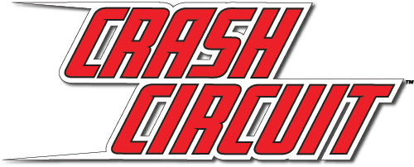
What: Last year, Far Out Toys launched the highly successful line of NASCAR Crash Racers including partnerships with NASCAR race tracks, with top YouTube influencers and supporting in-store programs at Walmart. In 2020, our high-speed vehicle and track set line will expand with two new NASCAR branded sets, all compatible with our “blue groove” track system.

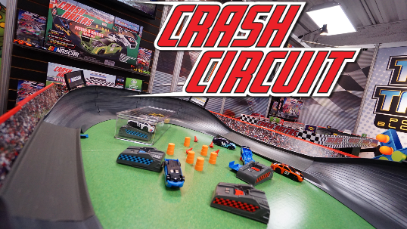
- NASCAR Crash Circuit Super Figure 8 Track brings the classic Figure 8 racing experience to a whole new level with remote control action! The set features lights, sounds and flash chargers that also function as remote control devices to give you full control over the racing and crashing. The track is for ages 5+.

- The NASCAR Crash Circuit Short Track Speedway is inspired by NASCAR’s famous Bristol track, this set features triple-wide pieces of track for ultimate racing and passing action with multiple cars. The speedway is for ages 5+.

- Far Out Toys will also launch a motorized vehicle assortment that allows kids to build their own Crash Circuit racing team with collectible flash-charging cars and then send them flying on their Crash Circuit track set. Four styles will be available for ages 5+.

- NASCAR Die-cast vehicles from Far Out Toys will come in a two pack and a 5 pack that NASCAR fans and vehicle lovers will be able to collect. Multiple styles will be available for ages 5+.

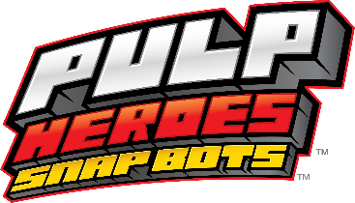
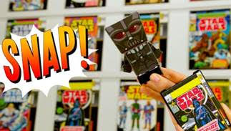
In 2020 Far Out Toys will debut new characters featuring more collector favorites in the Pulp Heroes line! The flat, spring-loaded popular characters literally snap out of the story into a 3-D form when ejected from their colorful, comic book-themed protective sleeves! The Snap Bots spring into action with pullback motor technology that send them zooming into battle against their arch enemies. In Spring 2020, Far Out Toys will debut new Marvel and Star Wars characters including Princess Leia, Captain Marvel and Thanos. Pulp Heroes are for ages 5+.

Where: NASCAR Crash Circuit Super Figure 8 Track will retail for $39.99 and NASCAR Crash Circuit Short Track Speedway will retail for $19.99.

Pulp Heroes will retail for $9.99. All of Far Out Toys’ new products will be available at major retailers.

When: The new Crash Circuit Track Sets will be available Fall 2020.

New Pulp Heroes characters will be available Spring 2020.

Who: Far Out Toys Inc. is a rapidly growing force in the global toy marketplace, with a mission to innovate to the outer reaches. With fully integrated manufacturing, distribution and marketing capabilities, Far Out Toys leverages its expertise and extensive relationships with inventors, IP holders and mass retailers to launch new brands in every toy category - including vehicles, arts & crafts, games, licensed collectibles, electronic toys and fashion dolls.
For more information, visit Far Out Toys.

