Media Contact: Lisa McKendall
McKendall Communications
310-641-1556
lisa@mckendall.com

FUN AND GAMES FROM FAR OUT TOYS
FACT SHEET

What: 2020 will be an amazing year for Far Out Toys with the introduction of five brand new games; Snot Nose, Hot Pot Lobster, Tic Tak Pop Block, Ryan’s World Surprise Reveal and Clown Blasters!

Snot Nose
Players must choose wisely in this slimy new game, Snot Nose, or they will get #snotted! With Snot Nose, players take turns pulling a booger out of the oversized nose and if the booger pulls out cleanly they are still in the game. But, if you get a Snot Gush, you’re out! The game comes with a wearable snot nose and make-your-own slime packets. The Snot Nose game is for ages 5+.

Hot Pot Lobster
Free the lobster from the pot! Hot Pot Lobster is the game where you add vegetables to the soup pot and tap the lid to help the lobster escape. If he jumps out of the pot, you win! Comes with silly lobster, soup pot, vegetable pieces and 1 spoon. Hot Pot Lobster game is for ages 5+.

Tic Tak Pop Block
Spring into action and use your “blaster” to knock all four of your opponent’s pegs out of the X and send them flying! Tic Tak Pop Block is a one-of-a-kind game with that keeps you attacking and blocking at high speed. Tic Tak Pop Block is for ages 8+.
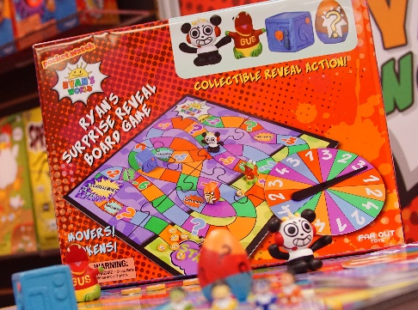
Ryan’s World Surprise Reveal Board Game
In 2019, Far Out Toys’ Ryan’s World line made splashes, leaps and squawks with Splash Out, Head Splat, Springin’ Spiders and Boneless Chicken Launch, drawing in over 10 million views on YouTube. Now in 2020, Far Out Toys will debut a new Ryan’s World game that combines 3D figures and classic gameplay to provide endless fun.

With the Ryan’s World Surprise Reveal Board Game players move around the board with their Ryan’s World characters to find mystery eggs that are filled with surprises. This surprisingly fun game will be for ages 3+.

Clown Blasters Games
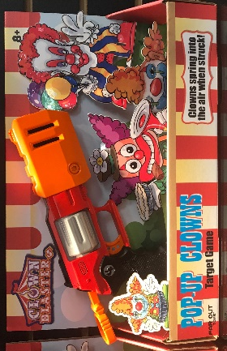
Just like those popular carnival games, Clown Blasters allows kids to blast annoying clowns away with fun new games from Far Out Toys. Put those creepy clown targets out of their misery and watch them explode, spin and flip as you blast them with your Magnum Blaster!

The Creepy Clown Drone game includes one walking drone clown target that breaks into pieces upon impact! The Spinning Clown game includes one spinning clown target and a pistol blaster. Using your Magnum Blaster in the Pop-up Clowns game, you can blast away the three pop-up clown targets!

Where: Snot Nose, Hot Pot Lobster and Pop-up Clowns will retail for $14.99 each. Tic Tak Pop Block, Creepy Clown Drone and Ryan’s World Surprise Reveal Board Game will retail for $19.99 each. Spinning Clown will retail for $9.99. All of these games will be available at major retailers.

When: Snot Nose will be available Spring 2020. Hot Pot Lobster, Tic Tak Pop Block, Ryan’s World Surprise Reveal Board Game and Clown Blasters will be available Fall 2020.

Who: Far Out Toys Inc. is a rapidly growing force in the global toy marketplace, with a mission to innovate to the outer reaches. With fully integrated manufacturing, distribution and marketing capabilities, Far Out Toys leverages its expertise and extensive relationships with inventors, IP holders and mass retailers to launch new brands in every toy category - including vehicles, arts & crafts, games, licensed collectibles, electronic toys and fashion dolls.
For more information, visit Far Out Toys.

