Ahoy! Fin Fun Overflows With Mermaid Treasures & Exotic Animals

New Coral Cloud and Sweet Dreams Limited Edition Mermaid Tails
One-of- a-kind Custom Tail Creator
Ace Eagle and Flutters Butterfly Wild Things Blankets

February 16th, 2018 - New York, NY… Fin Fun, leader in the mermaid lifestyle category, introduces a bevy
of new Limited Edition tail styles for mermaids who want to dazzle on land and under the sea at American
International Toy Fair (Booth #1155). Also new are Wild Things animal blanket styles that allow kids to
transform into their favorite creature of the wild in a soft and cozy blanket.
Show highlights include:

Sweet Dreams Limited Edition Mermaid Tail
Just in time for Easter, this pastel confection combines mermaid dreams and
rainbow wishes in to every little girl’s perfect tail! The shimmery swimsuit fabric
features a sparkling foil treatment that adds that extra magic in or out of water,
so it’s sure to make a splash!
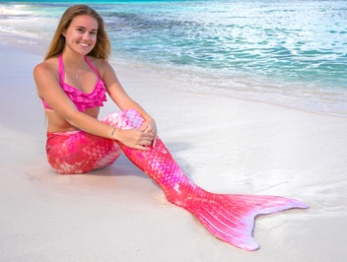
Coral Cloud Limited Edition Mermaid Tail
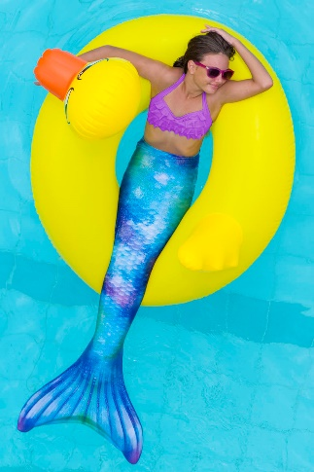
Get carried away in misty hues of pink and coral with Fin Fun’s latest Limited Edition mermaid tail, Coral Cloud, releasing this month! Bubbly, shimmery fish scales shift from light to dark hues in the most elegant way, kissed with a smattering of dusky accents. Made from premium swimsuit fabric, it’s available for both kids and adults.

Watercolor Waves Limited Edition Mermaid Tail
Paint your world with shades of ocean blue, sea green, and amethyst with Fin Fun’s Watercolor Waves Limited Edition mermaid tail! Made of high quality swimsuit fabric and sealed with a sparkly sheen, this mermaid tail for kids and adults is sure to awaken your artistic side.

MSRP for Limited Edition tails:
Youth $65 | Adult $75
Monofin Insert (required for swimming):
Monofin Jr. $60 MSRP | Monofin Pro $65 MSRP
Custom Tail Creator Platform
Custom Tail Creator allows mermaid dreamers to design their own tails and have them printed on swimmable mermaid tail fabric. An easy 3-step process allows gift givers and mermaids alike to choose a size, download its corresponding design template to be colored, and upload the finished artwork
to Fin Fun’s website to be produced as a real mermaid tail. Consumers can expect to receive their design in 2-3 weeks by mail. Aspiring mermaids can then swim in their own creation using Fin Fun’s patented monofin in their custom designed tail.

Custom Tail MSRP:
$80 Youth Sizes 6-12
$90 Adult Sizes XS-2XL
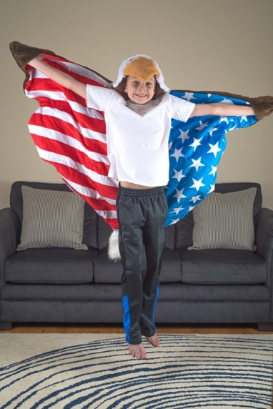
Eagle Wild Things Blanket
Salute the nation’s finest emblem (and stay warm too) wrapped up in Fin Fun’s latest Wild Things blanket for kids, Ace Eagle! Featuring a blend of the softest fabrics imaginable, this bird soars when it comes to character and quality. Fun features on this hooded blanket include an interior American flag design, 3D eagle eyes, fluffy white head and tail, had pockets on the wing tips, plus a realistic beak designed to encourage imaginative play.

Flutters Butterfly Blanket
Salute the nation’s finest emblem (and stay warm too) wrapped up in Fin Fun’s latest Wild Things blanket for kids, Ace Eagle! Featuring a blend of the softest fabrics imaginable, this bird soars when it comes to character and quality. Fun features on this hooded blanket include an interior American flag design, 3D eagle eyes, fluffy white head and tail, had pockets on the wing tips, plus a realistic beak designed to encourage imaginative play.
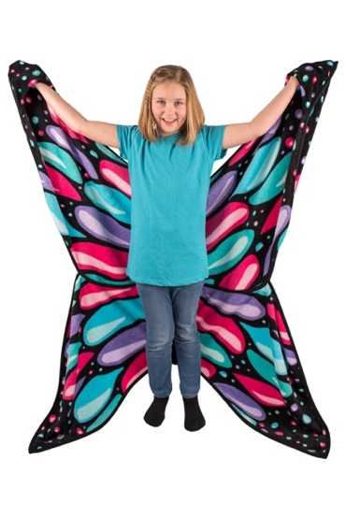
Wild Things Blankets are for ages 4+; MSRP starting at $30.00

Best known for introducing high quality, high performance swimmable mermaid tail sets that deliver safety, comfort and fun at an affordable price, the Fin Fun brand has grown to be the leader in the Mermaid lifestyle segment with a unique assortment of Mermaid tail skins, a premium patented monofin design, coordinating bathing suits and beach apparel & accessories. The trademark Mermaidens line of mermaid tails and swimwear allows girls to become their favorite characters from Fin Fun’s original Mermaidens series of stories and games found on FinFriends.com, the perfect place for girls who love mermaids. Fin Fun has extended the fun from water onto dry land with its Cuddle Tails mermaid blankets, Wild Things animal blankets and unique mermaid leggings.

About Fin Fun
Based in Idaho Falls, Idaho, Fin Fun originated the swimmable fabric mermaid tail and patented monofin in 2010. Fin Fun produces wearable mermaid tails, monofins, mermaid-themed clothing and accessories as well as its lines of Cuddle Tails plush mermaid tail blankets and Wild Things wearable animal blankets. A celebrity favorite, Fin Fun sells its products primarily online and to exclusive retail outlets in over 170 countries around the globe. In 2017, Eric Browning, CEO and Steve Browning, President & CFO, were named Idaho Small Business Persons of the Year by the U.S. Small Business Administration. In 2016, the family-owned and operated company made the Inc. 500 list at #119 and was recognized as an innovative e-retailer on the Internet Retailer Hot 100 list. For more information, visit www.finfun.com.

Media Contacts: Julie Livingston/Erika Sanchez WantLeverage Communications
julie@wantleverage.com / erika@wantleverage.com
(347) 239-0249 / (917) 318-5697

