Bright Fairy Friends Doll Assortment
Item # 20301
SRP: $9.99
Ages 3+

Introducing the new, magical BFF Bright Fairy Friends! Unbox your new BFF to unveil which magical fairy doll you get along with 6 surprise fairy accessories! Each fairy comes housed in its very own fairy home with bright, motion activated twinkle lights. You can also use your fairy home as a night light! Press your fairy’s necklace to make her wings glow with radiating multi-colored lights! Collect all 12 BFF fairy dolls from Series 1 and enjoy swapping out their fashions and accessories! Light up, Reveal, Imagine!

Follow along Rosie, Dali, Opal, Penny, Dani, Harper, Lily, Sunny, Fleur, Nina, Cami and Sophie along their BFF adventures with all new animation on our BFF Bright Fairy Friends YouTube channel! Which BFF will become your favorite?!

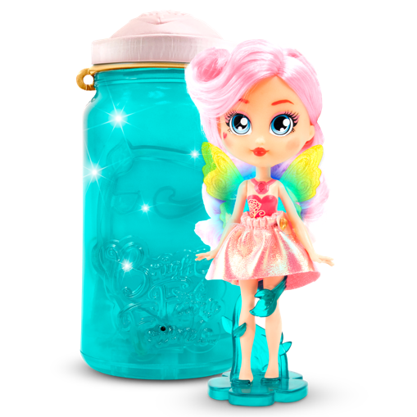

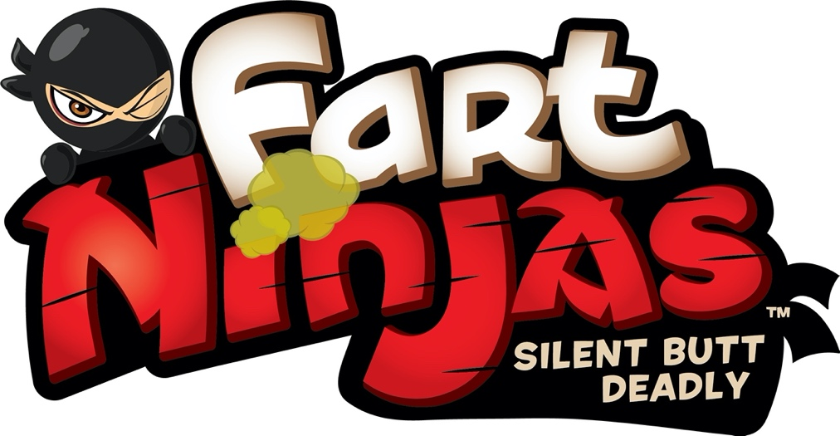

Trained in the art of espionage, gassassination and skilled in martial farts, Fart Ninjas is the gross out action-figure line that allows you to “surprise and disgust” your friends with…farts when you least expect it!

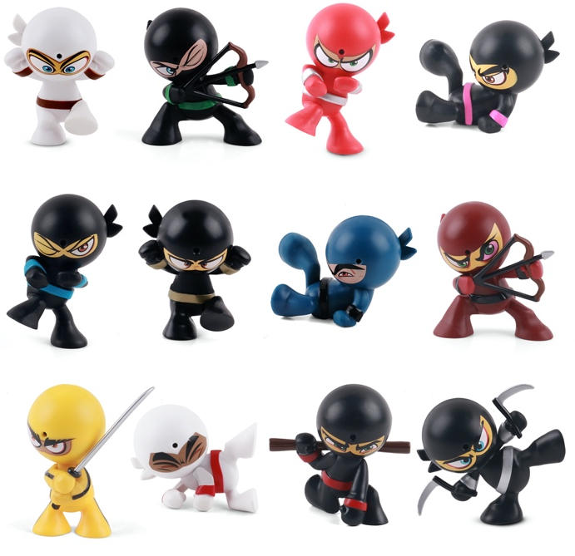
Fart Ninjas™ Series 2 Assortment
Item #: 70501
SRP: $5.99
Ages: 5+
Hide your FART NINJA figure to surprise and disgust your unsuspecting target! FART NINJAS Series 2 features 12 different collectible figures, each with 10 realistic motion-activated fart sounds. We call them Fart Ninjas, “Silent, Butt Deadly”.

Free app features a Fart Ninja Photo Booth, Fart Mixer to create your own custom fart mixes, and Augmented Reality to bring your Fart Ninjas to life!

Fart Ninjas™ Grenades Assortment
Item #: 70530
SRP: $4.99
Ages: 5+
Simply pull the key chain pin and roll it by your next victim, the FART NINJA Grenade will do the rest! Once it stops moving you’ll hear one of 10 realistic fart sounds. If you choose to use as a key chain you can also activate the sounds by holding down on the sensor for 1 second. FART NINJAS Grenades Series 1 is a collection of 4 different collectible grenades modeled after your favorite Fart Ninja figures.

Fart Ninjas™ XL Assortment
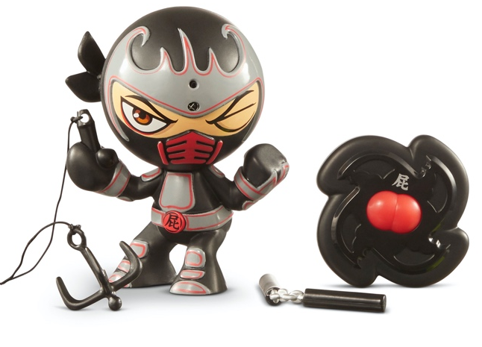
Item #: 70502
SRP: $14.99
Ages: 5+
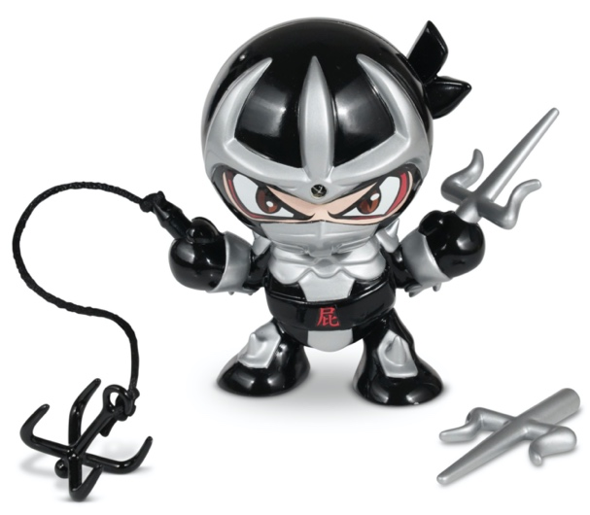
FART NINJAS XL are larger, 5” figures styled in awesome FART NINJAS armor. Hide your FART NINJA figure to surprise and disgust your unsuspecting target! Plan your attack with two different prank modes; either by using motion activation or by using the included ninja star remote control allowing you to “fart on demand” with the push of a button. If the 10 realistic fart sounds aren’t enough use the recording feature to record your own fart sounds for endless possibilities! Each FART NINJAS XL figure also includes two ‘martial farts’ accessories. We call them Fart Ninjas. “Silent, Butt Deadly”.

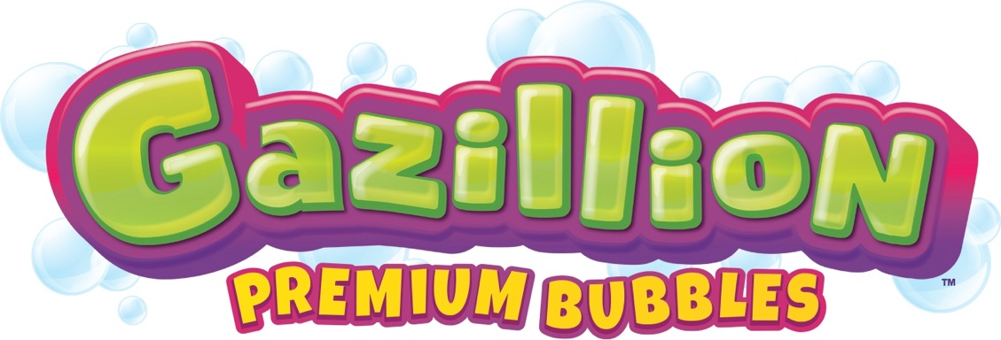

Gazillion Bubbles has led the charge in creating premium bubble products for over 15 years! Our top-secret bubble solution blows bigger, brighter, more colorful bubbles than any other solution on the market. With an extensive array of bubble toys and machines, Gazillion Bubbles has something for every young bubble fan! Check out our product pages to see everything we have to offer. With Gazillion Bubbles, you’ll run out of breath before you run out of bubbles!
Bubble Storm™
Item #: 36540
SRP: $14.99
Ages: 3+
Create bigger, better bubbles in seconds with the Gazillion Bubble Storm! Simply slide the bottle into the bottle holder until it clicks, then flip the bottle upside down and watch the bubble magic. This innovative and new solution dispensing technology functions as the ‘on/off’ button. With its compact design, this machine is made to be taken around for endless bubble fun! Each Bubble Storm includes a tray and 8 oz. bottle of premium Gazillion Solution.

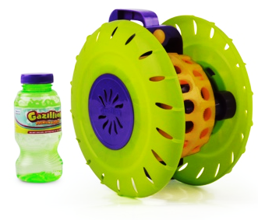

Roam N’ Bubbles™
Item #: 36523
SRP: $19.99
Ages: 3+
Unleash a moving cloud of bubbles with the Roam N’ Bubbles! This high powered motorized bubble machine rolls around on any flat surface blowing bubbles as it goes. This interactive machine is sure to keep kids entertained as they chase after the bubbles left in its path. Roam N’ Bubbles is easy to use simply add solution to the bottom reservoir and turn on to begin blowing bubbles and rolling around. Includes an 8oz bottle of premium non-toxic Gazillion Bubbles solution. 4 AA batteries required, not included.
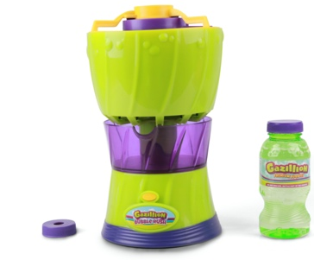
Bubble Rush™
Item: 36452
SRP: $19.99
Ages: 3+
With its revolutionary design, this high-powered bubble machine blows the most bubbles ever. This next generation bubble machine has a three- sectioned no-spill modular design including a removable washable top, solution recycling tray and batteries and motor sealed inside base. Simply pour solution into the reservoir and push the button for a bubble explosion in seconds. This item was designed to create hours of fun for kids, but easy clean for parents. Includes an 8 oz. bottle of Gazillion Premium Bubbles solution. 6 AA batteries required, not included.

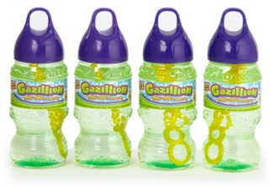
Gazillion™ Bubbles 8 Ounce Solution 4 Pack
Item #: 35300
SRP: $3.99
Ages: 3+
This top secret “super solution” has been formulated to create the biggest, brightest, most colorful bubbles on earth! Now in a convenient 4 pack, these 8 ounce bottles of solution work with any Gazillion Bubbles product. This premium solution is eco-friendly, safe, non-toxic, and will not stain clothing or furniture. With Gazillion Bubbles, you’ll run out of breath before you run out of bubbles!
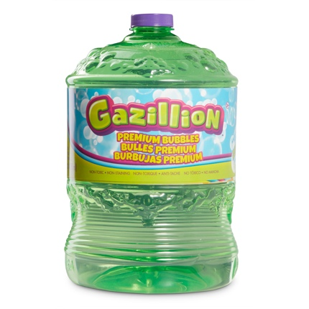

Gazillion™ Bubbles 4L Solution
Item #: 35404
SRP: $7.99
Ages: 3+
This top secret “super solution” has been formulated to create the biggest, brightest, most colorful bubbles on earth! You’ll be ready for hours and hours of fun with your favorite gazillion products with this oversized solution refill bottle. This premium solution is eco-friendly, safe, non-toxic, and will not stain clothing or furniture. With Gazillion Bubbles, you’ll run out of breath before you run out of bubbles!

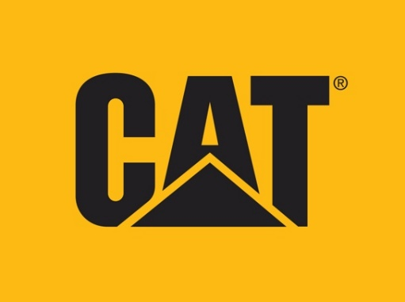

Cat® is the only construction vehicle brand that puts boys in the driver’s seat of their favorite construction vehicles with realistic styling and innovative features that bring the vehicles to life. CAT toys provide boys with an unmatched sense of realism and a strong feeling of empowerment. From their modern styling inspired by the latest real machines to utilizing innovative features to give boys full control in bringing their machines to life; Cat toys mimic the real machines in every sense.

Free Wheeling Bulldozer

Grow your fleet with the latest addition to our freewheeling segments the powerful and rugged Bulldozer. Be in the middle of the action by moving and posing the articulated vehicle bucket just like the real thing. Real Cat machines are known for their high quality, these toys are no different, built to withstand the elements and perfect for indoor or outdoor play. Appropriate for ages 2 years and up. Collect them all!

Mini Crew™ Bulldozer
Item #: 82012
SRP: $5.99

Construction Fleet™ Bulldozer
Item #: 82022
SRP: $9.99

Tough Rigs™ Bulldozer
Item #: 82032
SRP: $19.99

© 2020 Caterpillar. All Rights Reserved. CAT, CATERPILLAR, LET’S DO THE WORK, their respective logos, "Caterpillar Yellow", the "Power Edge" and Cat “Modern Hex” trade dress as well as corporate and product identity used herein, are trademarks of Caterpillar and may not be used without permission.

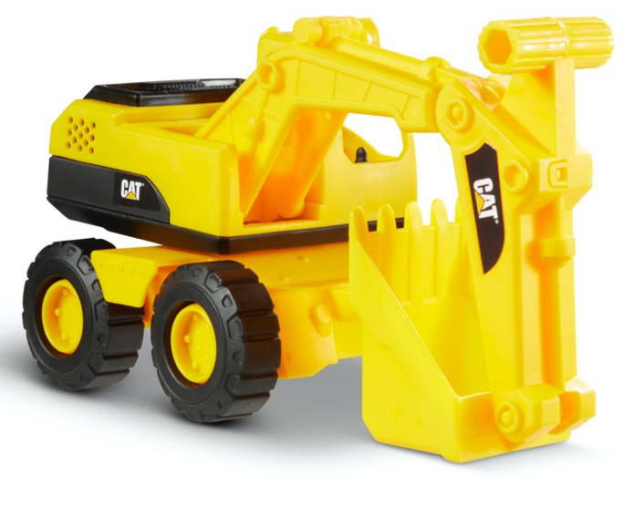
Construction Fleet™ Excavator
Item #: 82025
SRP: $9.99
Ages: 2+

Tackle any job with the Cat Construction Fleet, these 10” push-powered vehicles allow you to be in control every step of the way. Be in the middle of the action by moving and posing the articulated vehicle buckets and booms just like the real thing. Real Cat machines are known for their high quality, these toys are no different, built to withstand the elements and perfect for indoor or outdoor play. Collect them all!

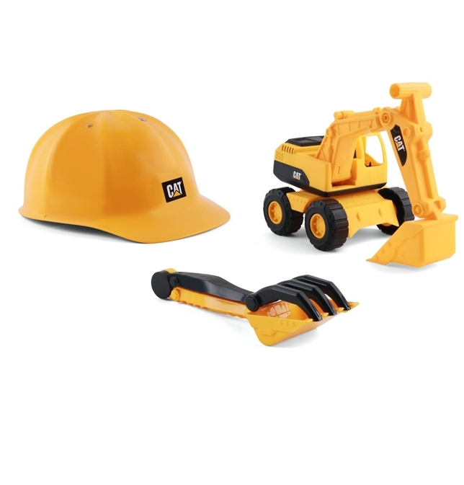

Construction Fleet™ Sand Set Excavator
Item #: 82065
SRP: $14.99
Ages: 2+
Take outdoor fun to the next level with the Cat Construction Fleet Sand Set! This set gives you all the tools you need to tackle any construction job, including a push-powered 10” vehicle along with a hard hat, shovel, and rake. Safety comes first on the job site so proudly wear your Cat hard hat when you’re controlling the action by moving and posing the articulated vehicle buckets and booms just like the real thing. Use the hand tools separately or snap them together to help excavate the job site. Real Cat machines are known for their high quality, these toys are no different, built to withstand the elements and perfect for outdoor play. Collect them all!

© 2020 Caterpillar. All Rights Reserved. CAT, CATERPILLAR, LET’S DO THE WORK, their respective logos, "Caterpillar Yellow", the "Power Edge" and Cat “Modern Hex” trade dress as well as corporate and product identity used herein, are trademarks of Caterpillar and may not be used without permission.

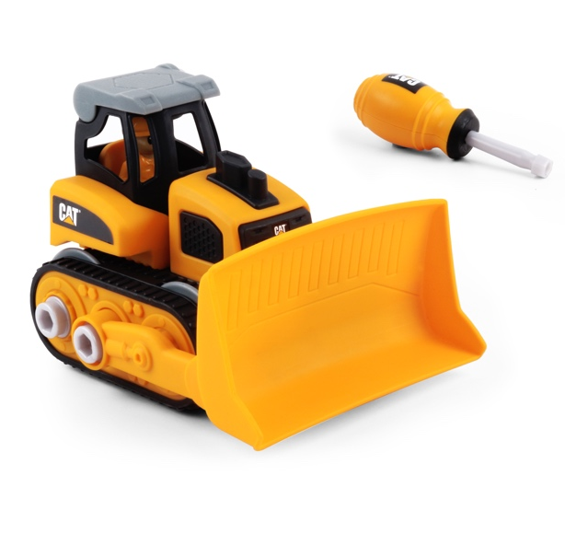
Build Your Own Junior Crew™ Bulldozer
Item #: 80902
SRP: $12.99
Ages: 2+
Your child will become the engineer as they build, take apart, and re-build their favorite construction vehicles with the Cat Build Your Own Vehicle Junior Crew. Each set comes with everything they need to create their very own vehicle plus a construction driver action figure to bring the worksite to life. Improve your child’s fine motor skills as they use the included screwdriver to easily assemble the different vehicle parts using the attached bolts. Let their creativity shine by mixing and matching the different parts to create their own custom vehicles. When playtime is over everything can be stored in the reusable carrying case the product comes in, making cleanup a snap. Collect them All!

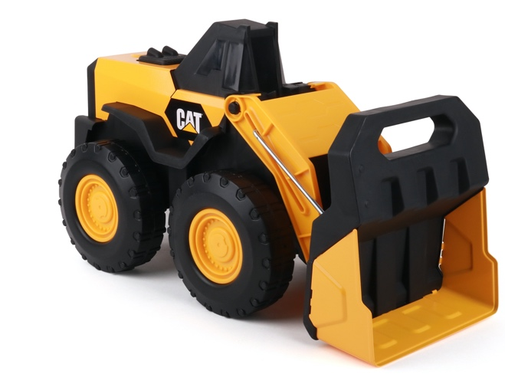
Steel Wheel Loader
Item #: 82414
SRP: $29.99
Ages: 3+
Take on the toughest construction jobs with the Cat Steel Wheel Loader. Built with sturdy steel construction and large wheels this 16” vehicle is just the like the real thing. You’re in control of the action, move the articulated arm and bucket up and down to scoop up dirt, rocks, or sand, haul it away, and dump out the payload. Real Cat machines are known for their high quality, these toys are no different, Cat steel toys feature a lifetime guarantee so you can be comfortable knowing this product is built to last.

© 2020 Caterpillar. All Rights Reserved. CAT, CATERPILLAR, LET’S DO THE WORK, their respective logos, "Caterpillar Yellow", the "Power Edge" and Cat “Modern Hex” trade dress as well as corporate and product identity used herein, are trademarks of Caterpillar and may not be used without permission.
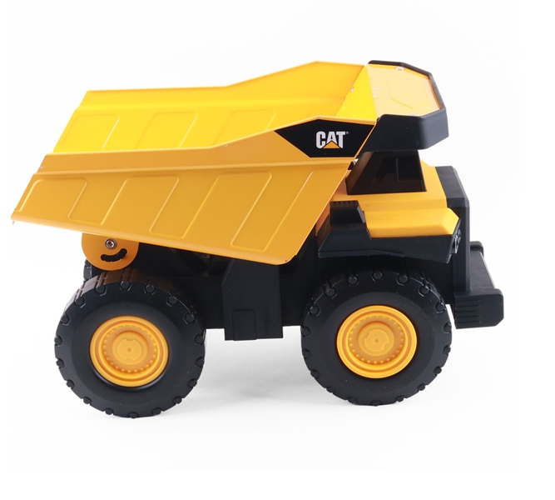
Steel Dump Truck
Item #: 82353
SRP: $29.99
Ages: 3+
Designed for the most demanding of jobs the Cat Steel Dump Truck is ready for action! Built with sturdy steel construction and large wheels this 16” vehicle is just the like the real thing. You’re in control of the action, fill the rugged dump bed, drive it to its destination, and use the real working dump bed to unload it! Real Cat machines are known for their high quality, these toys are no different, Cat steel toys feature a lifetime guarantee so you can be comfortable knowing this product is built to last.

Steel Excavator
Item #: 82354
SRP: $49.99
Ages: 3+
Even toughest of dig sites are no match for the Cat Steel Excavator! This heavy duty Steel Excavator is built with attention to detail from the heavy metal bucket to the real working treads so you can dig like a pro. Grab onto the ergonomic handles to work the arm and bucket and haul dirt all day long! Real Cat machines are known for their high quality, these toys are no different, Cat steel toys feature a lifetime guarantee so you can be comfortable knowing this product is built to last.

© 2020 Caterpillar. All Rights Reserved. CAT, CATERPILLAR, LET’S DO THE WORK, their respective logos, "Caterpillar Yellow", the "Power Edge" and Cat “Modern Hex” trade dress as well as corporate and product identity used herein, are trademarks of Caterpillar and may not be used without permission.

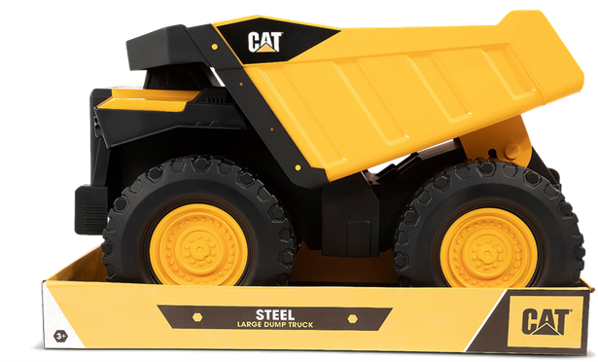

Mighty Steel™ Dump Truck
Item # 82415
SRP: $49.99
Ages: 3+
A big job demands big equipment. Conquer the construction site with the Cat Mighty Steel Dump Truck measuring in at an astounding 20” in length. Thoughtfully designed and constructed with heavy duty steel and massive wheels this rugged vehicle is tough enough to handle even the most demanding of jobs. You’re in control of the action, fill the sturdy dump bed, drive it to its destination, and use the real working dump bed to unload it! Real Cat machines are known for their high quality, these toys are no different, Cat steel toys feature a lifetime guarantee so you can be comfortable knowing this product is built to last.

Tough Machines™ Excavator
Item #: 82399
SRP: $14.99
Ages: 3+
Round out your Tough Machines collection with the the all new excavator. Are you ready to rumble! Fire up the touch start ignition on your Cat Tough Machines for machine rumbling action. Push the other buttons to activate realistic flashing lights along with engine revving, back-up, and hydraulic sounds. Be in control of the action by moving and posing the articulated vehicle buckets and booms just like the real thing. Batteries included. Collect them all!

© 2020 Caterpillar. All Rights Reserved. CAT, CATERPILLAR, LET’S DO THE WORK, their respective logos, "Caterpillar Yellow", the "Power Edge" and Cat “Modern Hex” trade dress as well as corporate and product identity used herein, are trademarks of Caterpillar and may not be used without permission.

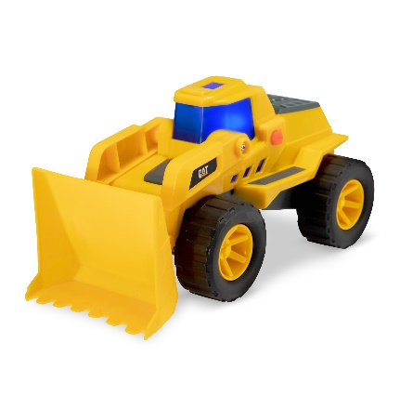
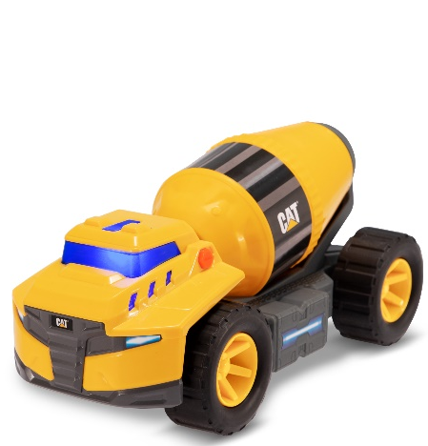
Future Force™ Assortment
Item #: 82377
SRP: $14.99
Ages: 3+

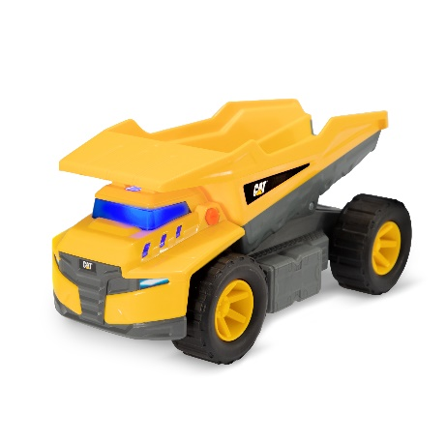
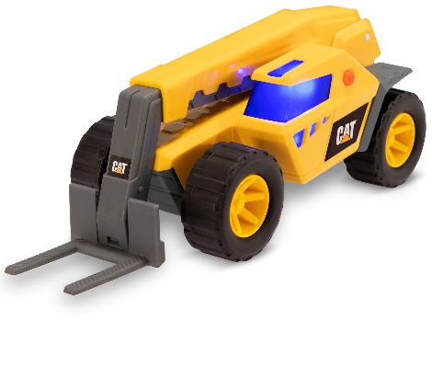
Step into the future of construction vehicles with Cat Future Force. Inspired by advanced technology and innovative design, these futuristic super sleek vehicles feature electro-power sounds and next-gen glow effects. Press the red button to power up the vehicles lights and sounds, pressing the button again while the vehicle is still powered on will trigger a new sound and lighting effect. Be in control of the action by moving and posing the articulated vehicle buckets, booms, and drums just like the real thing. This reimagined line includes a Dump Truck, Wheel Loader, Telehandler and Cement Mixer. Real Cat machines are known for their high quality, these toys are no different, built to withstand the elements and perfect for indoor or outdoor play. Collect them all!

© 2020 Caterpillar. All Rights Reserved. CAT, CATERPILLAR, LET’S DO THE WORK, their respective logos, "Caterpillar Yellow", the "Power Edge" and Cat “Modern Hex” trade dress as well as corporate and product identity used herein, are trademarks of Caterpillar and may not be used without permission.

