FOR IMMEDIATE RELEASE

Media Contacts:
Jennifer Robenalt
(512) 653-9656
Jennifer.robenalt@gmail.com

GeoToys to Introduce New 3D Dodoland Model Kits, City Puzzles and Name Chase Games at 2016 at Toy Fair NY16, February 13-16, Booth #5913

(NEENAH, WI—February 3, 2016) — The complete line of award-winning GeoToys products will be on display at Toy Fair NY16, February 13-16, 2016. in New York City. GeoToys specializes in toys, puzzles and games designed to bring geography, social studies and history to children and adults of all ages.

"We're really excited to introduce Dodoland models to the U.S. market. These items were created by New Zealand artists and are beautiful art pieces, as well as models,” CEO Bob Galinsky said. “We saw them at the Nuremberg toy show and fell in love with them, and now we're happy that Geotoys is the sole U.S. distributor for the line."

GeoToys 2016 product releases include:
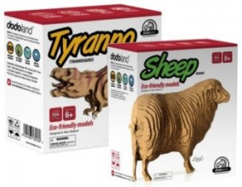
Dodoland:
Eco-friendly hands-on model kits for kids who can make their own dinosaurs and animals. Little works of art, they are not only challenging and fun, but make great decor for kid and family rooms. Designed in New Zealand.
Read Amazon description and reviews…

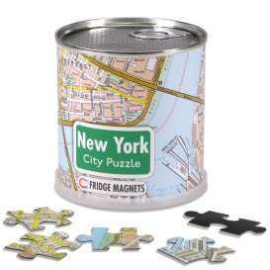
City Puzzles:
Hip, contemporary designs on cans filled with city map puzzles perfect for gift-giving, solitary or group fun, geography curriculum and education projects. Two kinds of puzzles include 1000-piece "Mypuzzles" and 100-piece magnetic puzzles in cans. About 9-10 cities for each kind of puzzle (see sell sheet) with more magnetic puzzles on the way (Austin, Houston, Washington DC, etc). Both are maps of cities, Mypuzzles include a printed map as well as the puzzle. Read Amazon description and reviews…

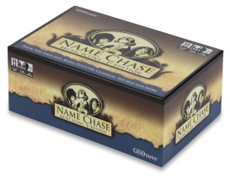
Name Chase:
Group-pleasing trivia games in which players guess names of celebrities, historical figures and other famous people. Notable people in history and music were introduced in 2014-2015. Sports figures are coming in 2016. Some of GeoToys' bestselling games.
Read Amazon description and reviews…

Launched ten years ago, Geotoys has established itself as a force in geography-inspired toys and has earned impressive benchmarks including:

- Winner of top awards from Dr. Toy, NAPPA (National Association of Parenting Publications), Creative Child Magazine and Fat Brain Toy of the Year
- Geotoys puzzles and games are available at thousands of toy, book and gift stores, as well as at 400+ Barnes and Noble stores.
- Now distributed in 20 countries in the Americas, Europe, Africa and Asia.

For more information about Geotoys, visit http://www.geotoystore.com For more information about Toy Fair NY16, visit http://www.toyfairny.com. To schedule an interview with Mr. Galinsky, please contact Jennifer Robenalt at 512.653.9656 or jenniferhillrobenalt@gmail.com.

-30-

