1 Runyons Lane ∙ Edison, NJ ∙ 08817

FOR IMMEDIATE RELEASE
February 9, 2018
Contact Information:
GUND
Colleen Morrison
Ecommerce Marketing Manager
Phone: 848-260-0947
Email: cmorrison@enesco.com

GUND EARNS TILLYWIG AWARD AND SIXTH CONSECUTIVE HONOR FROM “TEDDY BEAR AND FRIENDS” MAGAZINE

EDISON, NJ — GUND is proud to announce three recent industry honors: one from Tillywig and two from “Teddy Bear and Friends Magazine.”

The Tillywig Toy & Media Awards honored the brand-new for Winter 2018 Flappy Soft Book with a Parents’ Favorite Product award, which celebrates products that enhance the quality and playfulness of daily life. The Tillywig Toy & Media Awards aim to provide retail buyers, news media, parents, and consumers with product information and reviews of superior children's products available in today's marketplace. Products under consideration for awards are evaluated for quality, appearance, replay value, educational value, creativity, and more.

The book features the image of GUND’s award-winning Flappy the Elephant with sensory-stimulating additions on each page, including crinkly ears and tail, super plush pages, satin ribbon accents, and bright shapes throughout.

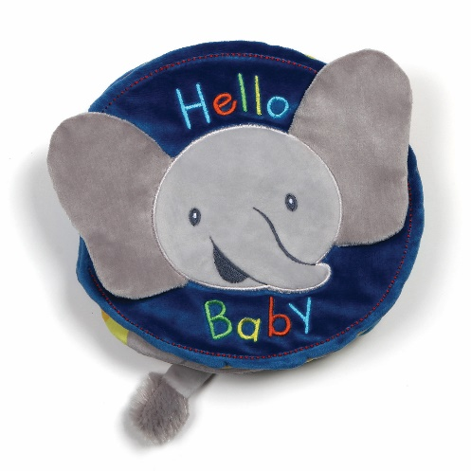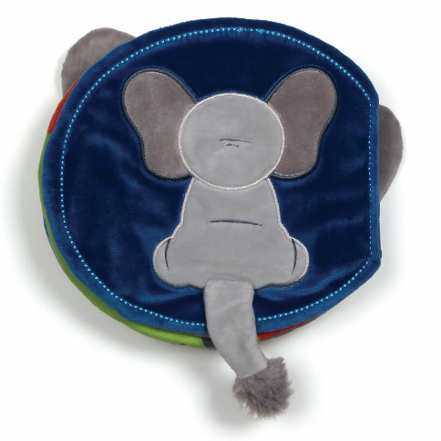

The Teddy Bear of the Year (TOBY) competition rewards and encourages excellence in the manufacturing of teddy bears and soft-sculpture animals. TOBY Industry’s Choice entries are evaluated for their design and execution, as well as their quality of material and workmanship by professionals within the teddy bear collecting field. The highest-scoring creations in each category receive the TOBY Industry’s Choice Awards and go on to be the nominees for the Public’s Choice Awards voted on by Teddy Bear & Friends readers.

Limited-edition Archer has won in the TOBY “Manufacturer Bear of the Year” category while Georgette has won in the “Manufactured Friend” category, both for the first time. This newest Industry’s Choice TOBY award represents the sixth consecutive win for GUND products.

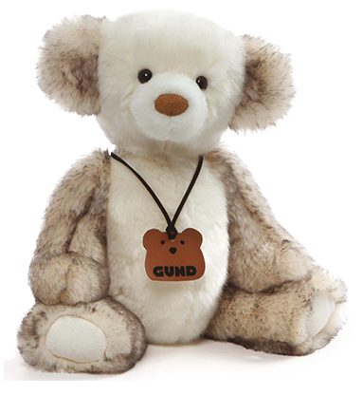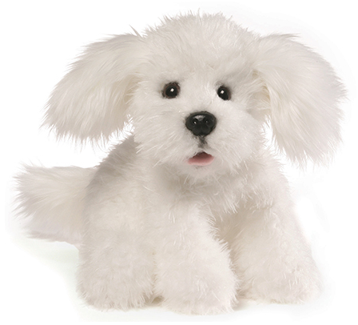
“It’s a huge honor to be chosen by our peers to win the Manufactured Bear category as well as Georgette winning for Manufactured Friend this year” said GUND Vice President of Marketing Sally Drewes. “We take great pride in our products and it wonderful to be recognized and awarded by both Teddy Bear and Friends and Tillywig.”

Flappy Soft Book, Archer, and Georgette are available now at www.gundbusiness.com.

About GUND
GUND®, a division of Enesco, LLC, is known worldwide for its top quality, soft, and huggable plush designs and gift products. Award-winning GUND products appeal to all ages, from infants up, and are perfect for both play and collecting. The 120-year old company is based in Edison, New Jersey, and distributes throughout the United States and Canada as well as in Europe, Japan, Australia, and South America. GUND products may be found in gift, specialty, toy, book, museum, and department stores as well as many other retail outlets. To find your nearest retailer or to purchase directly please visit www.gundbusiness.com.

About Enesco

Enesco, LLC, is a global leader in the giftware and home and garden décor industries. Serving more than 44,000 customers worldwide, Enesco distributes products to a wide variety of specialty card and gift retailers, home décor boutiques, mass-market chains, and direct mail retailers. With subsidiaries in the United Kingdom, France, Canada, and Hong Kong, Enesco serves markets operating in Europe, the Americas, Australia, and Asia. The company’s product lines include some of the world’s most recognized brands including Heartwood Creek® by Jim Shore, Foundations®, Our Name is Mud®, GUND®, Lolita, Department 56® Villages, Country Artists®, Walt Disney Classics Collection®, Disney Traditions™, The Trail of Painted Ponies®, among others. Further information is available at www.enesco.com.

–###–

