Contact: Temi Sacks
tjsacks@tjsacks.com
212-787-0787
Lou Ann Gleason
lgleason@gelliarts.com
267-457-3119

Gelli Arts® Gel Printing System
Introduces Mini Kits
Booth 6642

February 1, 2017 (Philadelphia, PA) Gelli Arts® is a breakthrough gel printing plate system that is used to make prints for mixed media art projects, journals, cards, paper crafting, scrapbooking, and much more.

Artists have long known the special appeal of gelatin printing: a form of monoprinting in which a “plate” of gelatin can be used with acrylic paints to create prints of varying colors and patterns. Used by both accomplished and aspiring artists, Gelli Arts has transformed the art of printmaking. The unique gel printing surface makes it easy, affordable and fun to create art: think printmaking with more expansive possibilities and less mess. Gelli Arts plates are the only gel printing plates made in the USA and are odor free. They are durable, reusable and portable.

New for Toy Fair, Gelli Arts is introducing two new Mini Kits. Now moms and kids have an easy-to-use printing kit—great for projects like birthday cards, mobiles, wall art, t-shirts, room décor, scrapbooking, and so much more. Find many project ideas at www.gelliprintingprojects.com

Gelli Arts Mini Kit contains:
- 3” round or 3” hexagonal durable gel printing plate (two versions)
- Punchinella stencil
- 3-sided design comb
- Case for storage or use as a stamping block
- MSRP $17.99

Acrylic paint is not included but can be inexpensively purchased at craft and hobby stores.

Gelli Arts plates have created a resurgence in printmaking. They provide many benefits versus other common printing surfaces like real gelatin and Plexiglas. Key features include:
- Easy to use (roll on paint, place stencil on plate, cover with paper—and presto, a beautiful, unique print appears)
- Durable and reusable
- No-fuss cleanup (cleans up with water, paper towels or baby wipes)
- Prints fine details
- Versatile (use with any type of paper, fabric, polymer clay and acrylic paint)

Our website offers a wide variety of projects for parents and kids. Bring out the artist in you with Gelli Arts® Mini Kits. www.gelliarts.com

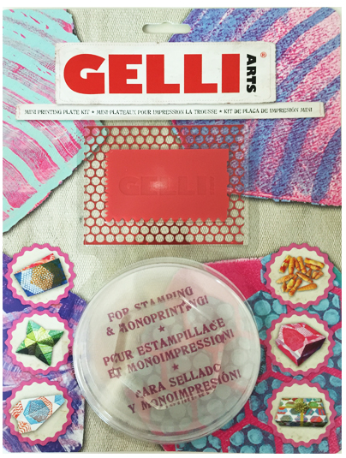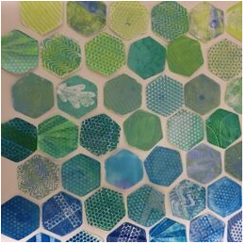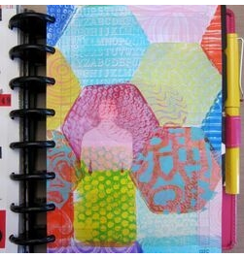
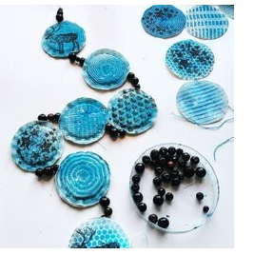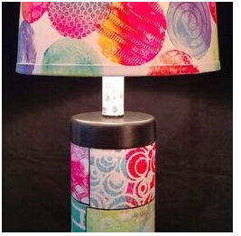

Copyright Gelli Arts® 2017

