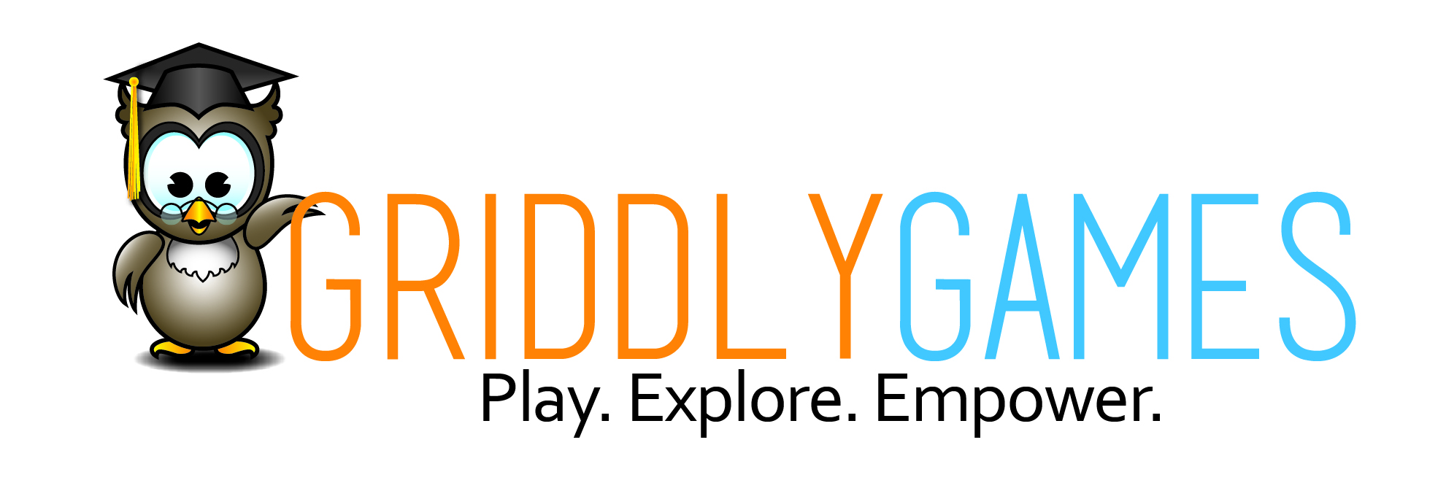
PRESSRELEASE

FOR IMMEDIATE RELEASE Media Contact: Greg Walsh, Walsh Public Relations
305 Knowlton Street, Bridgeport, CT 06608
T: (203) 292-6280; E-Mail: greg@walshpr.com

STEM-ulating Games from Griddly

New York, NY - (February 16, 2019) – Griddly’s games are finding added success in STEM trend.

From the beginning, Griddly Games held a strict company philosophy to provide products that encourage social interaction, learning, strategy and challenges that anyone (from across the grid) can enjoy. The mission has proved to be a great Griddly game collection of fun and STEM-ulation.

STEM, the acronym for interest in Science-Technology-Engineering-Math, is an ever-growing trend in the toy industry that continues to prosper as a category for products that offer edu-tainment. The category swept into the Griddly Games collection and enveloped several games from the company that were already keying in on the STEM elements for strategies and challenges in the games.

Games from Griddly Games had also been designed to help develop logic, strategic thinking, memory, hand eye coordination and math skills, which are all elements of STEM.
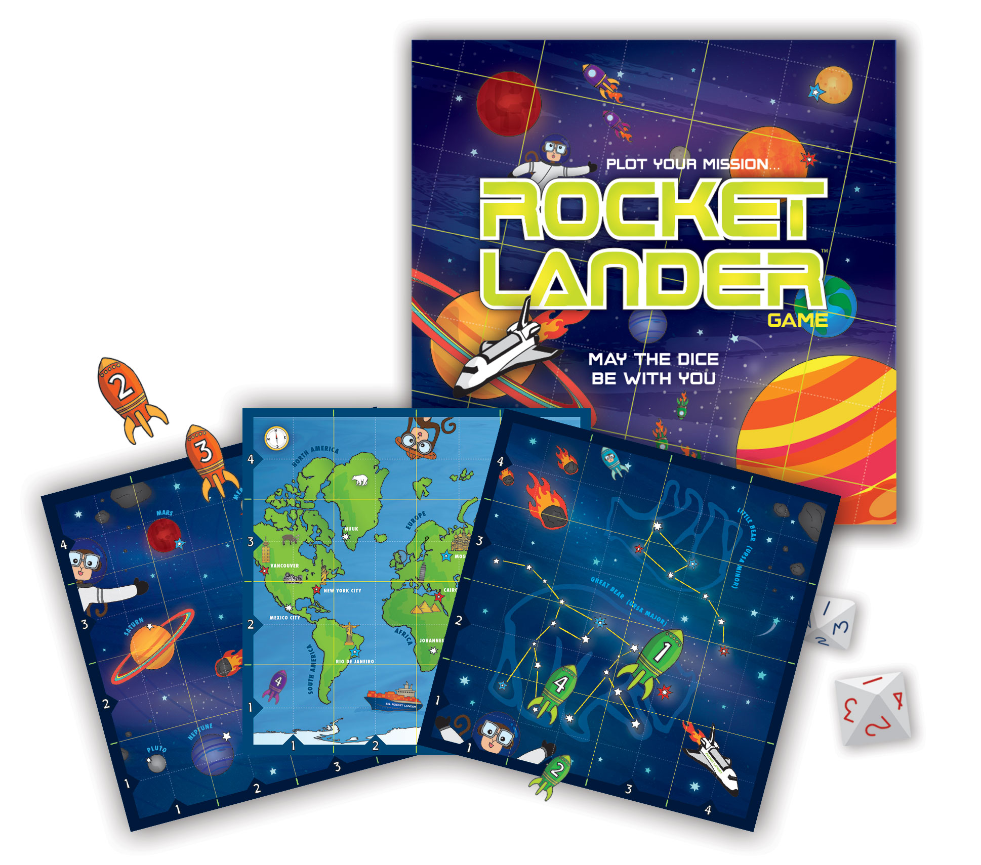

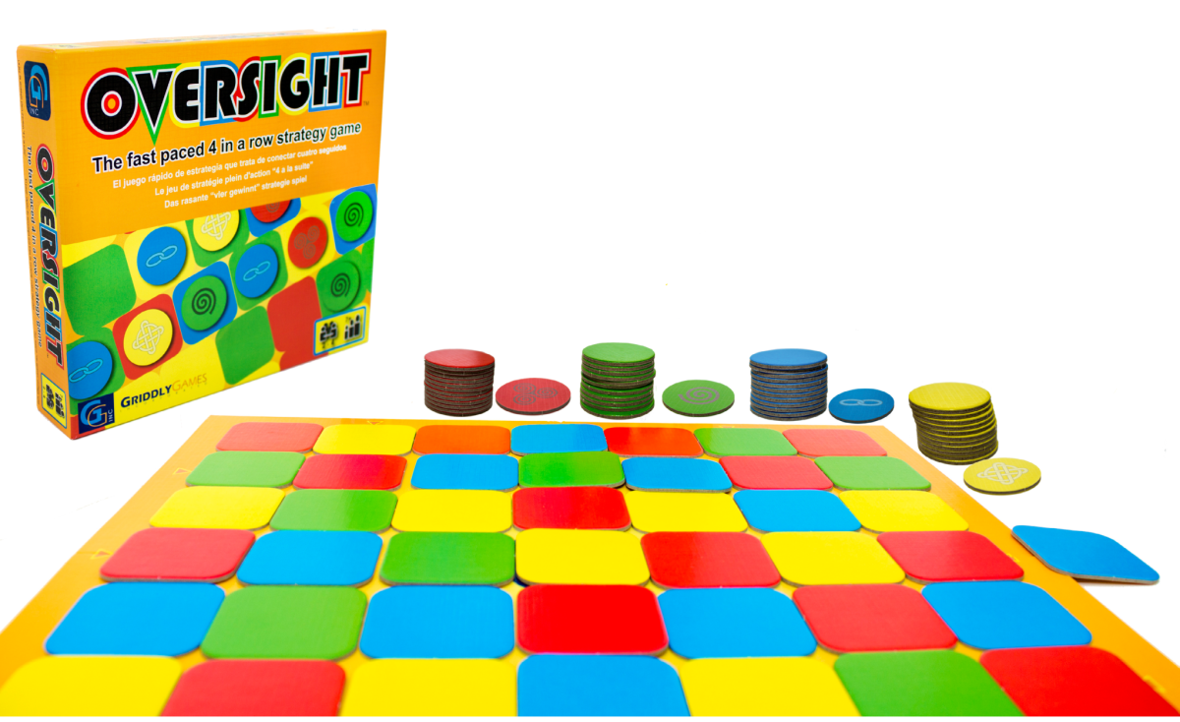
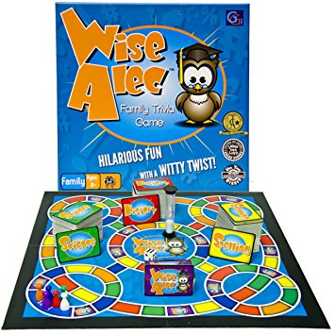
The Griddly STEM line-up now includes:
Rocket Lander (MSRP $27.00 for ages 10+) is a spatial strategy game with a fun outer space theme. In the game, players control a group of rockets exploring the vast world and outer space. Each player has to embark on an epic mission to settle and build the greatest rocket station. Using dice and plotting (x, y and z axis) points, players coordinate best landing spot for their rocket, while overtaking opponents and defending home turf.

Oversight (MSRP $26.50 for ages 7+) is an abstract strategy game that is a colorful twist on the fast-paced 4-in-a-row game. With a 4-color checker style block board, Oversight adds movable squares and tokens for a completely fun challenge to outwit your opponents to get four colors in a row. It’s a simple concept, but when each player has his or her own vision of where the 4-in-a-row will be formed, the colors may not line up as planned. Players take turns to either place a token on the board, or slide an entire row or column of moveable squares over by one space. Try to predict the movement of the board and put your tokens in the right places to block your opponents but also get 4-in-a-row to win the game.

Wise Alec (MSRP $27.50 for ages 8+) is a family trivia game with a fun twist. Designed for 2-6 players, the goal is to earn points by moving around the board and answering questions in three different categories. Each question offers a choice of an easy or more difficult question. Players can use their strengths for maximum or minimum risk and reward, but when a player lands on a Wise Alec card, the fun really begins because there may be physical challenges, tongue twisters or silly acts to accomplish to get the points.
Since the introduction of Wise Alec in 2008, there are now a half dozen Wise Alec game expansions (MSRP $16.00 each), that can all be played as integrated into the general game. The topics and skills are catering to each player’s interests and age level, making the original Wise Alec board game one of the most diverse games. Players as young as 3 years-old can compete in a multi-generational playing platform. The six different Wise Alec extensions are:
- Wise Alec Body Works: Anatomy, human body theme
- Wise Alec Bright Ideas: Invention and innovative theme
- Wise Alec Civilize This: Cultural theme
- Wise Alec Nature Nuts: Nature theme
- Wise Alec Sports Buffs: Sports-related theme
- Wise Alec Junior: Trivia and activities designed for ages 4 and up.

Other products from Griddly Games include STEM-sational Just Add (Milk, Sun, Glue, Sugar and new Egg) kits, and family of award-winning Show Me The Kwan, Rainbows and Storms, 5 Stones, Words of the Wise and Chronicles of the Mind games

About Griddly Games: We are the creators, manufacturers and marketers of original games and activity kits that are designed for the entire "grid" of people. Our mission is to inspire creativity, imagination, out-of-the-box learning, healthy living and lively interaction through the fun of games and activities. Our multi-award-winning line of STEAM (Science. Technology. Engineering. Art. Math) activity kits and STEM games continues to "Just Add" more and more new "ingredients" that cultivate natural curiosities and memorable experiences. All of our products inspire and engage people in a lifetime of play and learning about themselves and their limitless capabilities. The company, based in Richmond, near Vancouver, British Columbia, was founded in 2007 by Reisa Schwartzman, a mother of three boys, who took it upon herself to deliver wholesome family fun that multiple ages could enjoy at once. Griddly Games’ instills a strict company philosophy to encourage social interaction, learning, strategy and challenges that anyone (from across the grid) can enjoy. To discover more about Griddly Games, visit www.griddlygames.com and get all of the most up-to-date, immediate information by interacting with the company on Facebook, Instagram and YouTube.

