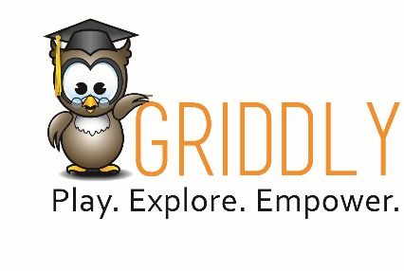
Saturday, Sept. 30, 2023
TOY FAIR INVITATION

New York Toy Fair is the debut of
The first toy from the newly established Griddly Kids division of Griddly, Inc.
Javits Center Booth #6235
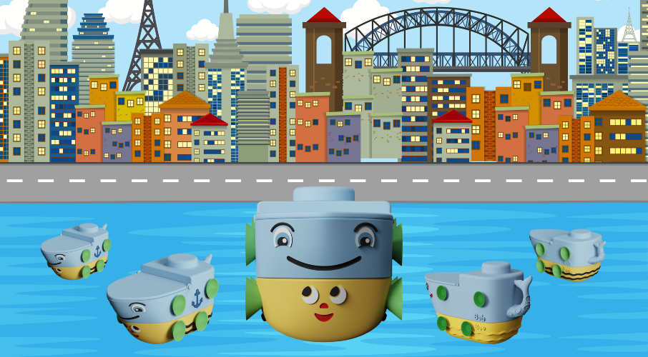

You’re Invited!
“Cruise” By Griddly Kids’ Booth #6235 at the New York Toy Fair
On Saturday, Sept. 30th from 3:00-5:00pm
to meet BobBee, the amazing new water toy,
and enjoy a "splash" of a Canadian spirited refreshment
(special imports from our Vancouver headquarters)
(If you've never tried ice wine, now is your chance)

Relax at the end of your busy first day of Toy Fair.
See a demonstration of BobBee as presented by the Griddly Kids’ Captain Reisa Schwartzman
RSVP Here

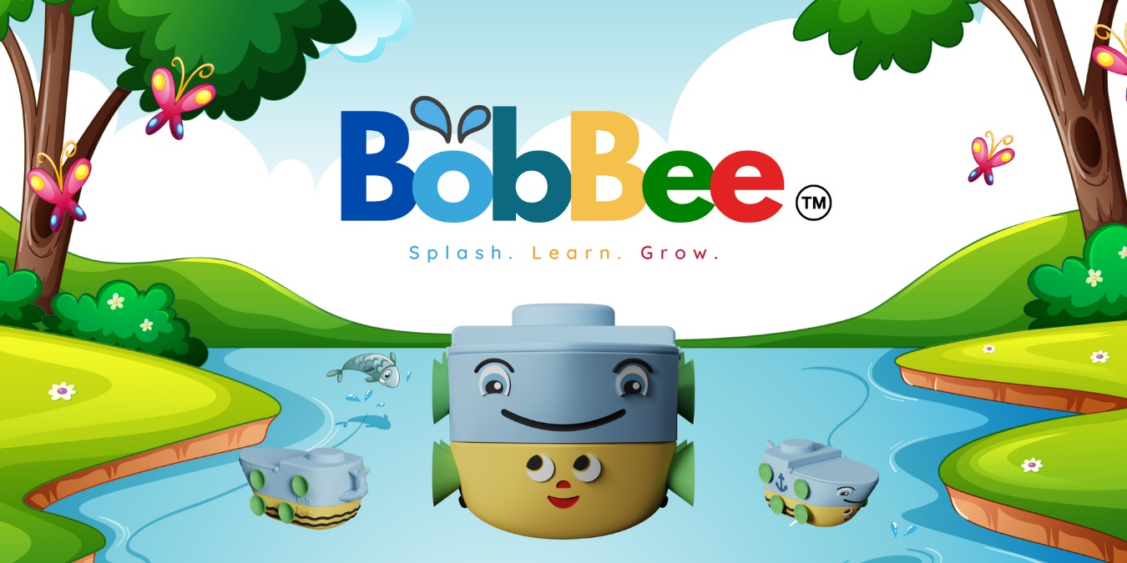

The newly established toy division of Griddly, Inc., Griddly Kids, launches the debut of BobBee

BobBee is the water toy that is three boats in one:
Bob and Bee… and BobBee

The new water craft is the toy development brainchild of Schwartzman with contributions from the architects, engineers, designers and development team from The Cape Group, one of Vancouver’s top property development companies, plus Griddly’s University Research Project.
As the story goes,
- Bob is a barge with heavy load and strong capabilities, but with slow, steady movement.
- Bee is a smaller, agile, and quicker boat.
- Together (literally fitting two toys together) BobBee is a strong and swift channeling vessel of fun.
BobBee is the best of the best from all parties in product development.

From the soft, safe, durable silicone materials and advanced buoyancy engineering, to the child development social-emotional facial expressions and storyline, and play experts accessory additions,

BobBee is one of the most sophisticated water toys invented!

To discover more about Griddly, please visit www.griddlykids.ca and follow on social media platforms: Facebook, Instagram and YouTube.

If you are attending the NY Toy Fair and would like to schedule a press info session with us about all of the Griddly products, including BobBee, please reach out to our PR guys by email: greg@walshpr.com or phone: 203-216-6101

Find our full press kit here:
