Disney Junior's Fancy Nancy follows the adventures of a girl who brings the fancy to everything from her advanced vocabulary to her creative, elaborate attire, and so much more. The stories, geared towards kids ages 2-5, have an underlying theme of self-expression, originality, and love of family.

My Friend Fancy Nancy™
SRP: $34.99| 3+ years | Available: Fall 2018
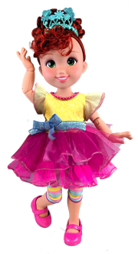
- Nancy is ready for a fabulous play day dressed in her signature outfit -- leggings, tiara, and chic party dress, which are removable for fashion play!
- This 18-inch feature doll has fully posable arms and legs with 12 points of articulation at the neck, shoulders, waist, elbows, wrists, hips, and knees.

Shall We Be Fancy Talking Fancy Nancy™ Doll
SRP: $49.99 | 3+ years | 3 AAA Batteries and 3 AG13/LR44 required | Available: Fall 2018
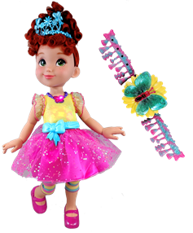
- Kids can press the butterfly on Nancy’s necklace or the accompanying wearable light-up butterfly bracelet for the child to hear Nancy say 38 phrases or sing songs from the television series.
- The Interactive Friend doll works with and without the interactive bracelet.
- The doll stands at 18-inches tall and features nine points of articulation at the neck, shoulders, elbows, wrists, hips, and knees, and the bodice lights-up in six different colors: blue, yellow, orange, green, pink, and purple.
- The doll comes dressed in Nancy’s signature fashion --removable fabric skirt, removable signature striped leggings, removable tiara,
and molded bodice and shoes.

Nancy Fancy™ Ballerina
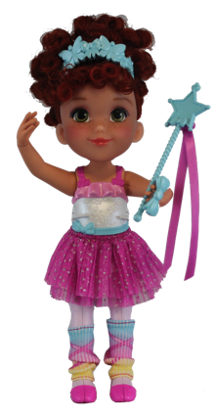
SRP: $19.99 | 3+ years | Available: Fall 2018
- Kids can press the buttons on her side to watch Nancy transform
into the fanciest of ballerinas.
  - Her arms will raise into the air and her legs will form the
perfect Grand Jeté with pointed toes.
  - Following her performance, her feet lay flat as she bends
at the waist to take a bow.
- The Prima Ballerina Feature Fashion Doll features seven points of
articulation at the neck, shoulders, hips, and ankles, and comes
with a wand and removable tiara, tutu and leg warmers.
- The doll is compatible with Friend Doll assortment fashions
and accessories.

Make Nancy Fancy™ (Assortment)
SRP: $12.99 | 3+ years | Available: Fall 2018

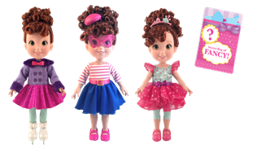
- This fashion doll is assorted in four different “fancy” fashions from the show: Winter Wonderland, Parisian, and Tea Time.
- The dresses and shoes are removable.
- Fashion doll features three points of articulation at the neck,
shoulders, and hips.
- Included with the doll is a Secret Bag of Fancy, with additional piece count that includes cute icons and decorative tape so girls can make things in their world “fancy” too!

Make Nancy Fancy™ Classique
SRP: $12.99 | 3+ years | Available: Fall 2018
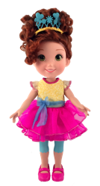
- This fashion doll is sold separately and comes in Nancy’s Signature fashion from the show.

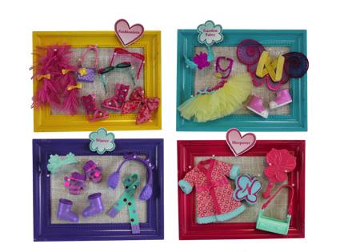
Make Nancy Fancy Accessories (Assortment)
SRP: $7.99| 3+ years | Available: Fall 2018
- Fancy Nancy™ can be even fancier with this Fashion Doll Accessory Assortment, which includes four different sets. Each accessory pack includes fancy things from her world:
  - Fashionista: Boa, Purse, Two Pairs of Sunglasses, Gladiator Sandals, and a Fluffy Bow.
  - Garden Fairy: Butterfly Wings, Tutu, Necklace, Wand, and Sneakers.
  - Winter Wonderland: Earmuffs, Mittens, Scarf, Snow Boots, Tiara.
  - Sleepover: Robe, Pillow, Overnight Bag and Brush.

Fantastique (Assortment)
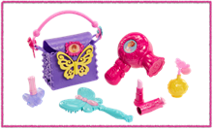
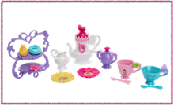
SRP: $14.99 | 3+ years | Available: Fall 2018

- The Accoutrements Assortment provides key role play themes for girls to play out with their Fancy Nancy doll. The assortment includes 2 sets for some fancy fun:
  - Fantastique Tea Set: Tea Pot, Creamer, Sugar Bowl, two cups, two saucers, two spoons, a cake stand and pastries.
  - Fantastique Vanity Set: purse, hair dryer, brush, play lipstick, atomizer, play nail polish.
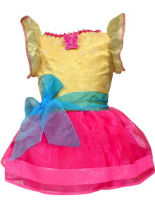
- Pieces from these sets compliment the Fancy Nancy™ Friend Dolls and Fancy Nancy Bistro Set.

Fancy Nancy™ Dress
SRP: $19.99| 3+ years | Sizes 4-6x |Available: Fall 2018
- Girls can look just as fancy as Nancy while wearing her signature dress inspired by the show.
- This shimmery dress includes her signature cameo and beautiful layers of shimmery fabric.

Fancy Boa (Assortment)
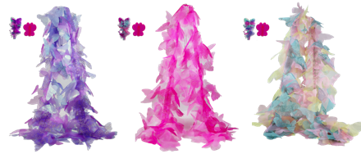
SRP: $9.99 | 3+ years | Available: Fall 2018

- Now girls can get fancy like Nancy with this special butterfly shaped boa assortment.
- Each boa includes two butterfly hair clips and is available in pink, purple, and multi-color.

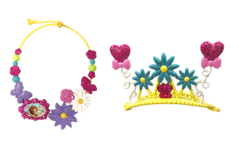
Fancy Tiara and Necklace Set
SRP: $9.99| 3+ years | Available: Fall 2018
- Inspired from the show, this set includes Tiara Clip (works like
banana clip) and floral-themed Necklace.

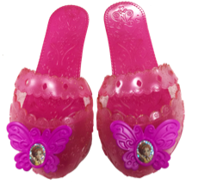
Fancy Shoes
SRP: $6.99 | 3+ years | Available: Fall 2018

- Inspired by the show, these plastic shoes come with butterfly toppers and a cameo label.

Fancy French Phone
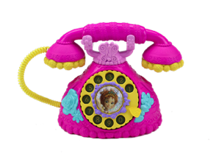
SRP: $14.99 | 3+ years | 2 AA Batteries required | Available: Fall 2018
- The Fancy French Phone has lights and telephone sounds and kids can hear 12 phrases from Nancy when they push the center button.

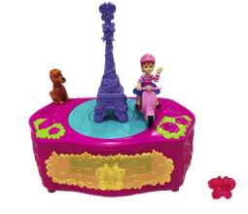
Ooh La La Music Box
SRP: $14.99 | 3+ years | 2 AA Batteries required | Available: Fall 2018
- Kids can wind up the music box to hear the theme song, “Add a
Little Fancy,” and watch Fancy Nancy as she scooters around the
Eiffel Tower on this magnifique wind-up Oh La La Music Box.
- Includes butterfly ring and storage drawer.

