MorfBoard™
MorfBoard™ Skate/Scoot Combination
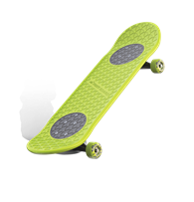
SRP: $99.99 | 8+ Years | Available Spring 2018
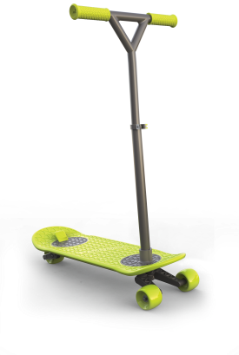
- This high-performance deck and component system transforms in seconds and creates an entirely new play experience.
- MorfBoard™ ecosystem encompasses super simple Lock & Release Technology (LRT™): simply drop Xtensions into the board and turn them 90-degrees.
- The flex trigger locks in so kids are ready to skate or ride.
- Includes: A MorfBoard™, front and rear skate, scoot Xtensions and scoot T-Bar.
- Skate Xtensions feature 53mm Urethane wheels, durable cast aluminum trucks, and Performance ABEC 5 skate bearing
- Scoot Xtensions feature lean to steer wishbone front truck and rear wheel with inset lever brake.
- Variable height T-Bar with rubber anti-slip grips.
- Available in a variety of color options to customize the board.
- www.morfboard.com

The Incredibles 2
Incredibles 2 - Power Couple
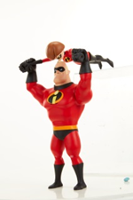
SRP: $29.99| 4+ years | 2 AAA Batteries included | Available: April 2018
- The Power Couple is the ultimate Incredibles team! Kids can use Mr. Incredible’s super strength to launch Elastigirl into action.
- Includes over 50+ sounds and phrases.
- Elastigirl stretches and can be launched up to 20 feet!
- Power Couple includes Mr. Incredible, Elastigirl, and three practice targets.

Incredibles 2 - Jack-Jack Attacks
SRP: $39.99 | 4+ years | 3AAA Batteries required | Available: Spring 2018
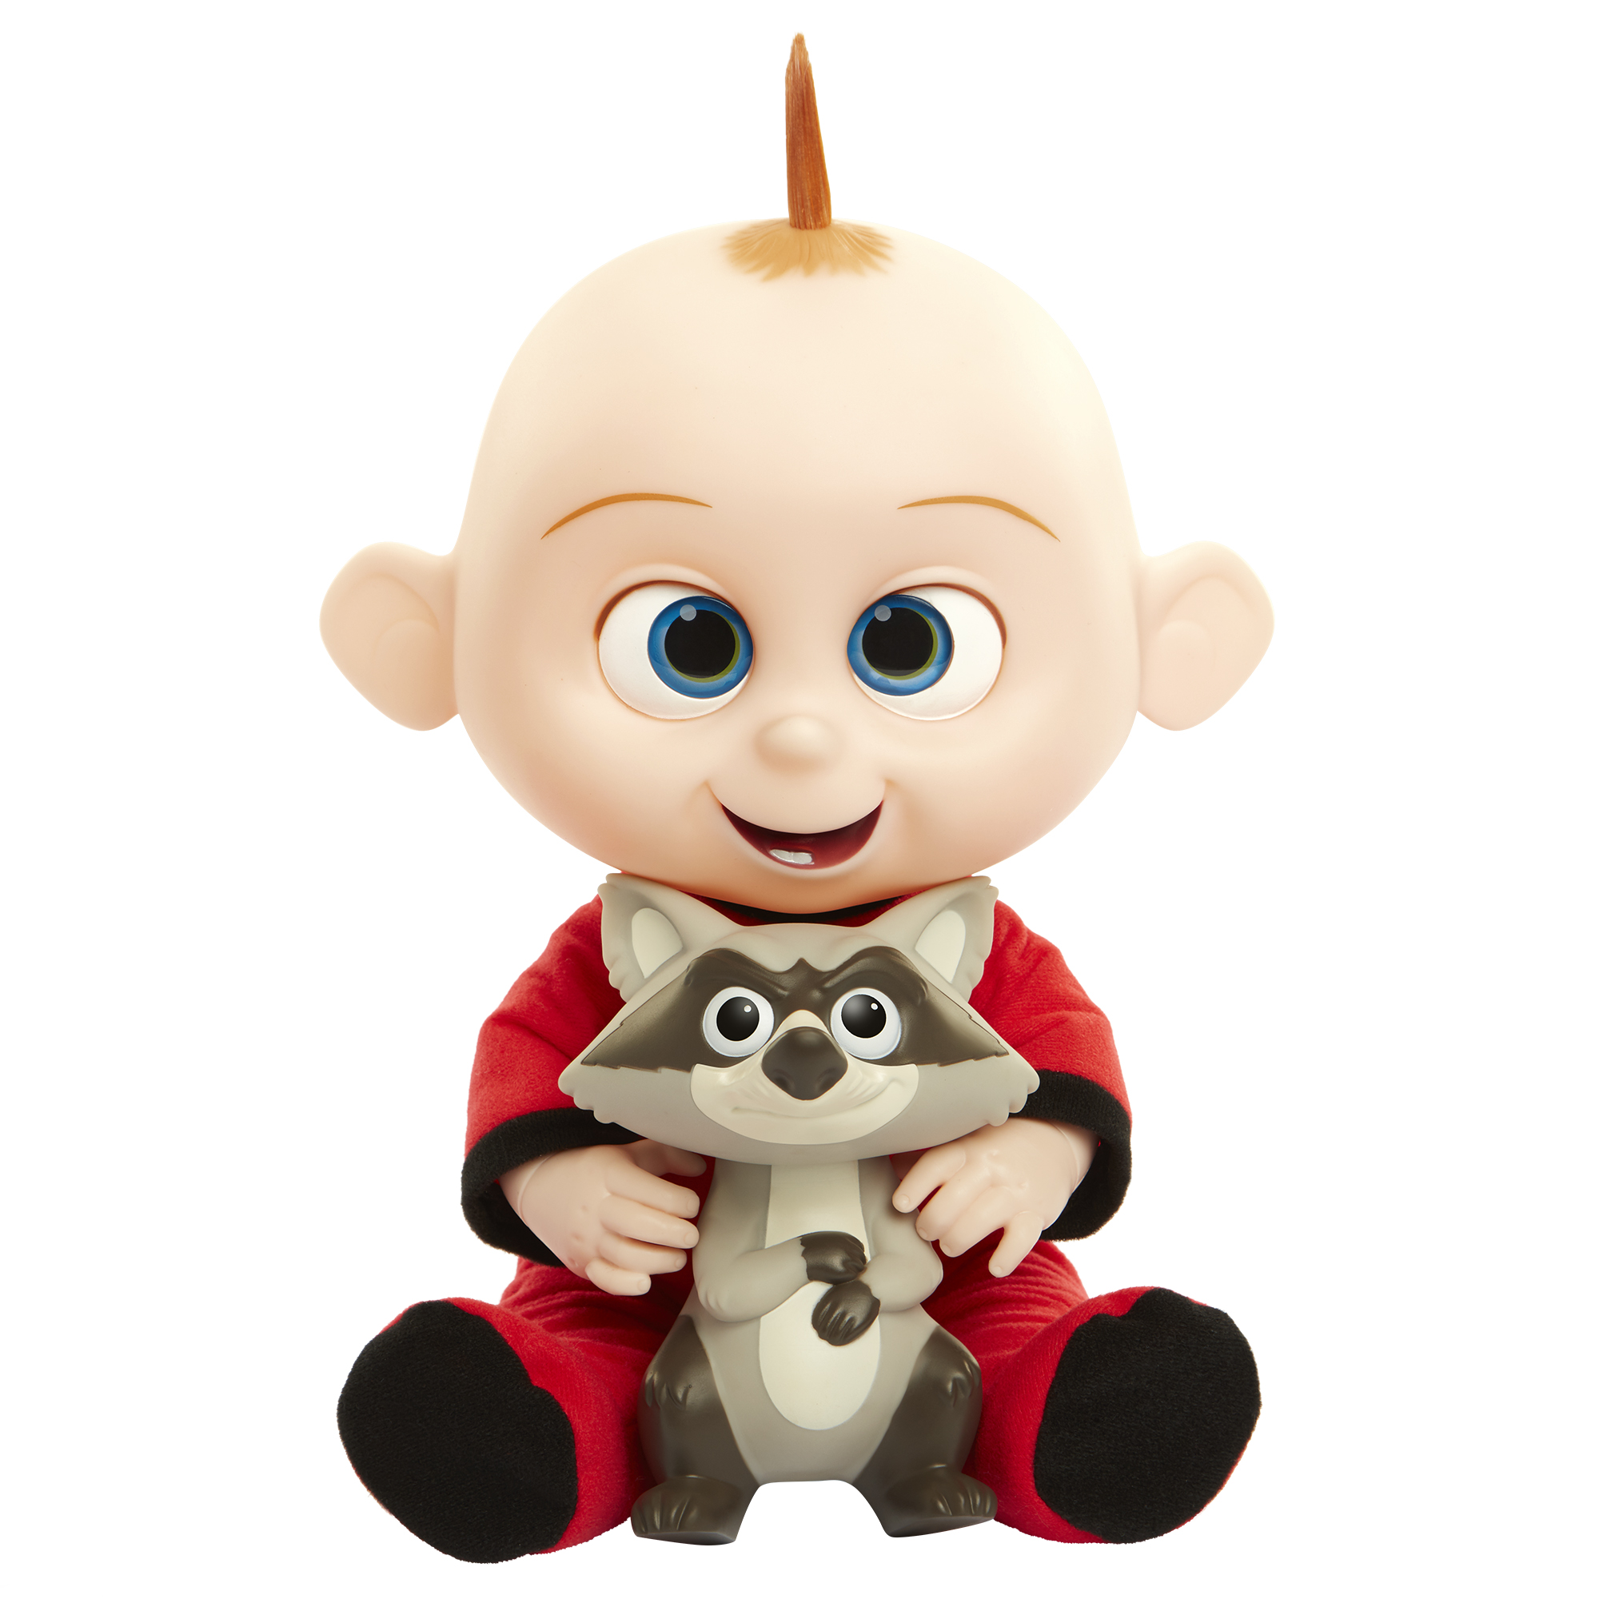
- Kids can press on Jack-Jack’s tummy to hear him laugh, giggle, babble, cry, and shout, as well as make electric sparks sounds.
- Repeatedly pressing on Jack-Jack’s belly or pressing and holding Jack-Jack’s belly will result in Jack-Jack cycling through his “powers”:
  - He will turn red to show off his fiery flames.
  - He flashes yellow and creates spark sounds to show off his electric sparks.
  - His eyes glow blue to show his piercing lasers eyes.
- Doll includes Jack-Jack with lights and sounds and a raccoon.

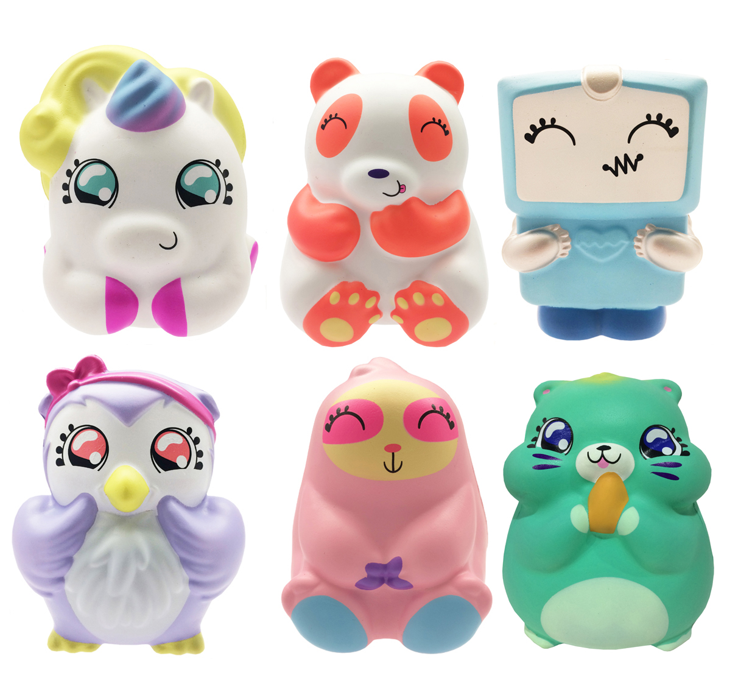
Squish-Dee-Lish™
Squish-Dee-Lish™ Jumbo Series #1
SRP: $14.99 | 6+ years | Available: Spring 2018
- Squish-Dee-Lish™ squishes now come in Jumbo size for even more squishing fun!! These super slow-rise jumbo squishy toys come in six adorable styles to collect including a hamster, panda, unicorn, robot, owl, and sloth.
- Each one is approximately 7-inches tall.
- Each is packed in a gusseted blind bag.

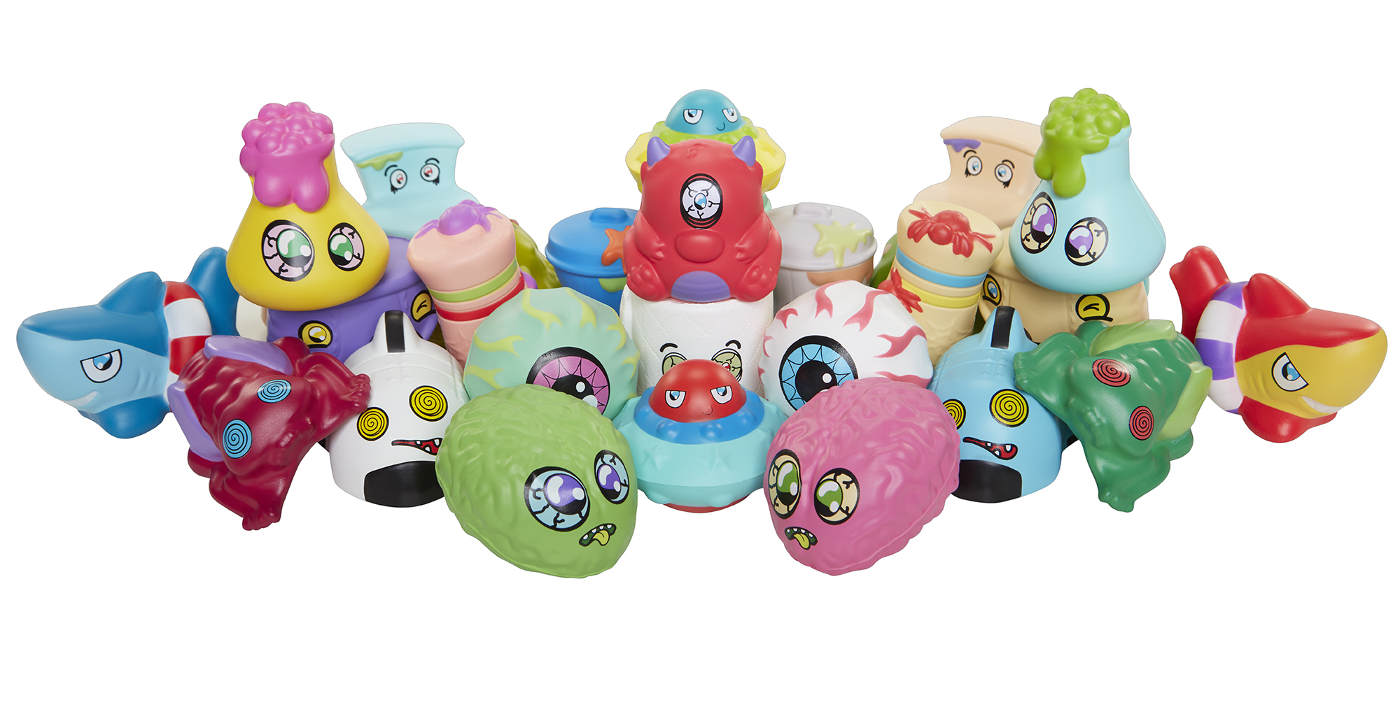
Squish-Dee-Lish™ Wacky Series #1
SRP: $4.99 | 6+ years | Available: Only at Target Spring 2018
- Wacky Series #1 includes super awesome and super gross designs including a UFO, toilet, vomit, poo, and many more!
- 30 styles to collect!
- Each is packed in a foil blind bag.
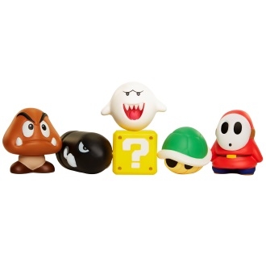
Squish-Dee-Lish™ -- Licensed Properties
World of Nintendo® Squish-Dee-Lish™
SRP: $5.99 | 6+ years | Available: Spring 2018
- Each blind bag comes with an iconic Nintendo™ villain or accessory that kids can squish, just like in the game!
- Six different characters to collect!

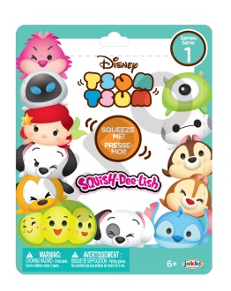
Disney Tsum Tsum Squish-Dee-Lish™ Series #1
SRP: $5.99 | 6+ years | Available: Spring 2018
- Kids will love squishing their favorite Disney characters including Ariel, Chip, Mike, Pluto, and more!
- Squeeze and watch these squishy figures shrink down and transform slowly back to their original and lovable shape.
- Eight characters to collect.
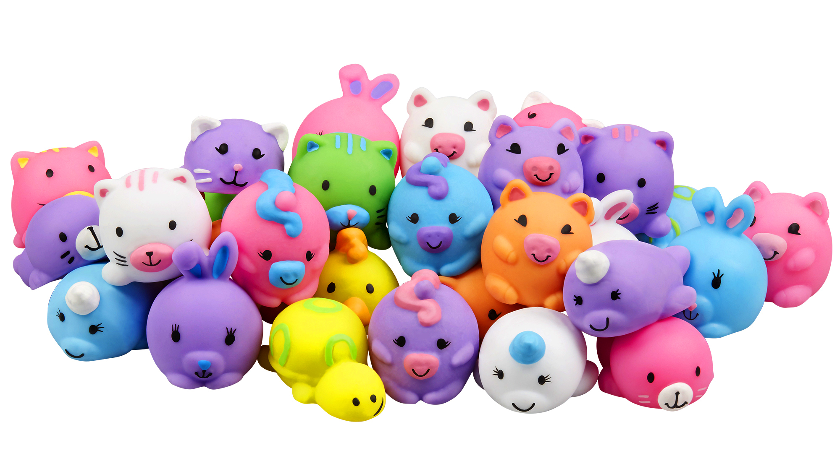
- Each is packed in blind bag.
JigglyDoos™
JigglyDoos™ 2pk Series #1
SRP: $3.99 | 4+ years | Available: Spring 2018
- Includes two cute JigglyDoos™ friends.
- Soft, squishy, jiggly and wiggly.
- 32 JigglyDoos™ to collect in Series No.1.
- Characters include: unicorn, bunny, kitten, narwhal, tiger, bear, and more!

FALL:
Harry Potter
Wizard Training Wands
SRP: $24.99| 8+ years | 3 AAA Batteries included | Available: Fall 2018
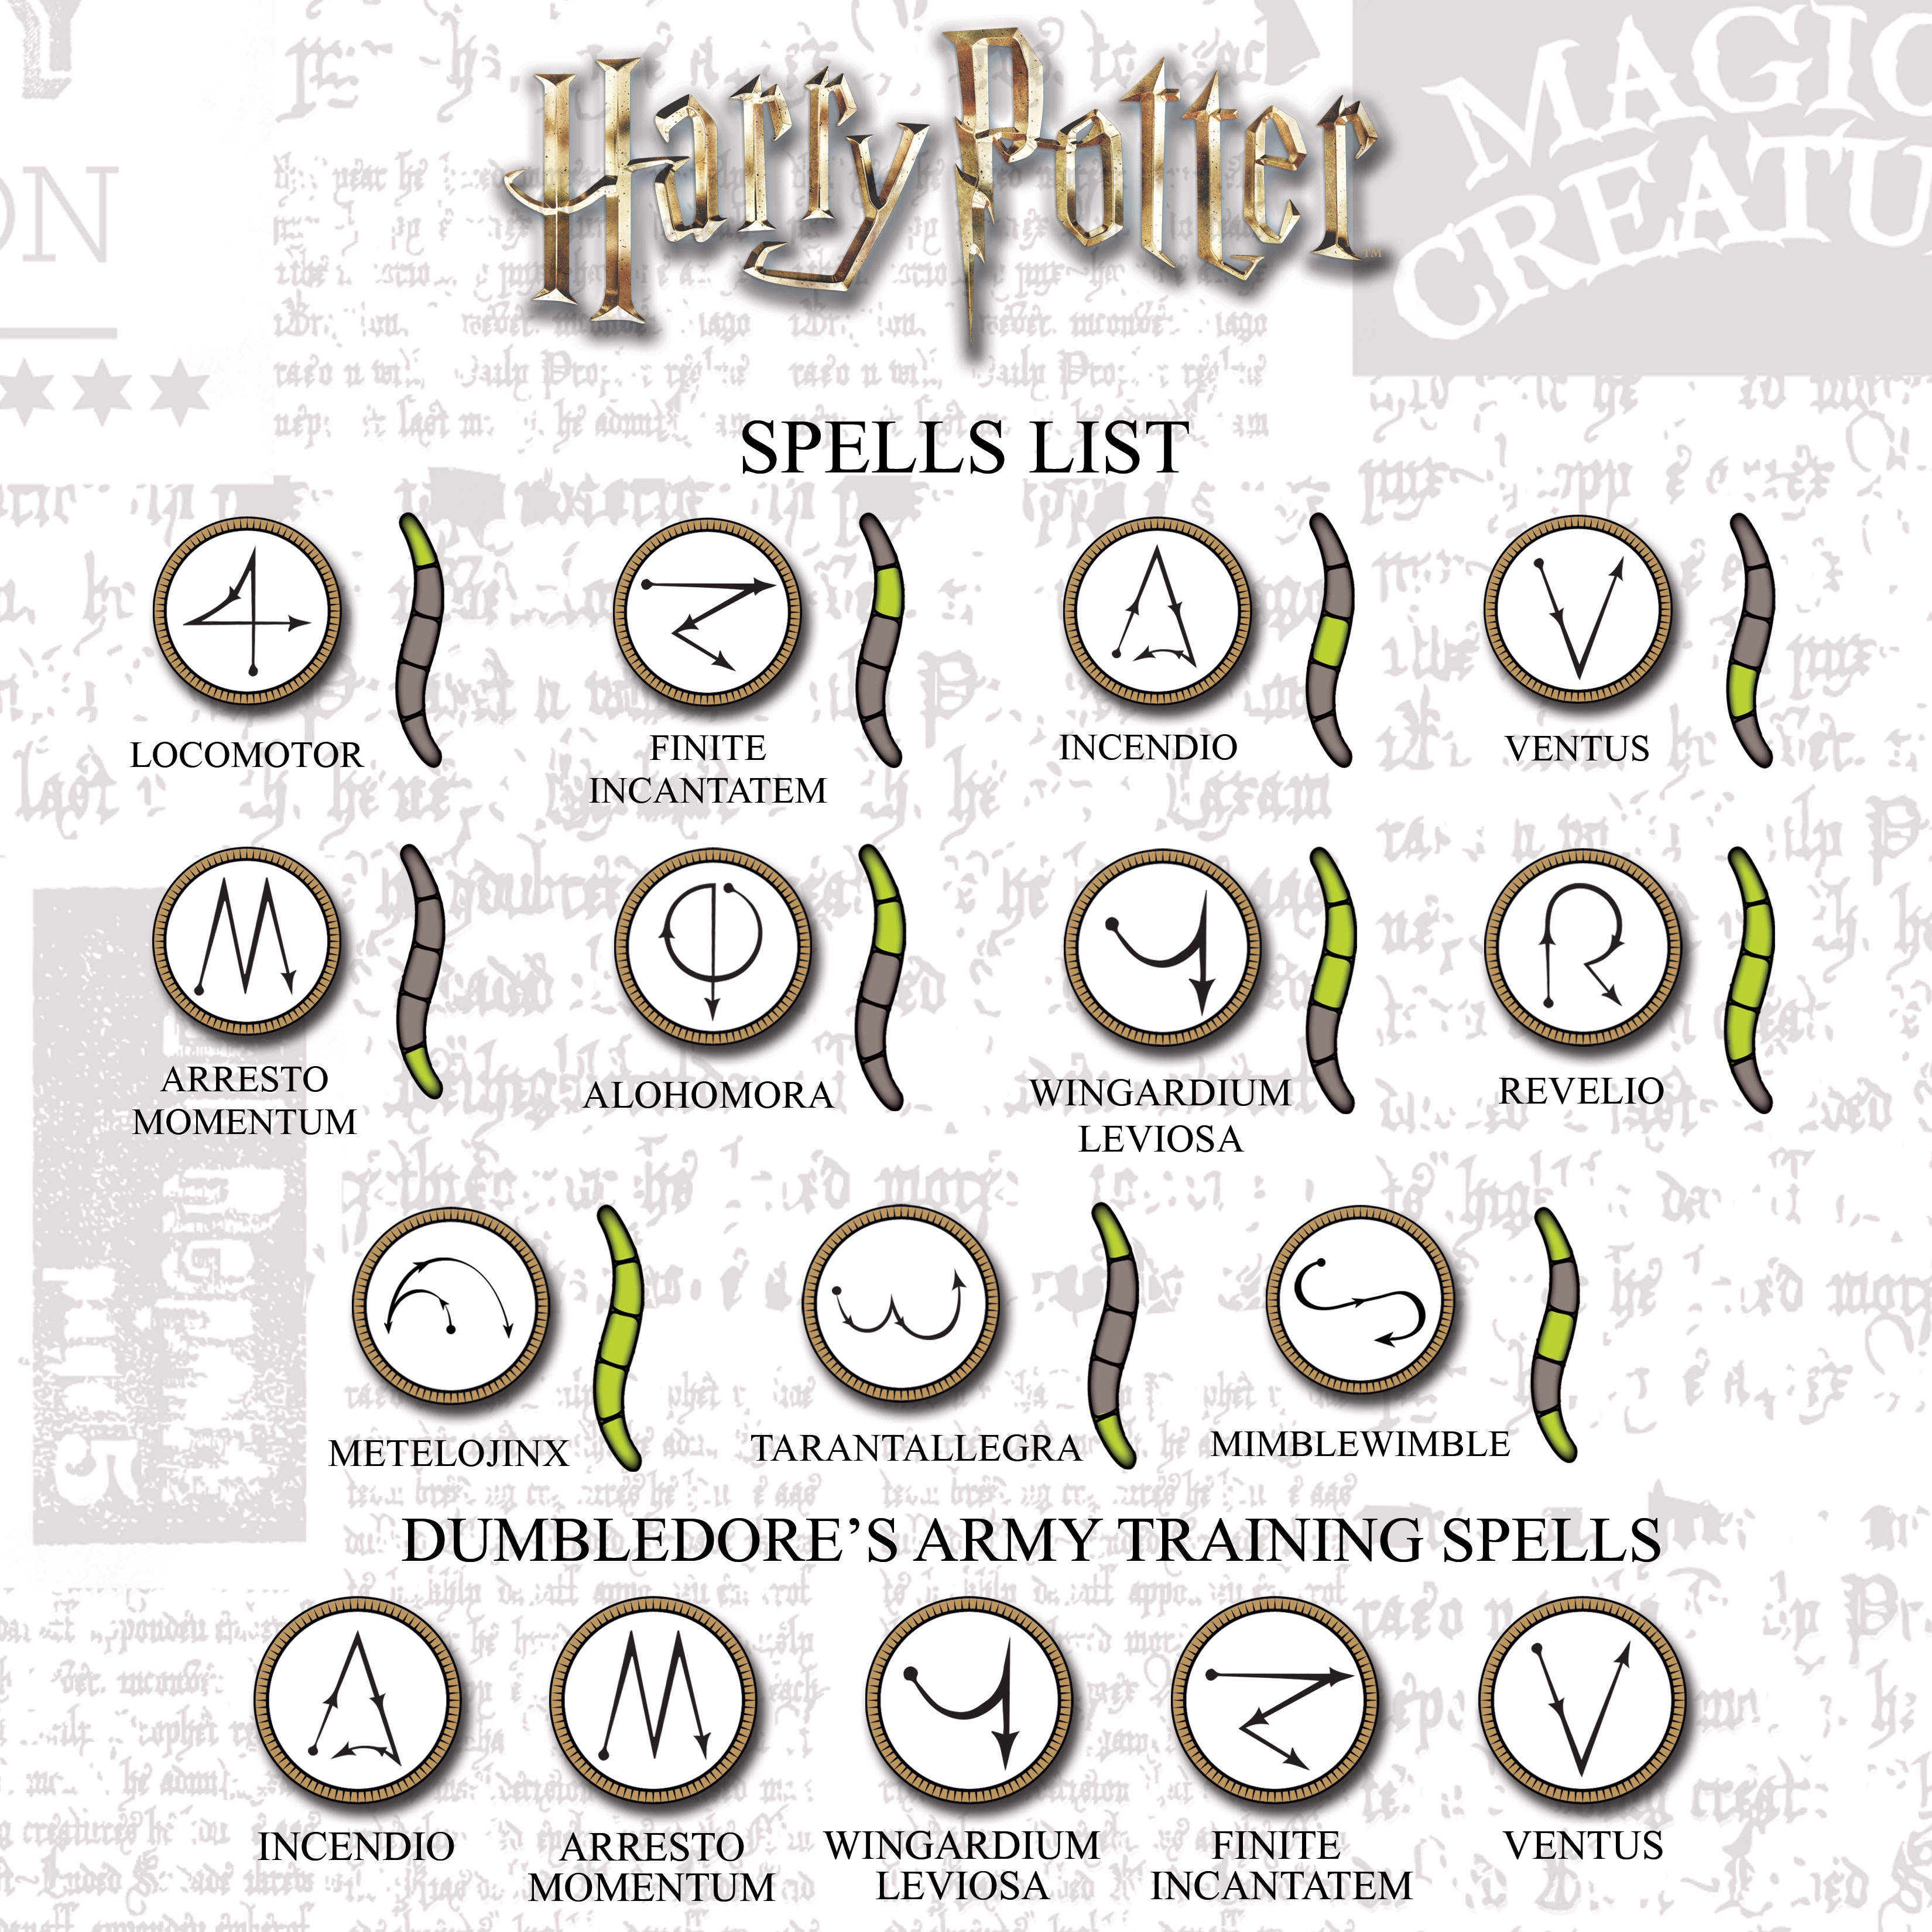
- Kids can now train like a wizard with the Harry Potter Wizard Training Wands
- There are 11 different spells for kids to learn and master using the included spell training guide.
- The wand recognizes movement to know when kids have cast their spells. The wand provides sound feedback that the spells have been cast correctly.
- Each wand includes five modes of play: two modes of standalone play and three modes to play with a friend. The light-up button allows them to select which mode to play.
- The assortment includes Harry Potter’s wand, Albus Dumbledore’s wand (i.e. The Elder Wand), and Lord Voldemort’s wand.
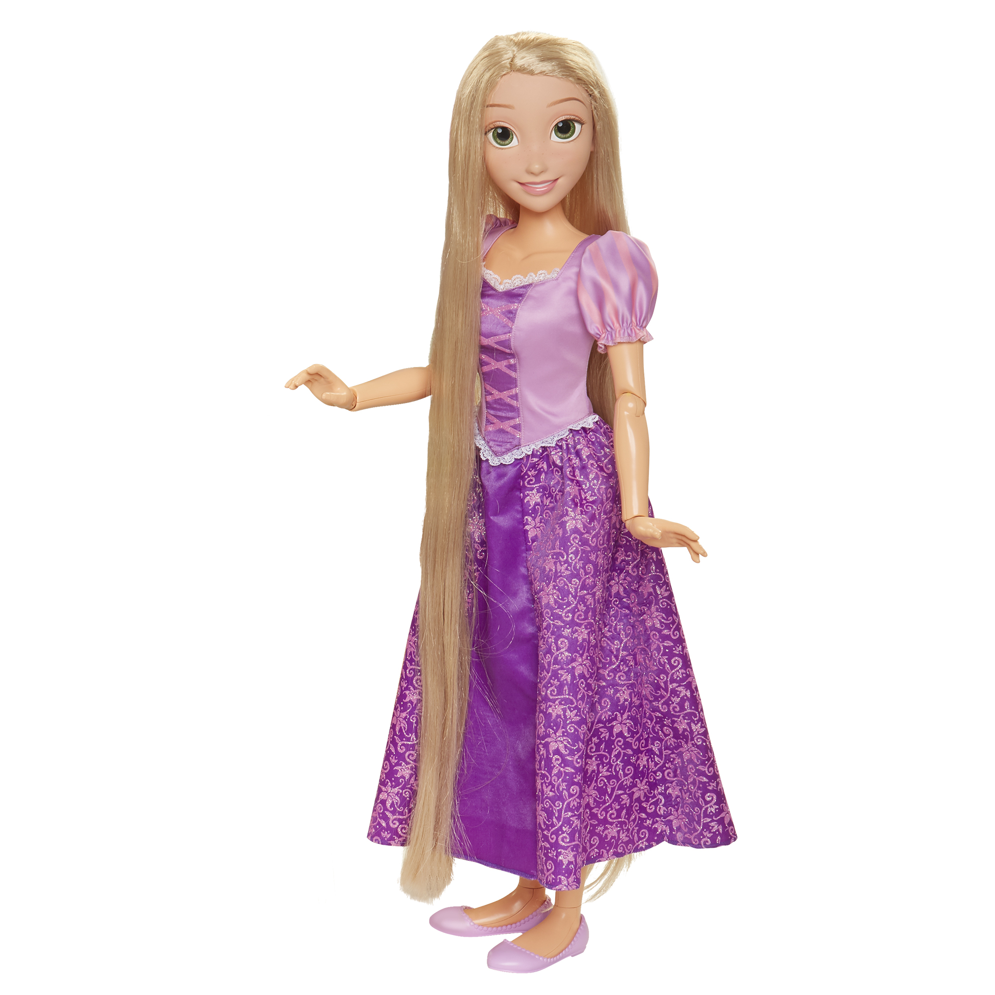
Disney’s Tangled
Playdate Rapunzel
SRP: $59.99 | 3+ years | Available: Fall 2018
- Rapunzel is 32-inches tall and is fully articulated at the neck, shoulders, elbows, wrists, hips and knees.
- Styled in her signature purple dress, Rapunzel has long, stunning, blonde hair that flows from her head to her ankles and Royal Reflection™ Eyes
- Includes a brush and doll with removable dress, shoes, and tiara.

Disney’s Maximus
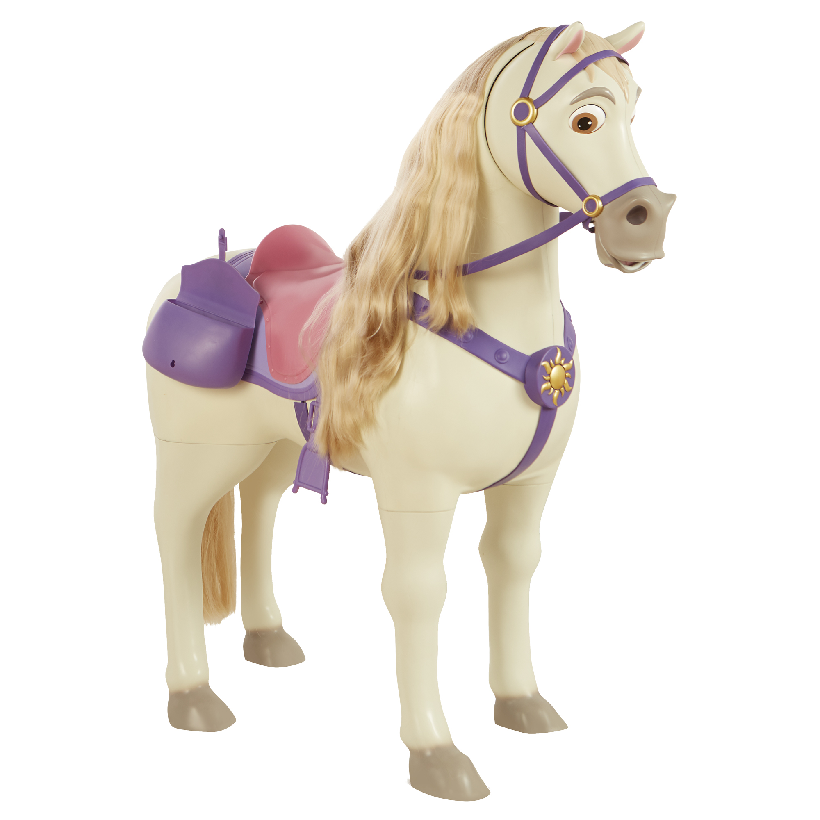
SRP: $99.99 | 3+ years | 3 AAA Batteries included |Weight 207 | Available: Fall 2018
- Kids can have the best play date ever with Disney’s Maximus, Rapunzel’s trusted steed!
- Standing over 2-feet tall, Maximus is ready for adventure with any child or the Playdate Rapunzel doll.
- Maximus will respond with motion and sound as kids pull his reins.
- Kids can off him the included apple to stay on his good side - Maximus will hold the apple in his mouth and make “chomping” sounds.
- Maximus includes a hair brush and hair accessories for fun hair play with his mane and tail and a saddle bag for storage!

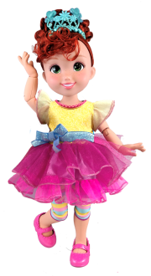
Fancy Nancy
Fancy Nancy™ Feature Doll
SRP: $34.99| 3+ years | Available: Fall 2018
- Nancy is ready for a fabulous play day dressed in her signature outfit of leggings, tiara, and chic party dress, which are removable for fashion play!
- This 18-inch feature doll has fully posable arms and legs with 12 points of articulation at the neck, shoulders, waist, elbows, wrists, hips, and knees.
- The doll works with the Closet of Fashions Assortment, Accoutrements Assortment, and Bistro Set with Marabelle.

Fancy Interactive Friend Doll
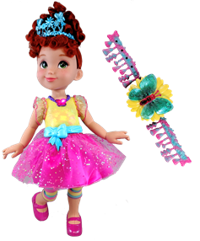
SRP: $49.99 | 3+ years | 3 AAA Batteries and 3 AG13/LR44 required | Available: Fall 2018

- Kids can press the butterfly on Nancy’s necklace or the accompanying light-up butterfly bracelet for the child to wear to hear Nancy say 38 phrases or sing songs from the television series.
- The Interactive Friend doll works with and without the interactive bracelet.
- The doll features nine points of articulation at the neck, shoulders, elbows, wrists, hips, and knees, and the bodice lights-up in six different colors: blue, yellow, orange, green, pink, and purple.
- The doll comes dressed in Nancy’s signature fashion with removable fabric skirt, removable signature striped leggings, removable tiara, and molded bodice and shoes.
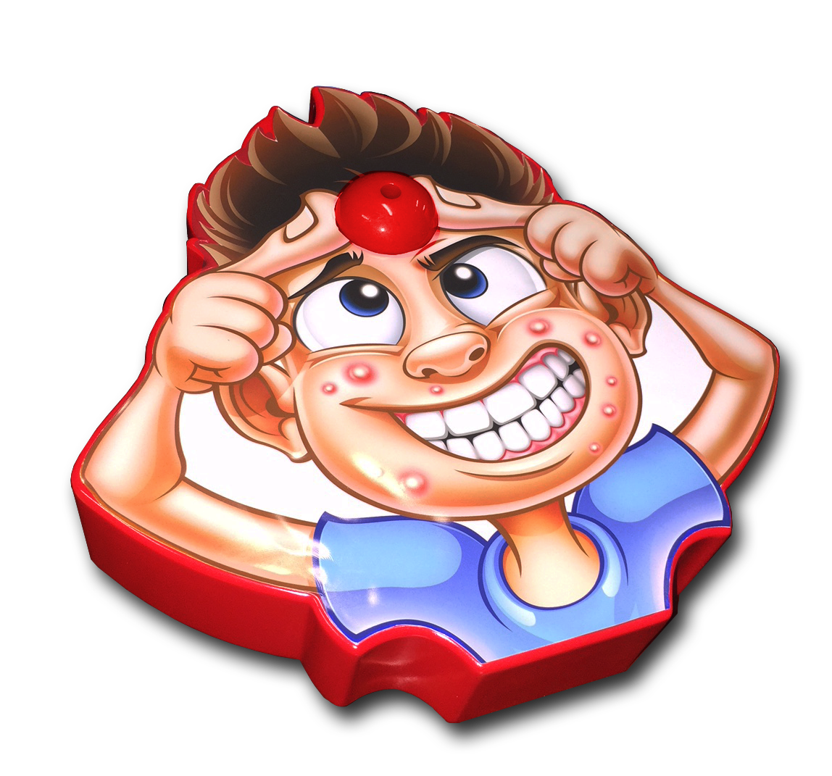
Pop-A-Zit Game
SRP: $19.99| 4+ years | Available: Fall 2018
- Gross and Fun Gameplay
- Players roll the die, and squeeze the zit depending on number rolled. You never know when it’ll pop!
- Sprays Silly String or water
- Game includes the main game board, one die, one can of Silly String, and one water bottle.

Toilet Paper Blaster™
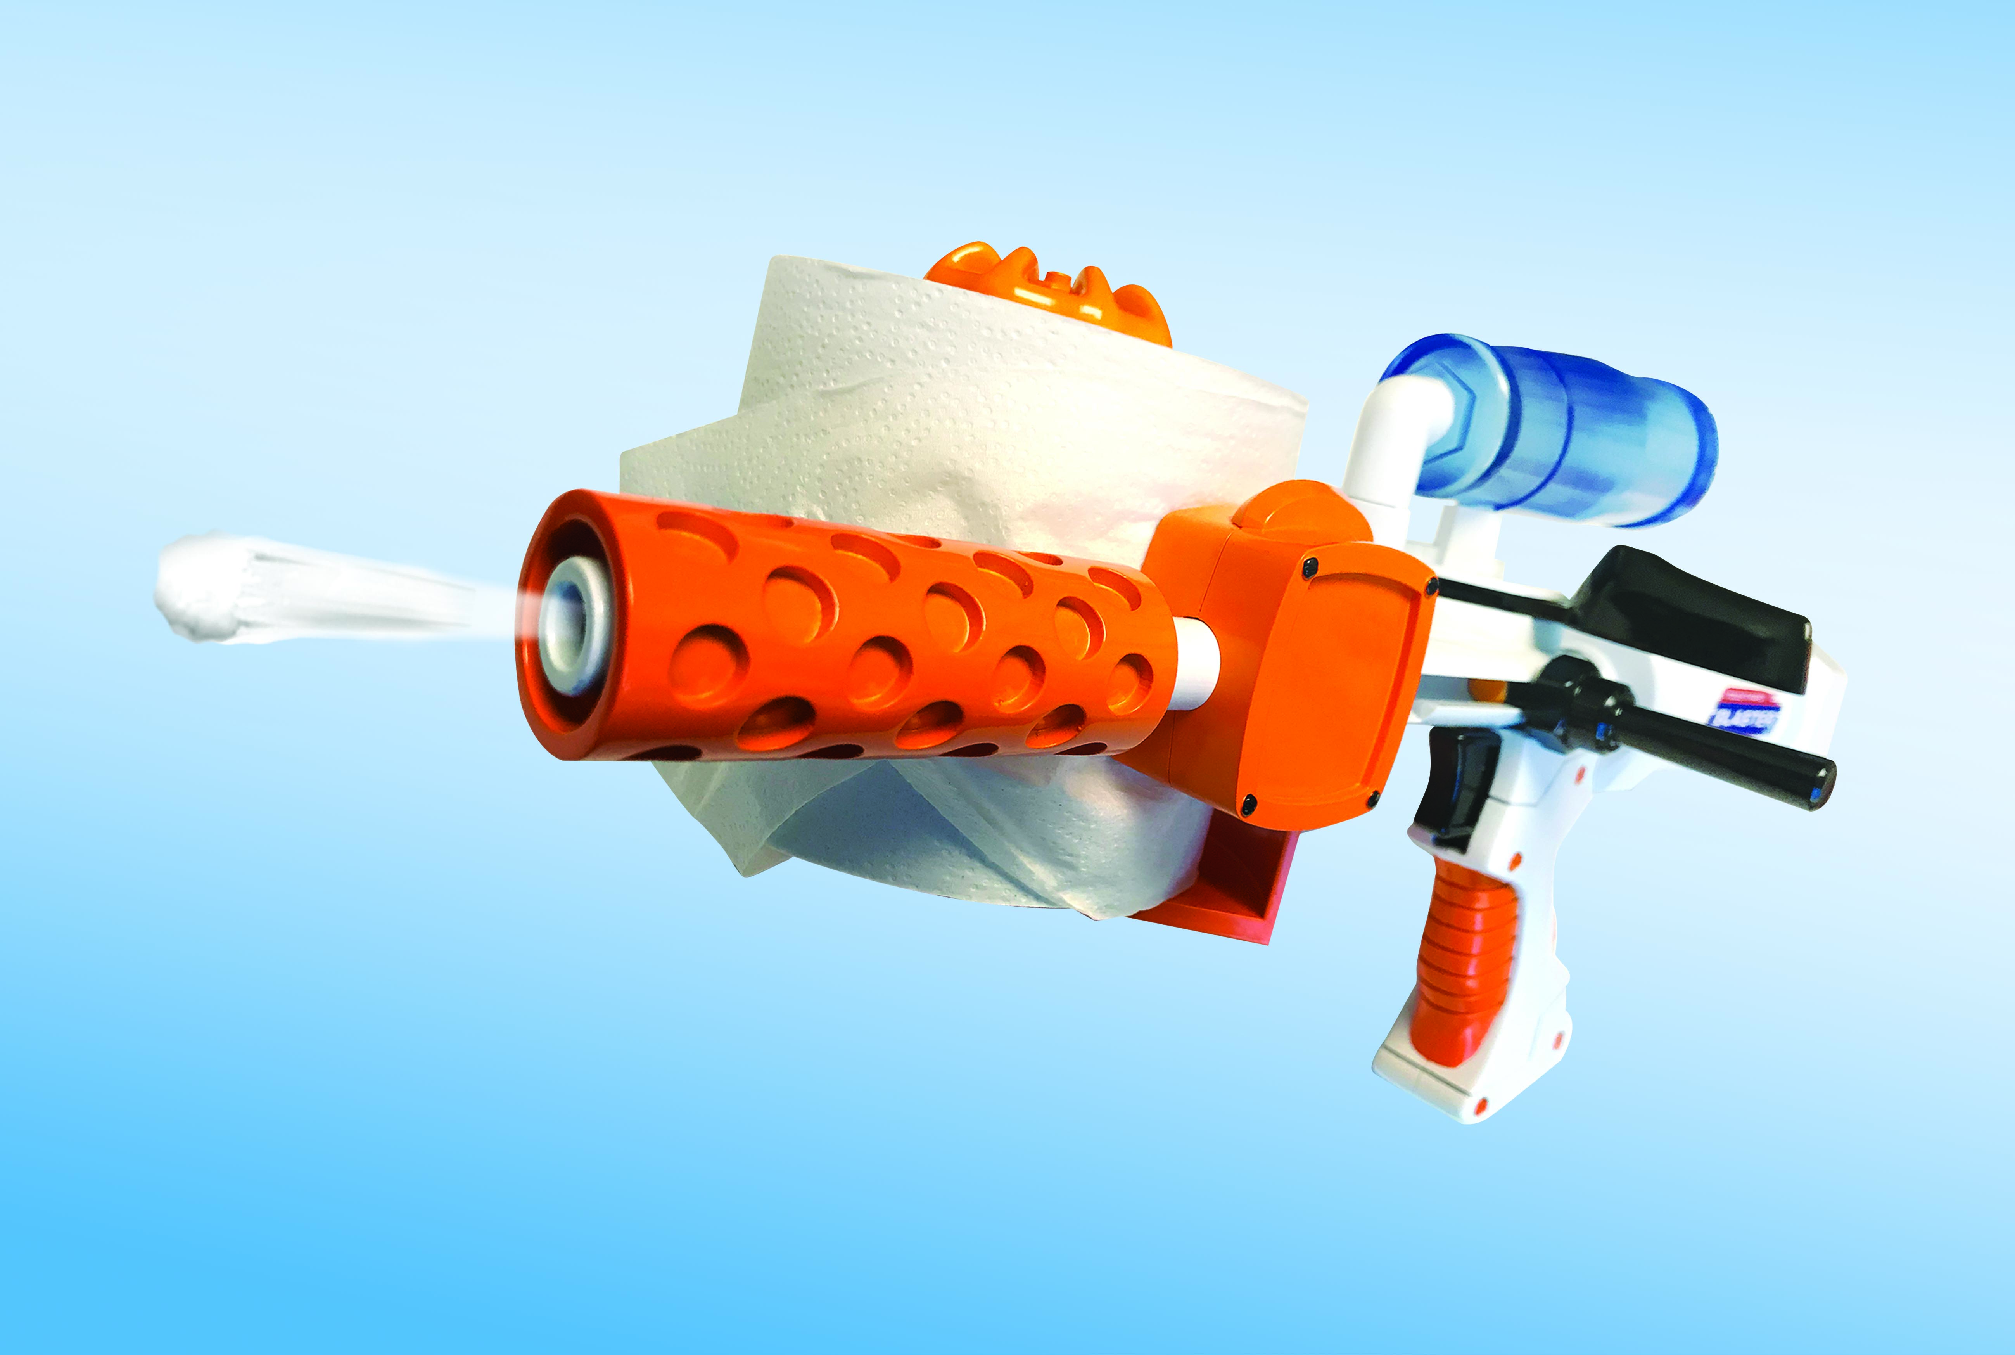
Skid Shot™ 30
SRP: $19.99| 8+ years | Available: Fall 2018
- Uses real toilet paper.
- Blasts up to 30 feet!
- Easy to use: load the toilet paper, add water, lock & load. Fire!
- No batteries required.
- Includes a single blaster.

Slime
Automatic Slime Drencher™
SRP: $19.99| 6+ years | Available: April 2018
- A game for two or more daring players, load up the reusable Automatic Slime Drencher™ with a Slime-filled balloon to get started.
- Kids wind up the timer and then pass around the Automatic Slime Drencher™ until the winner gets Slimed!
- The Automatic Slime Drencher™ includes four packets of Slime powder (each 7.5 grams) which mixes with water so kids can make their own Slime. Fill the balloons (24) with mixed Slime using the included nozzle and load into the reusable drencher.

Slime Burst™ Hat
SRP: $19.99| 6+ years | Available: May 2018
- The excitement starts for two or more players after mixing Slime using an included Slime packet and then loading up the Slime Burst™ Hat with a Slime-filled balloon.
- The first player spins the dial to see how many times to squeeze the bulb. Kids then pump up the balloon while watching it grow, not knowing who will get Slimed first.
- Pass the hat, spin the dial, and squeeze again. The winner is the first one to get Slimed!
- The Slime Burst™ Hat includes one hat, four Slime packets (each 7.5grams), a spinner dial, 48 balloons, one fill nozzle, and a balloon clip.

