Get ready to WIPE out the competition with the NEW Toilet Paper Blaster™ Skid Shot™ 30! It’s the only toilet paper shooting blaster in the market. The Skid Shot 30 is easy to use and easy to clean up. Fires up to 30 feet with no batteries required. Let’s Roll!

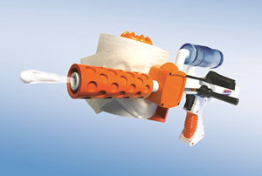
Toilet Paper Blaster™
Skid Shot™ 30
SRP: $19.99| 8+ years | Available: Fall 2018
- Uses real toilet paper.
- Blasts up to 30 feet!
- Easy to use: load the toilet paper, add water, lock & load. Fire!

