KELLYTOY ANNOUNCES 50 MILLION
SQUISHMALLOWS® SOLD

It’s Snuggles for Everyone as Kellytoy Reaches Milestone
Just Two Years After Launch

Meet the Squad at Toy Fair New York February 22-25, Booth #1553

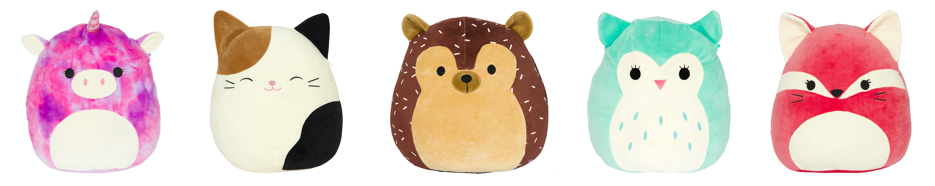

LOS ANGELES — February 10, 2020 — Toy lovers and collectors of all ages fell in love with the huggable line of Squishmallows when they were introduced just over two years ago, and now with more than 50 million sold, the ongoing love affair shows no sign of slowing down. In addition, Squishmallows social media (@squishmallows) mobilizes its global audience while entertaining and informing more than 200,000 rabid followers (there are more than 20 million video views on TikTok alone).

“From the very beginning with the original squad, the amazing appeal of Squishmallows has driven significant, ongoing demand for this award-winning plush line,” says Kellytoy CEO Jonathan Kelly. “The steadily increasing demand for our collectible plush toys and pillows have propelled the adorable squads of characters into an international phenomenon, making them one of the most recognizable and in-demand toys and pillows in the marketplace.”

Debuting in fall 2017, the delightful Squishmallows have expanded to more than 400 characters and are available in more than 40 countries. It will only get better, too, as more must-have characters are in the pipeline for release later this year, including scrumptious fruit themes, soothing, comforting textured fabrics, eye-catching mystery bags, reversible Flip-a-Mallows (two Squishmallows in one) and seasonal styles for spring, fall and the holidays. Squishmallows range from 3.5 inches to 24 inches with suggested retail prices from $2.99 to $39.99, depending on the character size and style.

A snuggly alternative to high tech toys, and a great gift alternative to candy and flowers, these versatile Squishmallows make great pillows, bedtime buddies, travel companions and can even serve as a best friend in times of need to help relieve stress and anxiety.

Popping with personality, each Squishmallows character’s background story is detailed on its hangtag. The unique line is made of super soft spandex “EF” and polyester stuffing as puffy as marshmallows. Caring for Squishmallows is easy; give them lots of love, machine wash in cold water and tumble-dry on low heat—and remember not to iron them.

Kellytoy will showcase original and seasonal squads as well as brand new Squishmallows styles February 22-25 at Toy Fair New York (booth #1553). Join the #SquishmallowSquad online and follow @Squishmallows on Facebook, Instagram, Twitter, Pinterest and YouTube.

The shape, look, feel, and texture of Squishmallow® branded plush toys constitute Kellytoy Worldwide, Inc.’s proprietary trade dress.

About Kellytoy
Kellytoy manufacturers a portfolio of award winning everyday and seasonal plush products that includes its best-selling Squishmallows, Kellybaby as well as a pet products line called Wags & Purrs™. Over the past three decades, Kellytoy has positioned itself to meet the needs of its customers in mass market, gift/specialty/toy retailers, party and pet stores, supermarkets, discount stores, drug stores, amusement parks and even crane machines in arcades the world over. Kellytoy also makes products in collaboration with leading classic characters, including major licenses, as well as blockbuster theatrical franchises. www.kellytoy.com

###

For media inquiries, or to set up a booth appointment, contact:
Dan Grody | Tellem Grody PR | 310-313-3444 | dan@tellemgrodypr.com

