KELLYTOY ANNOUNCES SQUISHMALLOWS®
LINE EXPANSION FOR TOY FAIR NEW YORK

50 All-New Everyday, Seasonal Characters and Reversible Flip-a-Mallows and Mystery Bag Styles Join the Line

Visit Kellytoy Booth #1553 at Toy Fair February 22-25

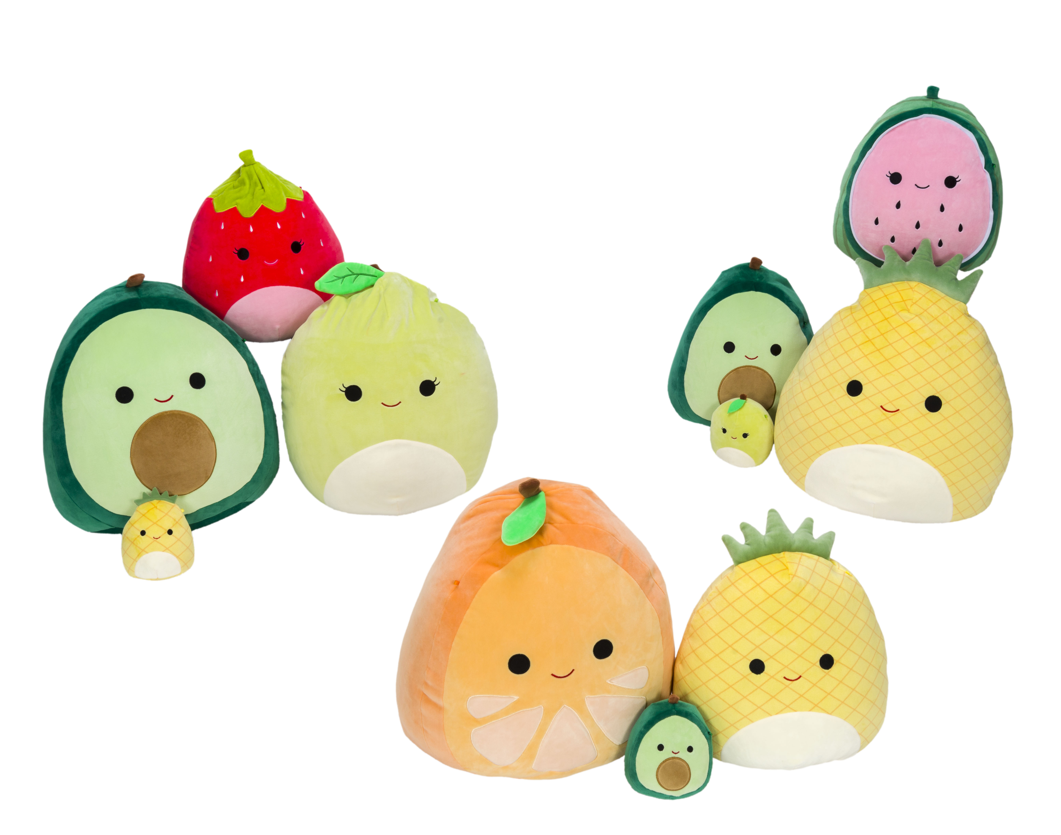

LOS ANGELES — February 5, 2020 — Kellytoy’s ever-evolving plush toy and pillow line Squishmallows (www.squishmallows.com), one of the hottest brands in the global marketplace, continues to expand with the launch of more than 50 new characters and completely new styles including the eye-catching mystery bags and reversible Flip-a-Mallows (two characters in one). Kellytoy offers retailers a wide array of Squishmallows sizes and styles to fit the needs of every customer – looking at you Axolotl fans – while all new character assortments will have collectors clamoring for the latest and greatest releases as they grow their #SquishmallowSquad.

“Squishmallows are as versatile as ever with textured fabrics and even more characters to choose from – more than 400 in all,” says Jonathan Kelly, CEO of Kellytoy. “Additionally, mystery and surprise products are incredibly hot right now and a great way to engage customers in store. Our fans already love discovering and collecting all the new styles and the mystery bags add to the excitement,” says Kelly.

Kellytoy is also releasing a series of six Flip-a-Mallows; “Turn these characters inside out for two Squishmallows in one,” says Kelly. The series includes shark/clown fish, corgi/calico cat, fawn/owl, dragon/unicorn, alpaca/dragon, and hedgehog/sloth and are available in five and 12-inch sizes.

From scrumptious fruit themes to soothing, comforting textured fabrics, Kellytoy will showcase other new Squishmallows styles at Toy Fair, including:

- Birds: toucan, parrot, peacock
- Dogs and cats: sheltie, rottweiler, German Shepherd, St. Bernard, schnauzer and terriers; grey and tan tabby cats
- Bears: white bear and brown bear
- Farm: horse, donkey, spotted pig and goat
- Sea Life: purple octopus, teal octopus, pink jellyfish, otter and crab
- Zoo: orange tiger, white tiger, teal leopard, orange panda and red panda
- Dragons: blue textured dragon, green dragon and teal dragon
- Dinos: purple textured dinosaur and green textured dinosaur
- Fruit: orange, pineapple, strawberry, avocado, watermelon and apple
- Fantasy: pink caticorn and purple caticorn

Squishmallows are bursting with personality and make great couch pals, pillows, bedtime buddies and travel companions. “They’ll go anywhere with you,” says Kelly. Squishmallows range from 3.5 inches to 24 inches, depending on the character and styles, and prices range from $2.99 to $39.99, respectively.

Each character’s background story is detailed on its hangtag. The unique line is made of super soft spandex “EF” and polyester stuffing as puffy as marshmallows. Caring for Squishmallows is easy; give them lots of love, machine wash in cold water, tumble-dry on low heat and remember not to iron them.

See the newest Squishmallows along with other loveable squads at Toy Fair New York, held February 22-25 (booths #1553). Join the #SquishmallowSquad online and follow @Squishmallows on Facebook, Instagram, Twitter, Pinterest and YouTube.

The shape, look, feel, and texture of Squishmallow® branded plush toys constitute Kellytoy Worldwide, Inc.’s proprietary trade dress.

About Kellytoy
Kellytoy manufacturers a portfolio of award winning everyday and seasonal plush products that includes its best-selling Squishmallows, Kellybaby as well as a pet products line called Wags & Purrs™. Over the past three decades, Kellytoy has positioned itself to meet the needs of its customers in mass market, gift/specialty/toy retailers, party and pet stores, supermarkets, discount stores, drug stores, amusement parks and even crane machines in arcades the world over. Kellytoy also makes products in collaboration with leading classic characters, including major licenses, as well as blockbuster theatrical franchises. www.kellytoy.com

###

For media inquiries, or to set up a booth appointment, contact:
Dan Grody | Tellem Grody PR | 310-313-3444 | dan@tellemgrodypr.com

