Return to the Shadow Realm with the brand-new Yu-Gi-Oh! TCG Speed Duel Starter Decks: Match of the Millennium & Twisted Nightmares!
Yu-Gi-Oh! TCG Speed Duel Starter Decks: Match of the Millennium & Twisted Nightmares each contain 2 fully customizable Decks, 4 brand-new Skill Cards, and 2 Ultra Rare variant cards. Choose your side and relive two of the darkest Duels from the original series!
Yugi and Pegasus face off in Yu-Gi-Oh! TCG Speed Duel Starter Decks: Match of the Millennium, themed after their epic clash from the end of Duelist Kingdom! Each Duelist brings a 31-card Deck that can be modified depending on which Skill Card you want to play. Yugi brings support for both Gaia the Fierce Knight and his Ritual Monster, Black Luster Soldier to fight off Pegasus’s army of “Toon” monsters and Thousand-Eyes Restrict! With each character having access to 2 brand-new Skill Cards to support their strategies, you decide the outcome!
Yu-Gi-Oh! TCG Speed Duel Starter Decks: Twisted Nightmares pits two masters of the Shadow Realm against each other. With two 30-card Decks designed to be customized around whichever of their 2 brand-new Skill Cards you want to play, you can relive their sinister Duel from the end of Battle City! Wield the power of Bakura’s corrupt Dark Necrofear and Dark Ruler Ha Des against Marik’s devious Lava Golem and “Dark Lucius” monsters! Featuring brand-new Skill Cards infused with the power of signature Spell Cards from their legendary Duel, their fate is in your hands!
Speed Dueling is a great way to get a taste of the Yu-Gi-Oh! TRADING CARD GAME while also providing compelling new gameplay options for existing fans. Keep an eye out on the Yu-Gi-Oh! TRADING CARD GAME events page to find out where you can play Speed Dueling events!
Each Yu-Gi-Oh! TCG Speed Duel Starter Decks: Match of the Millennium contains:
1 x 31-Card Yugi Deck
1 x 31-Card Pegasus Deck
4 Skill Cards (2 for Yugi and 2 for Pegasus)
2 Ultra Rare variant cards
Each Yu-Gi-Oh! TCG Speed Duel Starter Decks: Twisted Nightmares contains:
1 x 30-Card Bakura Deck
1 x 30-Card Marik Deck
4 Skill Cards (2 for Bakura and 2 for Marik)
2 Ultra Rare variant cards
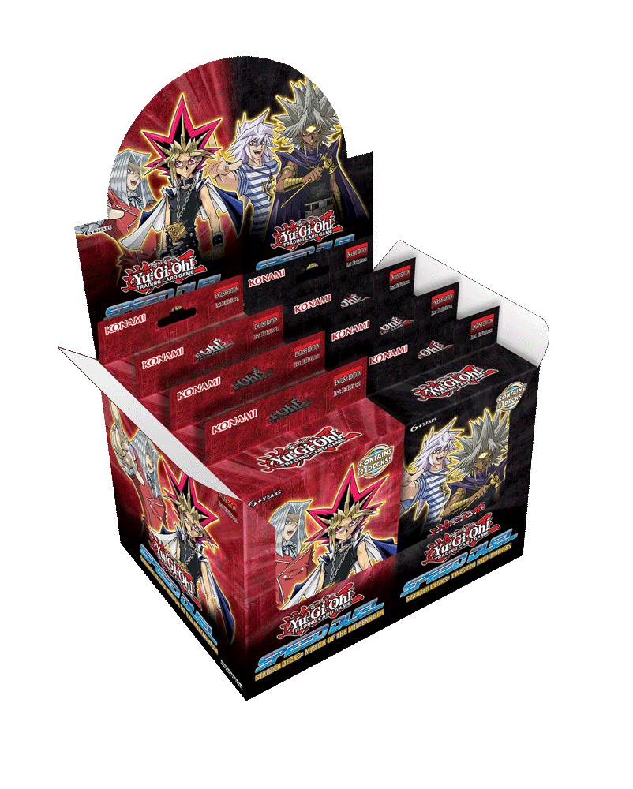
To use a card in Speed Dueling it must have the Speed Dueling Symbol on the card, other versions of the same card are not legal.
Skill Cards may only be used in Speed Dueling events.
*Name and content subject to change.

