NEWS RELEASE
New Company MEandMine Celebrates Several Awards and New Partnerships

LOS GATOS, CA— (Feb. 13, 2020) —
Started just last year in 2019, MEandMine has already celebrated several awards for its products. Fish Out Germs - MEandMine Story of Healing received the 2019 Tillywig Brain Child Award and the 2020 Family Choice Award. 5 other MeandMine products also went on to win the 2020 Family Choice Award. The Magic Set, which includes Fish Out Germs - MEandMine Story of Healing and iLuv's Color Gears - MEandMine Story of Emotion, also celebrated a 2020 Golden Award from Mom’s Choice.
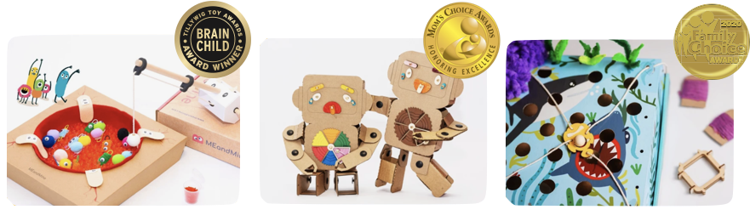
In addition to its award-winning products, MEandMine also offers Play Lab, providing content and educational aids for schools and educational groups. It recently formed partnerships with Gymboree and Children’s Creativity Museum, with the first class starting next month.
“As a mom of two, I feel that our children these days are overwhelmed by performance-based expectations”, says Elinor Huang, CEO of MEandMine, who interviewed more than 1000 parents across the United States and the Center of Developing Child at Harvard before starting the company. “That’s why I decided to create products that can develop children’s lifelong skills - such as resilience, social emotion, and many more - so that they are equipped for their future. I want them to be able to have fun with challenges, befriend uncertainties, and discover the magic hidden inside them”
MEandMine will showcase all products, including the upcoming releases, at the American International Toy Fair in New York City on February 21, 2020 to February 25, 2020, at Booth #4219. There will be goodie bags available for media partners. For more information about the company, visit www.meandmine.com.

MEDIA CONTACT:
Sandy Yu
Head of Marketing
sandy.yu@meandmine.com
310-467-0946

