FOR IMMEDIATE RELEASE PRESS RELEASE
Media Contact: Greg Walsh, Walsh Public Relations
305 Knowlton St., Bridgeport, CT 06608
T: 203-292-6280; masterpieces@walshpr.com

MasterPieces Builds with the Best
Company Signs License with Caterpillar for Cat® Brand

Tucson, AZ – (February 15, 2017) - MasterPieces Inc. constructs a powerful new selection of puzzles, toys and games with a new license agreement with Caterpillar Inc. for the Cat® brand.
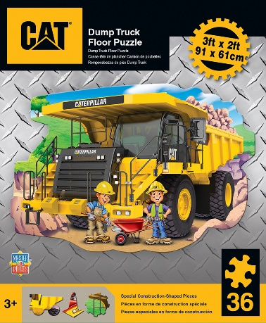
David Rolls, President of MasterPieces, said, "We're working with the #1 construction brand in the world! Our new Cat puzzles, crafts and games offer kids a new way of engagement with the fascination of building and construction."
A total of six new Cat products arrive in 2017. The line is led by three MasterPieces Cat puzzles, two 60-piece puzzles and one oversized floor puzzle of a monstrous Cat Dump Truck.
Two Cat wood craft kits are part of MasterPieces award-winning Works of Ahhh wood kits. The new Cat Wood Paint Kits; a Cat Dump Truck and Cat Backhoe, have been designed for ages 4+ with real working parts that turn the craft into a toy. Both products were awarded the Mother’s Choice Gold Award in January of 2017!
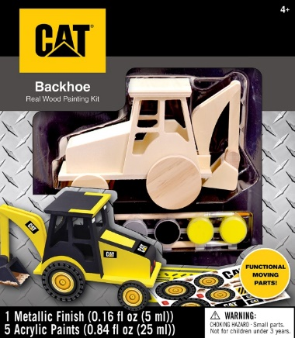
Rounding out the MasterPieces Cat line is the circular shaped Cat Matching Game, a memory and concentration card game designed for ages 3+ that features colorful Cat vehicles, tools and gear.
"Our first wave in the construction of our Cat line will debut at Toy Fair in New York and we plan to continue growing the line," Rolls explained. "We have been painstakingly precise for the Cat brand especially in our choice of images and packaging. We always maintain an extremely high quality package durability, which is even more important for this particular brand, and we've been very discerning in using the rugged graphics, including diamond plating, construction yellow and tough rubber black colors that stay true to the Cat brand."
About Caterpillar
For 91 years, Caterpillar Inc. has been making sustainable progress possible and driving positive change on every continent. Customers turn to Caterpillar to help them develop infrastructure, energy and natural resource assets. Caterpillar is the world’s leading manufacturer of construction and mining equipment, diesel and natural gas engines, industrial gas turbines and diesel-electric locomotives. For more information, visit caterpillar.com and caterpillar.com/social-media.

About MasterPieces:
MasterPieces Inc. was founded by David Rolls, former 8-year professional baseball player for the Kansas City Royals and Texas Rangers organizations, in 1995 with a passion to serve diverse retail markets and partner with evergreen brands and top puzzle artists. Twenty years later, MasterPieces has established itself as the market leader for combining the best quality products with the best value. Headquartered in Tucson, Arizona, MasterPieces reputation for producing innovative and high-quality products has propelled its global growth and the company’s commitment to ensuring great value and superior customer support has earned its dedicated, worldwide customer loyalty. MasterPieces creates some of the world most elegant puzzles and innovative packaging, as well as toys and gifts, while also partnering with brands such as John Deere, John Wayne, Tetris, Animal Planet, Hershey’s, and sports licensing with MLB, NFL, NCAA, NHL organizations. For more information about MasterPieces, visit the company website at MasterPiecesInc and for the most immediate information and interaction with the company, please like and follow MasterPieces on Facebook, Twitter, Pinterest, and YouTube.

Media Contact Information:
Claryssa Almada, Phone: (520) 741-1315 ext. 142; E-mail: claryssa.almada@masterpiecesinc.com
For Sales information, contact:
David Rolls, Phone: (520) 741-1315 ext 115; E-mail: david.rolls@masterpiecesinc.com

Additional MasterPieces Puzzle Press Releases and Product Images Available here.

© 2016 Caterpillar CAT, CATERPILLAR, BUILT FOR IT, their respective logos, “Caterpillar Yellow,” the “Power Edge” trade dress, as well as corporate and product identity used herein, are trademarks of Caterpillar and may not be used without permission.

