FOR IMMEDIATE RELEASE PRESS RELEASE
Media Contact: Greg Walsh, Walsh Public Relations
305 Knowlton St., Bridgeport, CT 06608
T: 203-292-6280; masterpieces@walshpr.com

MasterPieces Scores With Classic Sports Action Figure Toys
New Partnership with Kaskey Kids

Tucson, AZ – (February 13, 2019) – MasterPieces, Inc. today announced a partnership with Kaskey Kids to assume a role of manufacturer and marketer of the wildly popular, classic sports miniature action figures.
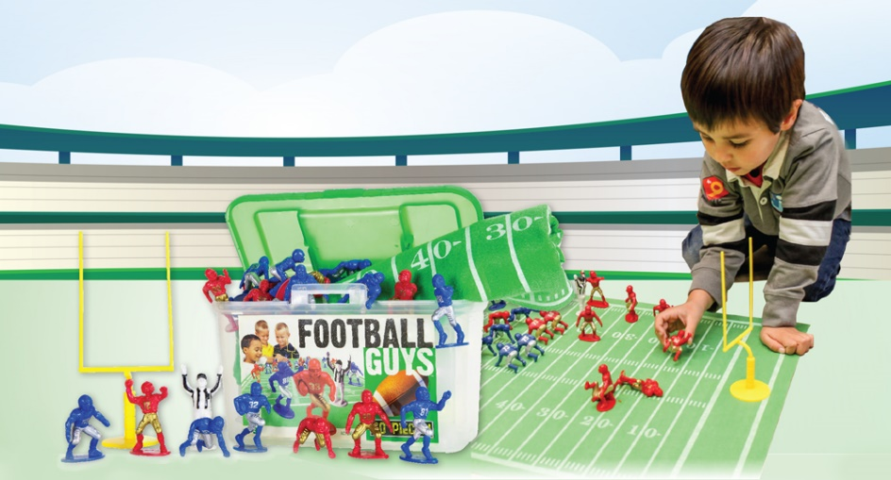
In the deal, MasterPieces becomes the official maker of the mini football, baseball, basketball, soccer and hockey role-play figures in all assorted packaged quantities and sizes, and will lead the sales and marketing for the products, which will now be under the MasterPieces brand.
David Rolls, President of MasterPieces, said, "The new toys are a perfect fit as we strengthen and expand our creative play product offerings. The collections provide unlimited open-ended, imaginative play for kids. We're proud to continue the high-quality craftsmanship and value of the toys."
MasterPieces will immediately begin managing all fulfillment of the products as well as broadening the reach of the products at retail. “We're now able to offer the sports figures to all of our sales channels directly, which will greatly increase the availability of the product for consumers,” Rolls added.
Collections come with various number of plastic players for football, baseball, basketball, soccer or hockey. Each player in any kit is made of durable, nearly indestructible material, and every kit comes in a stackable plastic bin with a handle for portable, on-the-go action and neat storage.

With this addition, MasterPieces adds a new dimension to its toy channel, as well as fortifying its position as the leading provider of sports toys, puzzles and accessories. The company has long-term success as a licensee with the NFL, MLB, NHL and NCAA, and its range of sports themed games, jigsaw puzzles, wooden toys, room décor and gifts. In 2018, MasterPieces became the exclusive licensee for Spot it!® MLB, NFL, NHL and NCAA league and team versions of the hit game, and also acquired College Toy Trains, to become the largest marketer of Collegiate toys, games and puzzles.

About Kaskey Kids: In 2002 Christy Kaskey blended her desire to find the perfect toy for her sports loving kids. With the memory she had of her brothers entertaining themselves for hours with action figures of their childhood, such as Army Men, Super Heroes and Cowboys and Indians, she created classic toy action figures from a child's favorite sport.

About MasterPieces: MasterPieces Inc. was founded by David Rolls, former 8-year professional baseball player for the Kansas City Royals and Texas Rangers organizations, in 1995 with a passion to serve diverse retail markets and partner with evergreen brands and top puzzle artists. Twenty years later, MasterPieces has established itself as the market leader for combining the best quality products with the best value. Headquartered in Tucson, Arizona, MasterPieces reputation for producing innovative and high-quality products has propelled its global growth and the company’s commitment to ensuring great value and superior customer support has earned its dedicated, worldwide customer loyalty. MasterPieces creates some of the world most elegant puzzles and innovative packaging, as well as toys and gifts, while also partnering with brands such as John Wayne, Animal Planet, Hershey’s, and sports licensing with MLB, NFL, NCAA, NHL organizations. For more information about MasterPieces, visit the company website at MasterPiecesInc and to interact with the company, please like and follow MasterPieces on Facebook, Twitter, Pinterest, and YouTube.
For Sales information, contact:
David Rolls, Phone: (520) 741-1315 ext. 115; E-mail: david.rolls@masterpiecesinc.com

