**FOR IMMEDIATE RELEASE PRESS RELEASE**

Media Contact: Greg Walsh

Walsh Public Relations

305 Knowlton St., Bridgeport, CT 06608

T: 203-292-6280; *masterpieces@walshpr.com*

**MasterPieces Puts Together Team of Sports Licenses for Major League Entry to Baby-Child Market**

***- New All-Natural Wooden Rattles; Push-Pull Toys -***

Tucson, AZ – (February 13, 2017) –Shake, Rattle, and Roll! MasterPieces Puzzle Company assembles team of sports licenses to build its entry into the Baby and Child product market.

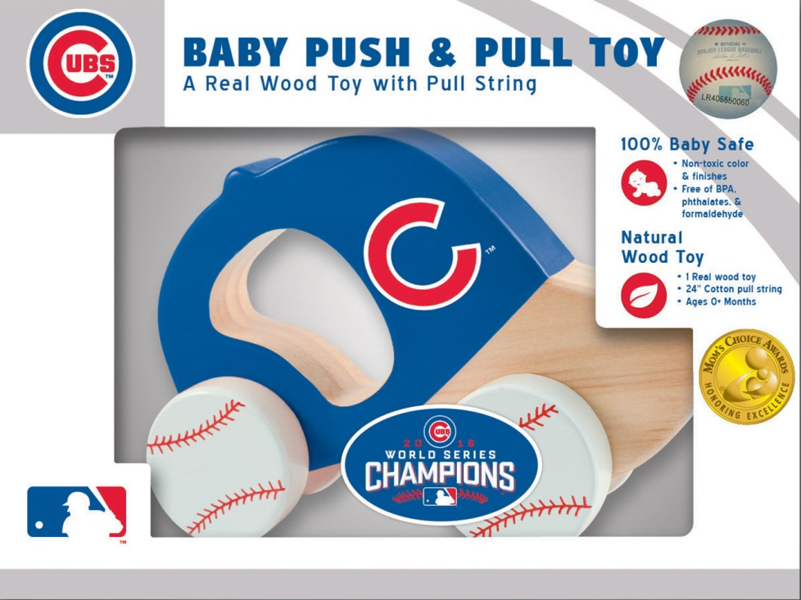***MasterPieces’ Chicago Cubs Push & Pull Toy***

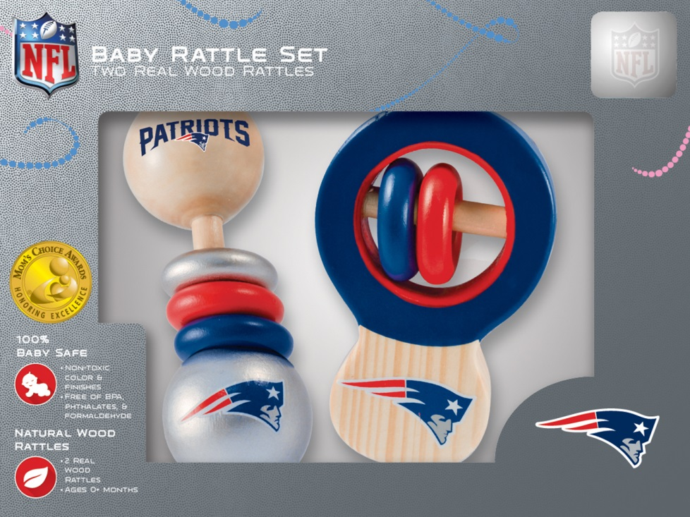

***MasterPieces' New England Patriots Rattle Set***

Making its Major League debut at the 2017 Toy Fair in New York City, MasterPieces will unveil its full line of baby, infant and child all-natural wooden rattles and push-pull products.

David Rolls, President of MasterPieces, said, "Entering the baby market was a 'natural' extension for our company. The tactile play, visual, hand-eye coordination and fun of the rattles and rolling toys build perfectly onto our existing agreements with top sports licenses as well as our printing and manufacturing abilities."

The new MasterPieces Baby Rattles (MSRP $17.99, for ages 0-18 months) and Baby Push & Pull Toys (MSRP $17.99 for ages 0-2 years) are 100% Baby Safe. The products meet all industry safety standards. They are made of real, all-natural wood with non-toxic colors and finishes, and are completely BPA, phthalates and formaldehyde free.

Both the rattles and push-pull toys come in (parents' and) little sports fans' favorite teams through MasterPieces licenses with the NFL, NHL, MLB and NCAA.

MasterPieces prides itself on the attention to detail of its new products. The large, smooth and sturdy Baby Rattles provide tactile play that helps babies to develop grasping and fine motor skills. The rattles have knobs, handles and rings to offer various shapes for baby to explore. Then, as the baby discovers cause and effect of movement, the toys' rings shake against each other to create entertaining sound.

Meanwhile the MasterPieces' Baby Push & Pull Toys, which come in varying shapes corresponding with each sport, such as a football helmet-shaped car, baseball cap-shaped car, and even a Zamboni, provide gross motor skill development and hand eye coordination. The movement and motion of the MasterPieces Push & Pull products can grow with the child and when the baby begins to walk, the product can be pulled and rolled along by a cotton string. The strong and durable wooden wheels offer a fine, smooth roll to follow the child along and the 24” cotton string to pull for extended play beyond first year.

The new Baby Products line adds to MasterPieces cornerstone identity of children and adult jigsaw puzzles and traditional games, as well as the company's Works of Ahhh line of wooden crafts for kids.

**About MasterPieces Puzzle Company:**

MasterPieces Puzzle Company was founded by David Rolls, former 8-year professional baseball player for the Kansas City Royals and Texas Rangers organizations, in 1995 with a passion to serve diverse retail markets and partner with evergreen brands and top puzzle artists. Twenty years later, MasterPieces has established itself as the market leader for combining the best quality products with the best value. Headquartered in Tucson, Arizona, MasterPieces reputation for producing innovative and high-quality products has propelled its global growth and the company’s commitment to ensuring great value and superior customer support has earned its dedicated, worldwide customer loyalty. MasterPieces creates some of the world most elegant puzzles and innovative packaging, as well as toys and gifts, while also partnering with brands such as John Deere, John Wayne, Elmer’s, Tetris, Animal Planet, Hershey’s, and sports licensing with MLB, NFL, NHL and NCAA organizations. For more information about MasterPieces, visit the company website at [MasterPiecesInc](http://www.masterpiecesinc.com/) and for the most immediate information and interaction with the company, please like and follow MasterPieces on [**Facebook**](https://www.facebook.com/MasterPiecesPuzzleCompany), [**Twitter**](https://twitter.com/MasterPiecesApp), [**Pinterest**](http://www.pinterest.com/masterpiecesco/), and [**YouTube**](https://www.youtube.com/channel/UC9toXM_cvFSmocXd9PM3t6A).

**Media Contact Information:**

Claryssa Almada, Phone: (520) 741-1315 ext. 142; E-mail: [claryssa.almada@masterpiecesinc.com](mailto:claryssa.almada@masterpiecesinc.com)

**For Sales information, contact:**

David Rolls, Phone: (520) 741-1315 ext 115; E-mail: [david.rolls@masterpiecesinc.com](mailto:david.rolls@masterpiecesinc.com)

**Additional MasterPieces Puzzle Press Releases and Product Images Available** [**here**](http://www.masterpiecesinc.com/press-room.aspx)**.**

 

 

 

 