FOR IMMEDIATE RELEASE PRESS RELEASE
Media Contact: Greg Walsh, Walsh Public Relations
305 Knowlton St., Bridgeport, CT 06608
T: 203-292-6280; masterpieces@walshpr.com

MasterPieces Scores Sports Figures,
Builds on Licenses, Adds Popular Art for Puzzles

Tucson, AZ – (Feb. 12, 2019) - MasterPieces Inc. constructs a powerful new selection of puzzles, toys and games for 2019.

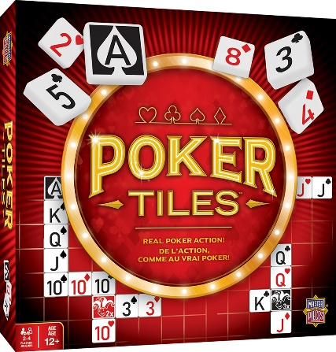
Playing to the crowd at New York Toy Fair (Booth 1135):
- The all-new original game, Poker Tiles ($24.99, for 2-4 players ages 12+) is a competition that combines the strategy of a tile game and the excitement of real poker action. Players use the game board to play traditional poker hands to score points, make combos with the tiles, and use the wild jokers to increase their score.

- Sports Guys line up as MasterPieces scored a deeper move into its toy offerings with a partnership with Kaskey Kids. MasterPieces assumes a role as the brand of manufacturer and marketer of the popular basketball, baseball, football, soccer and hockey role-play figures. Arriving in newly designed MasterPieces "toy boxes", as many as 24 figurines plus accessories (MSRP $24.99), such as "Football Guys" or "Baseball Guys", arrive as teams of classic open-ended, child-driven, fun and imaginary action figures.

- Building on some of its most successful licenses, MasterPieces connects to wood Lionel magnetic trains that capture all of the vintage details of classic, collectible trains. These trains are perfect for introducing the next generation of young train lovers to timeless Lionel designs. The new items are:
- Lionel Original Steam Engine Set (MSRP $19.99 for ages 3+)
- Lionel Santa Fe Cargo Train Set (MSRP $19.99 for ages 3+)
- Lionel Steam Engine & Coal Car (MSRP $14.99 for ages 3+)

And with one of its fastest-selling licensed product brands, MasterPieces increases its CAT brand products. Constructed off of its highly praised and award-winning CAT Dump Truck Floor Puzzle, the new items are:
- CAT branded Builder-Opoly Junior (MSRP $20.99 for ages 6+) where players try to collect all the authentic CAT equipment they'll need to get the job done! From dump trucks, to dozers, and more, players learn awesome facts about each vehicle as they get down and dirty with this fun new -Opoly game!
- CAT Checkers (MSRP $17.99)
- CAT Matching Game (MSRP $11.99)
- And more CAT wooden craft painting kits (Bulldozer, Dump Truck and Backhoe) (MSRP $15.99 each)

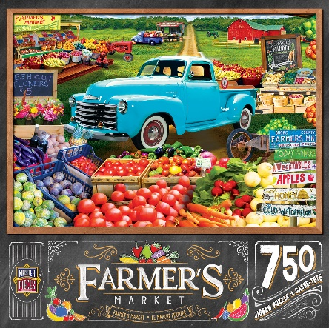
- As always, plenty of new high quality puzzles arrive from MasterPieces. Trending with today's most popular themes, MasterPieces crafted its Farmer's Market collection. Each of the first four Farmer's Market puzzles (MSRP $12.99) are 750-piece colorful scenes themed in the popular country folk-style style that are just the right combination of puzzle challenge and hobby fun.

About MasterPieces:
MasterPieces Inc. was founded by David Rolls, former 8-year professional baseball player for the Kansas City Royals and Texas Rangers organizations, in 1995 with a passion to serve diverse retail markets and partner with evergreen brands and top puzzle artists. Twenty years later, MasterPieces has established itself as the market leader for combining the best quality products with the best value. Headquartered in Tucson, Arizona, MasterPieces reputation for producing innovative and high-quality products has propelled its global growth and the company’s commitment to ensuring great value and superior customer support has earned its dedicated, worldwide customer loyalty. MasterPieces creates some of the world most elegant puzzles and innovative packaging, as well as toys and gifts, while also partnering with brands such as John Deere, John Wayne, Tetris, Animal Planet, Hershey’s, and sports licensing with MLB, NFL, NCAA, NHL organizations. For more information about MasterPieces, visit the company website at MasterPiecesInc and for the most immediate information and interaction with the company, please like and follow MasterPieces on Facebook, Twitter, Pinterest, and YouTube.

