FOR IMMEDIATE RELEASE PRESS RELEASE
Media Contact: Greg Walsh, Walsh Public Relations
305 Knowlton St., Bridgeport, CT 06608
T: 203-292-6280; masterpieces@walshpr.com

MasterPieces Adds Ahhh-Some Building Element to Wood Craft Kits

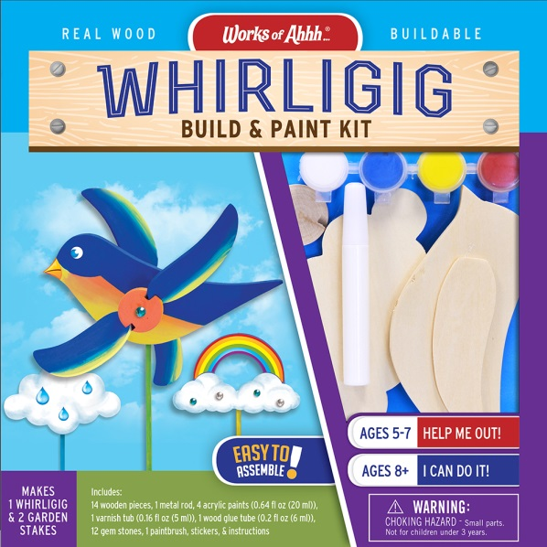
Tucson, AZ – (February 9, 2017) – Building on its hit Works of Ahhh Craft Collection, MasterPieces Inc. adds a new construction element to its wooden craft kits for kids.

The new Works of Ahhh Buildable Wood Paint Kits are all-inclusive, multi-step projects where kids can create with 3-dimensional building skills as well as detailing with paint and stickers.
David Rolls, President of MasterPieces, said, "We wanted to add another stage of the project experience for kids to enjoy. Our new Works of Ahhh buildable kits are great for engaging and entertaining young artists and engineers. The kits are designed to help develop skills like planning and reasoning, and we coupled it with individualized artistic expression."
The construction of the Works of Ahhh Buildables is a snap with MasterPieces' easy to follow directions. Each Works of Ahhh kit (MSRP $15.99 - $24.99, for ages 4 and up) includes everything you need to create both a personalized work of art and functional toy. The kits contain handcrafted real wood, and all of the accessories needed to finish the project, including (but not limited to) glue, an artist-quality paint brush, stickers, and non-toxic acrylic paints in vibrant colors. Each kit comes with special “extras” like gems or metallic paint, that makes it one of a kind.
In addition to detailed visual instructions, MasterPieces provides a painting guide with tips on how to paint each project and suggestions for advanced techniques such as mixing colors and blending shades. Tips and painted examples are only suggestions and the possibilities for creativity in any Works of Ahhh kit is only limited by a child's own imagination.
Works of Ahhh are great for parties, school projects or fun at home with the family.
Works of Ahhh kits include holiday themes, outdoor kits that come with varnish, boy themed kits that include metallic paints, and viable licensed Works of Ahhh versions for John Deere tractors, US Army tank and helicopter, and Caterpillar construction vehicles. Kids of all ages and artistic abilities can enjoy the popular Works of Ahhh birdhouses, jewelry boxes, race cars, wind chimes, fairy garden and treasure chests, among others.
About MasterPieces:
MasterPieces Inc. was founded by David Rolls, former 8-year professional baseball player for the Kansas City Royals and Texas Rangers organizations, in 1995 with a passion to serve diverse retail markets and partner with evergreen brands and top puzzle artists. Twenty years later, MasterPieces has established itself as the market leader for combining the best quality products with the best value. Headquartered in Tucson, Arizona, MasterPieces reputation for producing innovative and high-quality products has propelled its global growth and the company’s commitment to ensuring great value and superior customer support has earned its dedicated, worldwide customer loyalty. MasterPieces creates some of the world most elegant puzzles and innovative packaging, as well as toys and gifts, while also partnering with brands such as John Deere, John Wayne, Tetris, Animal Planet, Hershey’s, and sports licensing with MLB, NFL, NCAA, NHL organizations. For more information about MasterPieces, visit the company website at MasterPiecesInc and for the most immediate information and interaction with the company, please like and follow MasterPieces on Facebook, Twitter, Pinterest, and YouTube.

Media Contact Information:
Claryssa Almada, Phone: (520) 741-1315 ext. 142; E-mail: claryssa.almada@masterpiecesinc.com
For Sales information, contact:
David Rolls, Phone: (520) 741-1315 ext 115; E-mail: david.rolls@masterpiecesinc.com

Additional MasterPieces Puzzle Press Releases and Product Images Available here.

