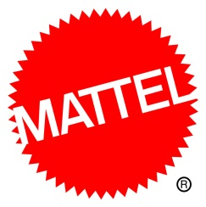

Advance Concepts
Aristotle™
SRP: $299 | + years | Available: Summer 2017
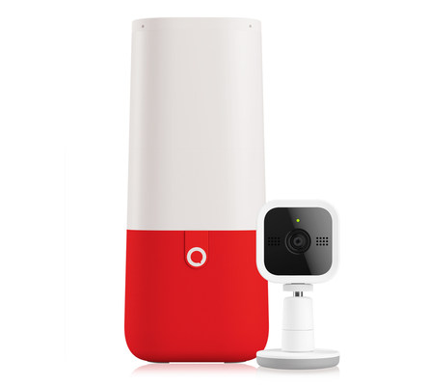
- Aristotle™ is a first-of-its kind connected kids room platform designed to aid parents and use the most advanced AI-driven technology to make it easier for them to protect, develop, and nurture the most important asset in their home—their children.
- Designed to comfort, entertain, teach, and assist during each development state—it evolves with a child as their needs change from infancy to adolescence.
- Tthe platform's Artificial Intelligence will utilize three distinct AI engines, including Microsoft Cognitive Services and the Silk Intelligence Platform. These multi-levels of AI enable Aristotle to learn patterns and autonomously act upon user habits to aid in child development and learning. Aristotle's AI will also have a unique personality that will appeal to parents and kids and will be presented as the great descendent of Aristotle himself.

Barbie®
Barbie On-The-Go
SRP: $3.99 - $29.99| Available: 2017
- Barbie is ready to move in the new On-The-Go line which features a smaller scale and unique motorized concept for more storytelling adventures – all pieces in the line are compatible.
- Articulated joints allow doll to sit in vehicle or on pony and ride together on any flat surface with a press of a button.
- Doll diversity and vehicle variety with car, scooter or horse are incorporated throughout line.
- Playsets available and includes track pieces, mini dolls and motorized ponies or vehicles

DC Super Hero Girls™
DC Super Hero Girls™ Supergirl™ X-Ray Vision + Locker (FCD38)
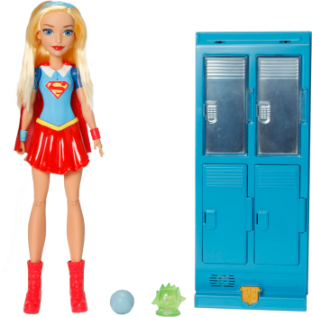
SRP: $39.99 | 6+ years | Available: Fall 2017
- Play out the x-ray vision of DC Super Hero Girls™ Supergirl™ with a locker accessory that highlights her amazing super power -when Supergirl™ action doll comes near, an easy child-activated mechanism lets her peek inside without opening the doors. Inspired by key DC Super Hero Girls™ entertainment to be released in Fall 2017, the set also includes two small accessories to place inside the lockers for Supergirl™ action doll to find.
- Four locker doors each open and close for access to storage space; when the mechanism is activated, the two upper doors light up to reveal the secrets inside.

DC Super Hero Girls™ Headquarter on Wheels (DVG94)
SRP: $34.99 | 6+ years | Available: Fall 2017
- The DC Super Hero Girls™ Batgirl™ action figure and her transforming headquarters vehicle hold multiple surprises!
- Open the side of the colorful van upward to reveal a mission headquarters with a cockpit seat that swivels and two chairs for Super Hero friends to join the mission (other action figures sold separately).
- The roof becomes a second level with a wardrobe for Batgirl™ action figure, complete with a second outfit. And to capture even more delight, the back of the vehicle pulls down to reveal a secret net launcher -- load with the net and push the button to launch the projectile and capture your villain.

Hot Wheels®
Hot Wheels® Track Builder Construction Crash Kit (DWW96)
SRP: $24.99 | 5+ years | Available: Spring 2017
- Combine Hot Wheels Track Builder and bricks for epic Hot Wheels action.
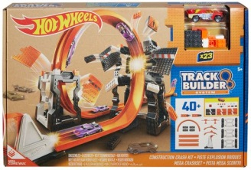
- There are 4+ unique builds with 4+ different pay offs with the Track Builder Blast It Kit.
- Take the checkered flag or send brick builds flying, launching cars and causing total destruction.
- Launch your cars on tracks and configure sets with brick components to foster creativity and experimentation.
- Re-configure and customize with bricks and Track Pivot Points for nearly endless configurations and crashing action. Blast through two crash panels before you hit the Blast Block and trigger the winning flag with the Blast Race Tower hero build.
- Hit the blast block to send the bricks flying with the Loop Crash. With the Gauntlet Crash build you hit the blast block to launch a second car.
- The Tower Takedown Crash has a ramp on the outside of the tower to launch mid-air to try to make it over the last Trick Brick and down the tunnel to the Blast Block. Hit the Blast Block for ultimate destruction when the tower goes down.
- Many of the items in this kit have more than one use, so kids can keep their imaginations—and their tracks—growing with a series of nearly endless configurations. Includes blocks in the box and 1 brick-compatible die-cast car.

Fast & Furious™
Fast & Furious Dom’s Turn & Burn Dodge Charger (FCG73)
SRP: $59.99 | 8+ years | Available: Fall 2017
- Fast & Furious is the action-packed global film franchise built on speed, pulse-pounding stunts and supercharged cars. Inspired by the hero vehicle in the Fast 8 movie and ready for battle, is a 16”, hero-scale replica of Dom’s Ice Charger.
- The vehicle has full-function RC capabilities that let you direct the car in multiple directions and fire “missiles.”

Justice League™
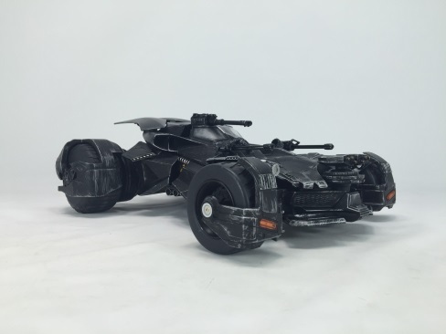
Justice League™ Elite-Tek Batmobile
SRP: $ 249.99 | Adult | Available: Fall 2017
• This highly articulated RC is inspired by the iconic Batmobile in the new Warner Bros. Pictures’ film, Justice League.
- The iconic vehicle comes to life in epic scale complete with RC functionality, premium deco and real world features.
• Through an app-enabled tablet or smartphone, users can assume the role as the Dark Knight and take complete control of the vehicle all from the palm of their hand!
• Remote-controlled Batmobile features smoke release from exhaust pipe, moving missiles on hood of car, roaring engine sounds, and four armored up wheels.
• Includes camera in the cockpit so you can drive from Batman’s POV via an app-controlled device.
• Special “jump mode” feature elevates the Batmobile with hydraulic-like movement
• Batman figure included has full body movement – foot presses gas pedal, arm shifts gear, and head turns

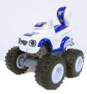
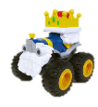
Fisher-Price®
Fisher-Price® Think & Learn Smart Cycle® (DRP30)
SRP: $149.99 | 3-6Y | Available Fall 2017
- The Smart Cycle® creates a physical play experience on tablet or TV, putting kids in control of racing and learning games full of kindergarten-readiness curriculum
- Adjustable tablet holder for various-sized tablets
- Multi-position handlebars with input controls, LEDs & joystick
- Adjustable seat makes play comfortable for kids of different sizes
- Bluetooth technology allows for play on tablet or TV for an even more immersive experience

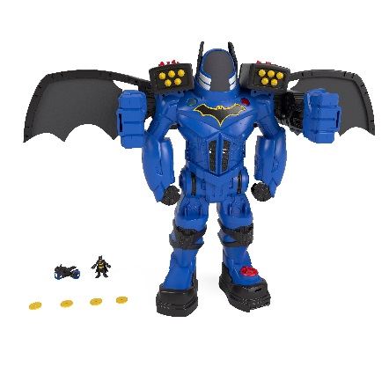
Imaginext® DC Super Friends™ Batbot Xtreme (FGF37)
SRP: $99.99 | 3-8Y | Available Fall 2017
- The ultimate Batman toy (over 2 feet tall) has everything from wings and punching fists to projectile launchers and a motorcycle!
- 3 Power pads:
  - Turn power pad on right shoulder to activate wings & punching fists
  - Turn left shoulder power pad to reveal Batman’s headquarters
  - Turn power pad on left leg for motorcycle
- Push down on buttons to fire 3 projectiles on each shoulder
- Squeeze triggers for SUPER PUNCHING ACTION!

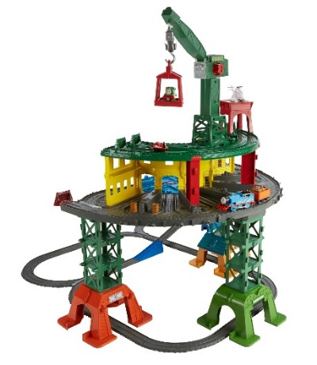
Thomas & Friends™
Thomas & Friends™ Super Station (FGR22)
SRP: $99.99 | 3Y+ | Available Fall 2017
- Includes 10 Iconic Sodor locations, like Tidmouth Sheds, Brendam Docks, Knapford Station, Search & Rescue Center, and more!
- Cranky, Harold and Owen are ready to roll on the all-new, special track
- Designed to work with ANY Thomas & Friends engines
- Three engines included in 3 unique scales
- Tons of storage all over the set, with room for over 100 engines!

Fisher-Price® Nickelodeon
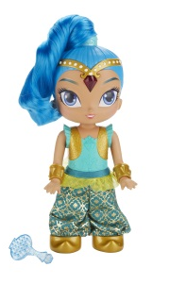
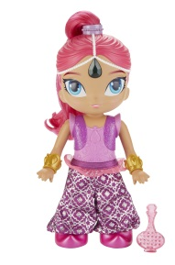
Fisher-Price® Shimmer and Shine™ Genie Dancing Genie Doll Assortment (DYV78)
SRP: $29.99 | 3+ years | Available: Fall 2017
- It's time to dance, groove, and learn some magical moves with Genie Dance Shimmer and Shine.
- Kids can slide Shimmer and Shine side to side to see them move to the music. They can also change the song's tempo by moving them fast or slow.
- These dolls will even teach kids the magic moves to great dances, like the "Shimmer Shuffle" and "Magic Carpet Slide.” As Shimmer and Shine move, the jewel in their headpieces will light up and sparkle to the music.

Mega
Mega Bloks® Elephant Parade (FFY13)
SRP: $29.99 | 1+ year | Available: Fall 2017
- Build out adventure from trunk to tail with a friendly elephant and his parade of animal friends.
- Pull the elephant along as the colorful blocks spin inside the tumbler storage bin.
- Then, open the tumbler, remove the blocks included and learn color association by using the building plate included to build a red monkey, yellow giraffe, purple hippo and green toucan.
- Once built, place your animal friends on the rolling wheelbases and connect them to the Elephant to create an animal parade.

Mega Construx™ Lea's 2-in-1 Rainforest Sanctuary (FDY98)
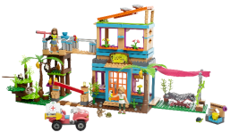
SRP: $69.99 | 8+ years | Available: Fall 2017
- You have two unique building choices with this deluxe 2-in-1 construction set. Choose to build Lea’s Rainforest Sanctuary, or her Animal Rescue.
- There are over 9 pets to take care of at the Sanctuary, which includes a haven where all the animals can rest. Lea can check on all the animals at the pet vet, and Camilla can greet new patients at the entrance.
- If there is an animal friend in need, rebuild the Sanctuary into the Animal Rescue, which includes a watchtower with a telescope. Lea can hop onto her ATV and take care of her animal friends at the mobile pet care tent, which includes a buildable pond.

Halo® Mega Construx® CTF Arctic Warthog (FDY52)
SRP: $29.99 | Collector | Available: Fall 2017
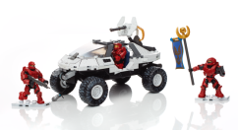
- Rip through the icy expanse and capture the flag. It’s Red’s turn to capture the flag when you roar across frozen terrain with three Spartans and a gun-toting Arctic Warthog.
- Build this classic all-terrain vehicle, with its authentic arctic camo finish, treaded rubber wheels, and rear-mounted turret. Then roll out with your Spartans and claim the blue flag for your own.
- Three highly detailed, super-poseable Spartan micro action figures in Red Team armor.

