FOR IMMEDIATE RELEASE

From Gravity Defying STEM Toys to 3D Puzzles and Expanding Fish – Ravensburger Puts Modern Twists on Timeless Classics “Upping” the Fun Quotient
Ravensburger to Unveil More than 180 New Puzzles, Games & Toys in 2018 – Building on its 134-year Legacy of Play Enjoyed by Generations of Families

Newton, NH, February 17, 2018 – Toy Fair Booth #2107 – Ravensburger, German toy company loved the world over for its high-quality puzzles, toys and games, debuts over 180 products for 2018. The new line-up covers a range of interests and brings new innovation to re-invigorate classic fun enjoyed for generations. Modern twists are added to classic marble runs turned STEM building kits, matching games that will “reel you in” and catch the attention of preschoolers, and puzzles that have gone 3D and appeal to millennials and the need to unplug and recharge.

“For over 130 years Ravensburger has been making puzzles, toys and games that promote playful development for all ages and stages, whether you are in preschool, college, working or retired,” said Filip Francke, CEO of Ravensburger North America. “Our products support learning and discovering, we teach players to think ahead, to lose graciously, and to problem solve. Most of all, our products are designed to bring people together for quality time, whether quietly building a puzzle or enjoying a raucous family game night.”

A few highlights for 2018 include:

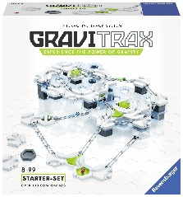
GraviTrax
Experience the power of gravity with GraviTrax. This interactive track system provides endless activities and challenges for any STEM enthusiast. Use the building blocks to design an action-packed course for your marbles! Experiment with gravity, magnetism, and kinetics to launch your marbles to the finish line. Bring the race to the next level with expansion packs and action accessories for more features and speed.
- For ages 8 and up the GraviTrax Starter Set is $59.99 (MSRP)
- Available exclusively at Barnes & Noble April 16, expanding to specialty retail in June

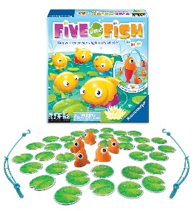
Five Little Fish
It’s a game of memory featuring five fish with different color retracting tails. In this matching game with a twist, it’s up to you to remember the positioning of the hidden fishtails! Look under the lily pad to see which fish to catch, then use the fishing rod to hook the color match! But, pay close attention – their positions will switch. So…can you remember which one’s which?
- For ages 4 and up with a $19.99 MSRP
- Available Summer 2018

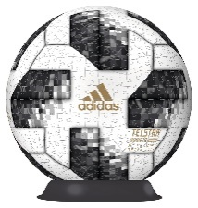
Adidas FIFA World Cup 2018 Ball
Test your puzzle skills with this 540-piece 3D World Cup Puzzle Ball – modeled after the official match ball that will be used in the 2018 FIFA World Cup held in Russia. 9-inches in diameter, this puzzle makes a beautiful display once put together. It's so realistic people will be tempted to pick it up and kick it around!
- For ages 7 and up with a $49.99 MSRP
- Available April 30

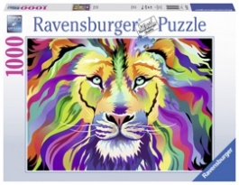
Puzzle-Mania – 143 New Puzzles for Children and Adults
Ravensburger has been making handcrafted puzzles since 1883, and today, is considered the world’s leading puzzle maker. This year alone, Ravensburger will unveil 143 puzzles that appeal to children and adults. As popular as ever – Ravensburger will unveil 4 new puzzle themes (“Wanderlust,” “Food Porn,” “Girls Night In” and “Color Pallet”) in 2018.

About Ravensburger AG
Founded in Ravensburg, Germany in 1883, Ravensburger AG is a leading producer of toys loved the world over for its commitment to detail and quality. In the U.S., the company is known for its extensive line of puzzles for children and adults, award-winning board games, such as bestseller Labyrinth, and its engaging science and arts and crafts kits. To learn more visit ravensburger.com facebook.com/Ravensburger/ @RavensburgerPC

About Ravensburger North America
Ravensburger North America (RNA), a division of Ravensburger AG, is a portfolio of award-winning brands with a shared vision to promote playful development at every stage and every age. The RNA family of brands, including Ravensburger, BRIO, Wonder Forge and ThinkFun, offers an expansive line of thoughtfully designed puzzles, games, toys and activities that focus on quality, craftsmanship and encourage timeless entertainment pursuits or shared moments of fun for the entire family.

###
Editorial Contact:
Lisa Krueger, Zebra Partners for Ravensburger
lisak@zebrapartners.net / (201) 892-3381

Press Assets:
https://www.zebrapartners.net/ravensburgertoyfair18/

