For Immediate Release
Media Contacts:
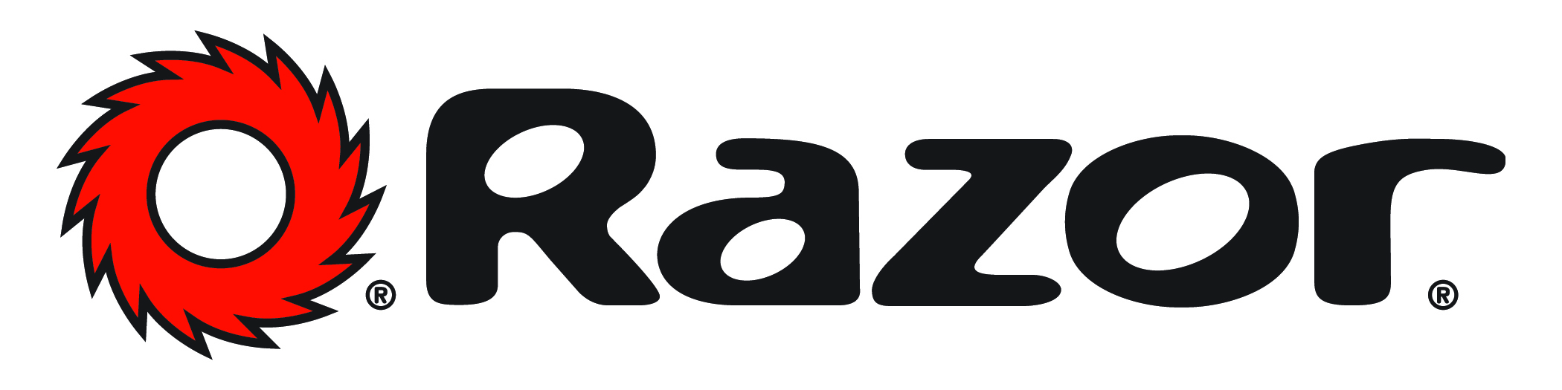
Lisa McKendall
lisa@mckendall.com
(310) 641-1556

Meggan Kring
Meggan.kring@wal-mart.com
(479) 204-9168

Razor® and Walmart, in conjunction with Marvel, Announce Complete Line of Ride-ons Featuring Classic Marvel Spider-Man Look

Cerritos, California – (February 20,2017) -- Razor USA LLC, innovators of outdoor fun and home of the iconic Razor kick scooter, announces their first manufacturing licensing program. In an agreement between Walmart and Marvel Licensing, Razor has been selected to be the manufacturer of Spider-man Razor products exclusively for Walmart. The line of ride-ons will begin to appear exclusively at Walmart stores in July 2017 to coincide with the premiere of the new movie Spider-Man: Homecoming. Each product in this innovative product line will feature the accuracy and authenticity that you would expect from Spider-Man and Razor.

“These are some of the coolest products that Razor has ever created and we know they are going to appeal to kids and collectors of all ages,” said Erin Bitar, Vice President of Global Marketing, Razor USA, “Marvel and Walmart have been amazing to work with to create these Spider-Man themed rides.”

Razor and Walmart’s new line of Spider-Man products include:
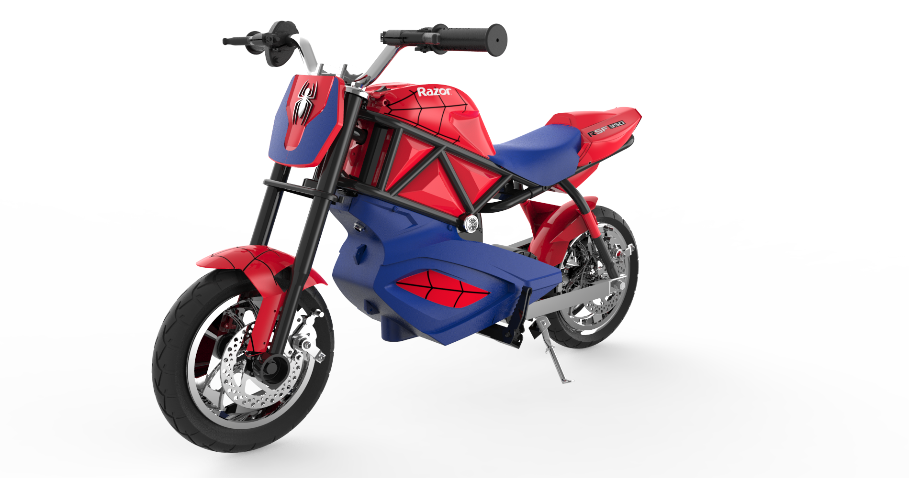
Razor® RSF350
Reflecting design inspired by the streetfighter style, the original Razor RSF650 now comes in a smaller size, RSF350. And now, the Spider-Man RSF350 has the look and feel of the classic character! Kids ages 13 and up can ride on custom 10” 3-spoke mag wheels and street tires and up to 14 mph - talk about unleashing 24 volts of super power! The two 12V rechargeable batteries allow up to 30 minutes of continuous use. Spider-Man design highlights include a spider emblem front flaring and chrome spidy details.

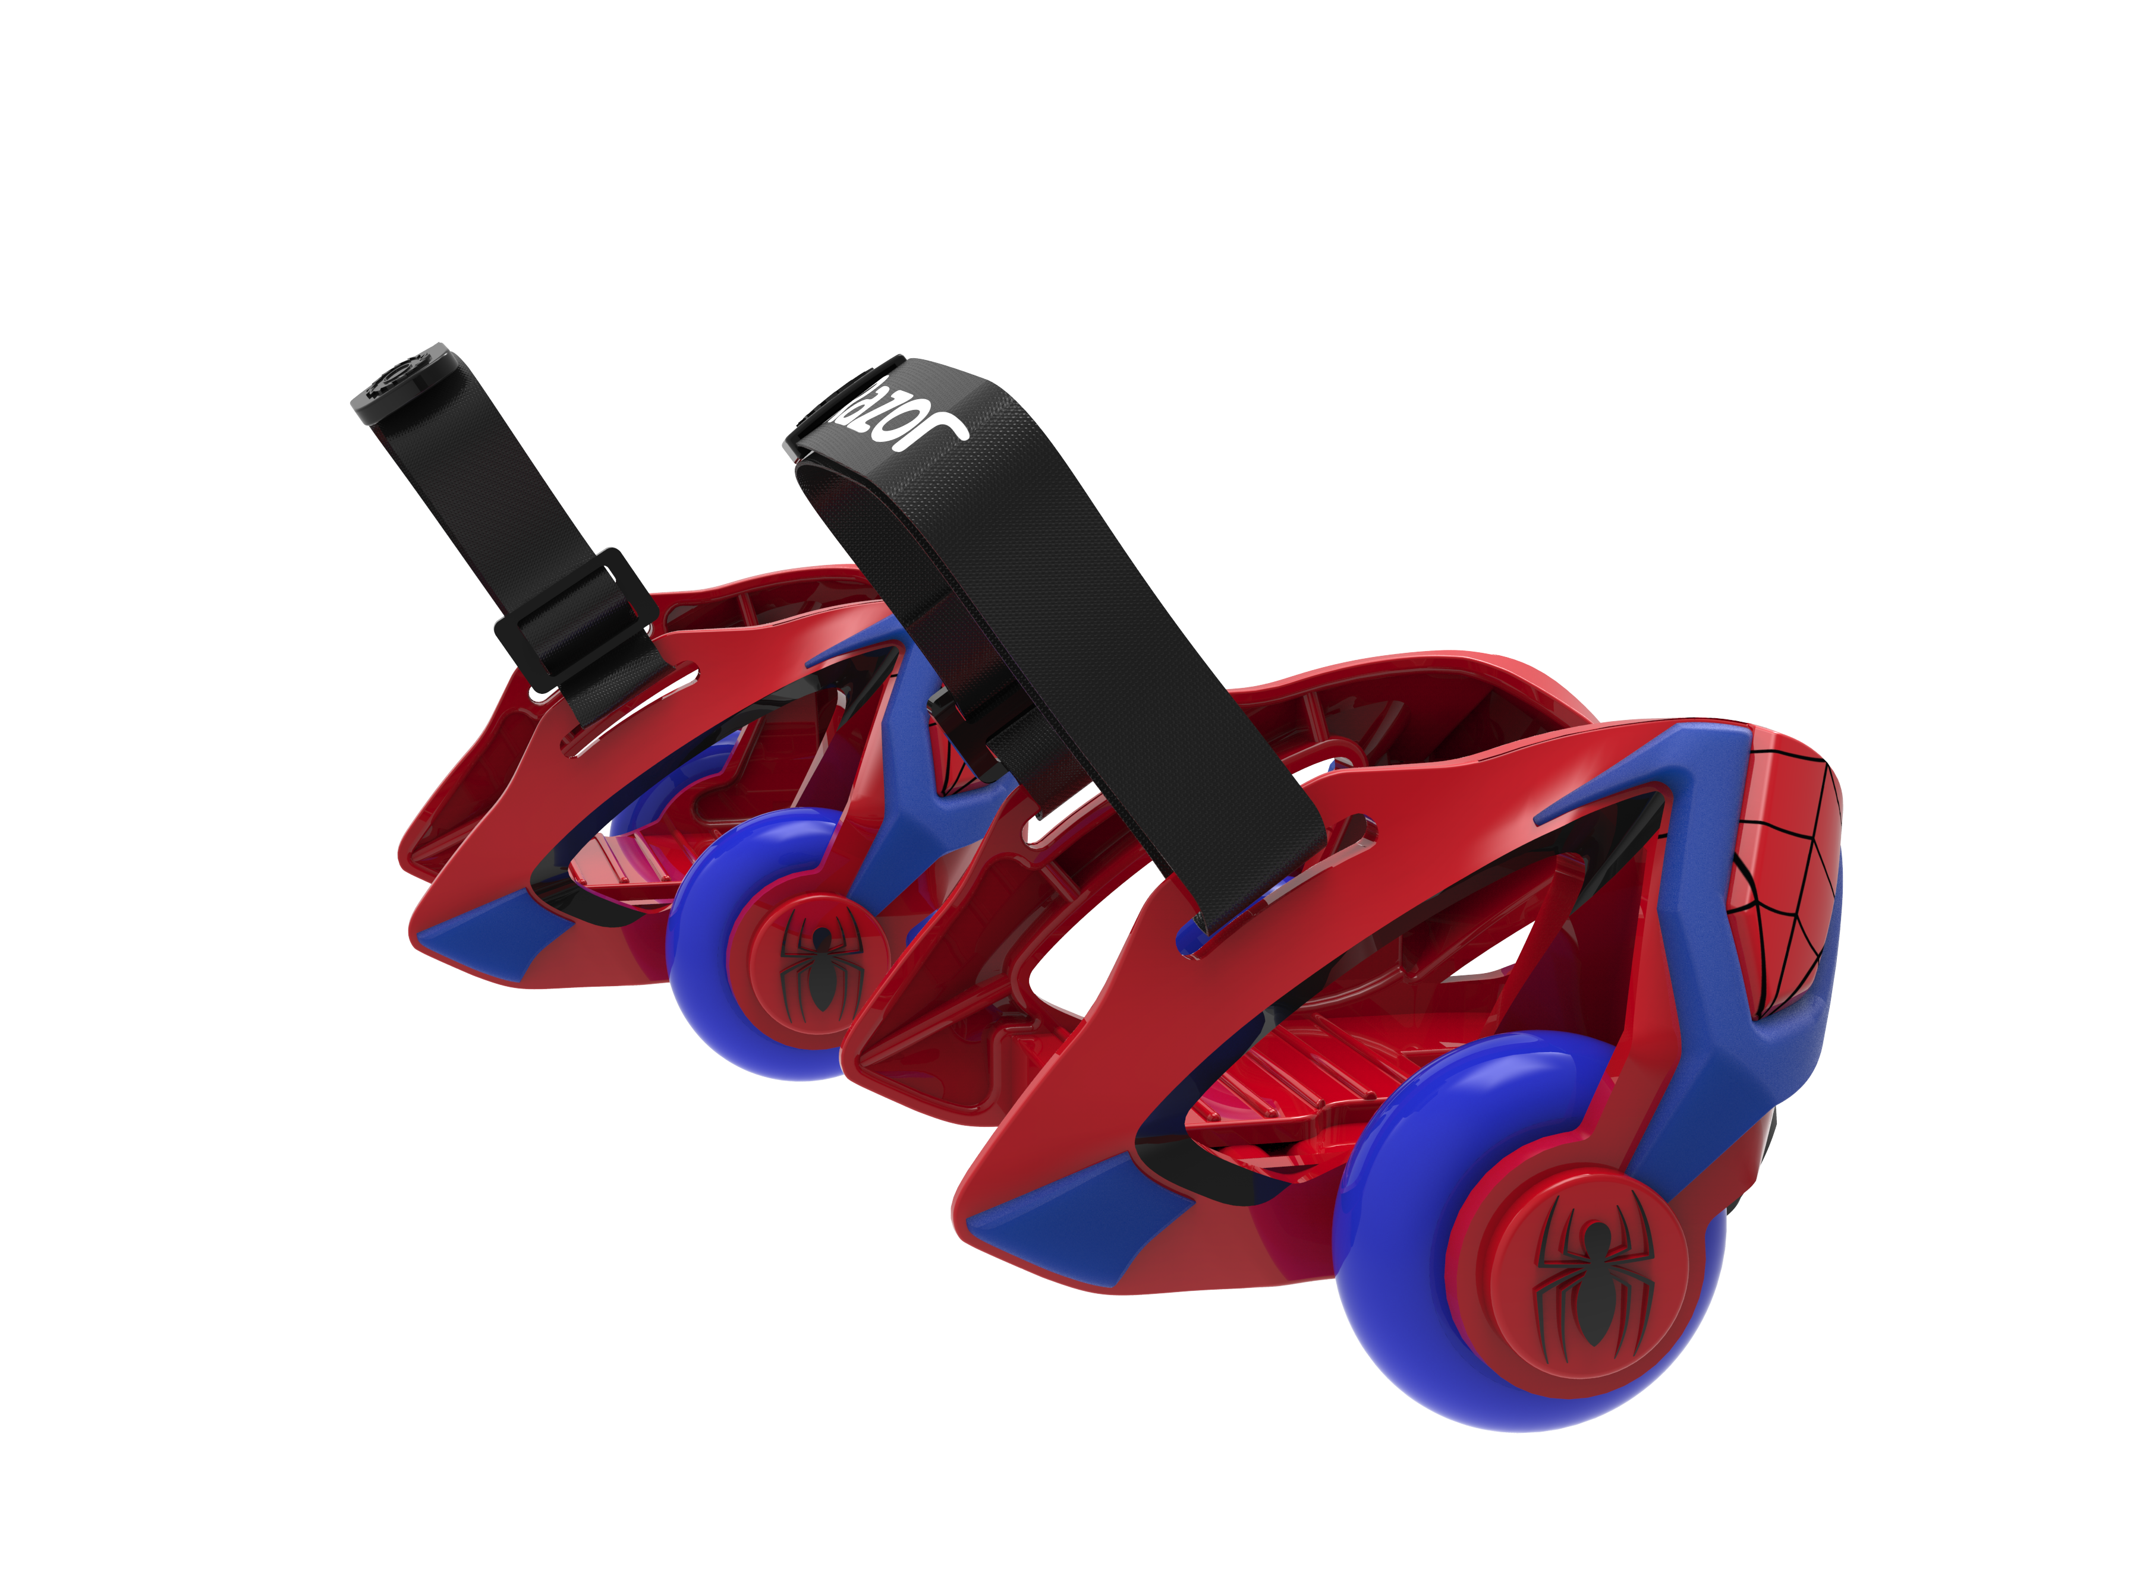
Razor® Jetts
The new Spider-Man Razor Jetts Heel Wheels will allow kids to skate and spark like a real super hero! Just step up, strap down and take off with these easily adjustable, always awesome heel wheels to transform your ordinary sneakers into the hottest way to roll.

Razor® RipStik Ripster
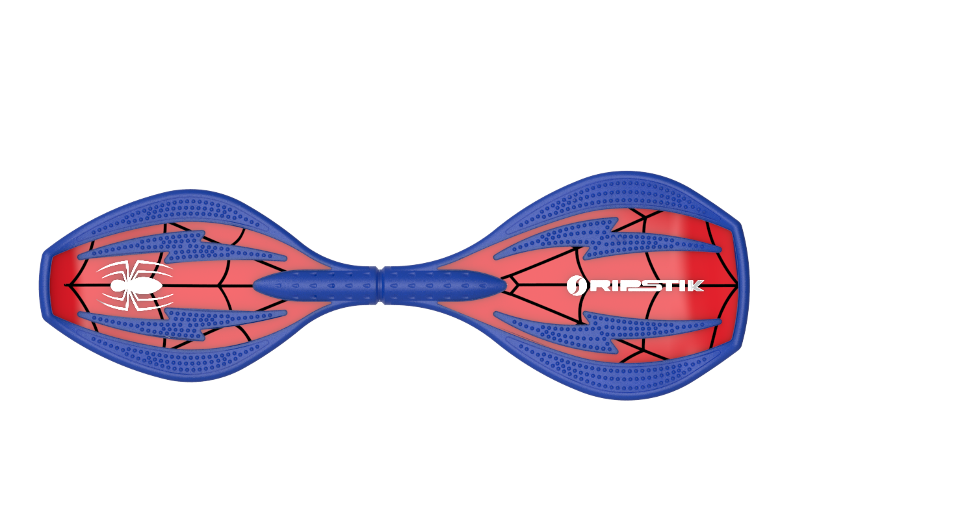
The Spider-Man RipStik Ripster is perfect for kids with a small stance but who want a big ride. The compact Ripster is a smaller version of the RipStik Classic, with a shorter wheel base ideal for riders with a narrower stance or for those who want to do more tricks. Spider-Man design highlights include a chrome spider emblem and web details for an authentic look.
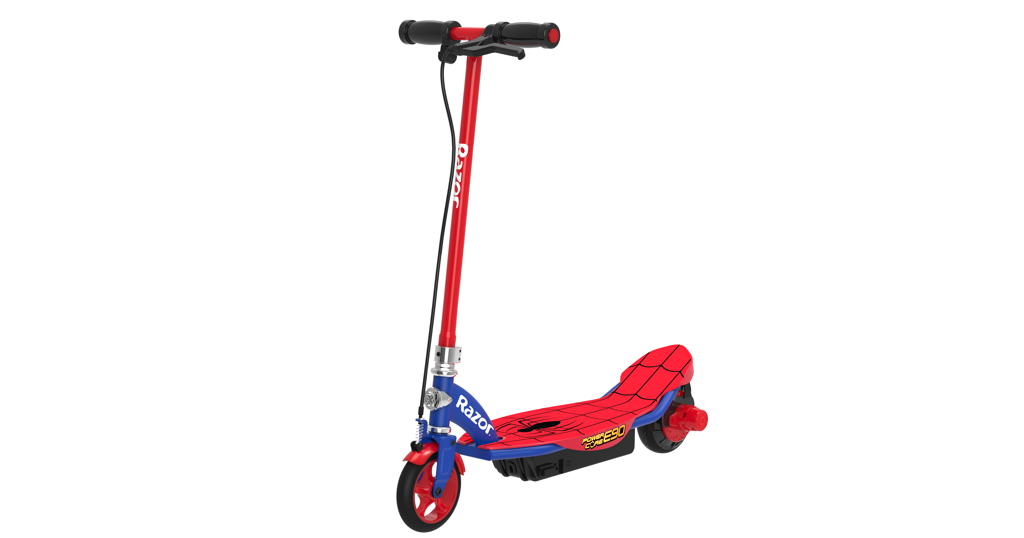
Razor® PowerCore E90
Razor is providing super hero power with the Spider-Man Power Core E90. This electric scooter has 80 minutes of continuous ride time and fifty-percent more muscle power. Its innovative hub motor delivers a more efficient, maintenance free ride, while the steel frame, lighter weight and increased torque take performance to the next level. Spider-Man design highlights include a spider web grip tape and chrome badging.

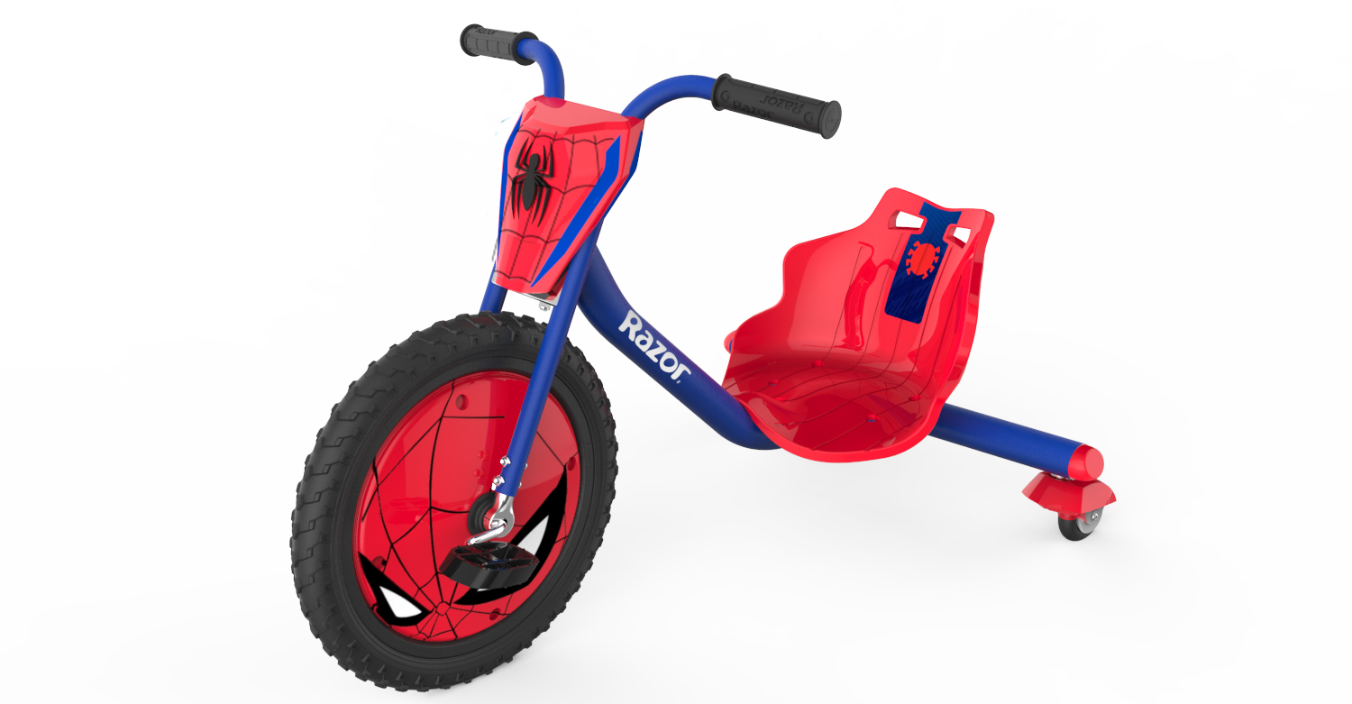
Razor® RipRider 360
This classic 70’s three-wheel trike is perfect for budding super heroes with its spinning and drifting on dual inclined caster wheels and classic cool custom Spider-Man theming! Talk about a wheel cover design with attitude.

About Razor USA LLC
The Razor brand embodies the spirit of fun and freedom. It defies boundaries and sometimes even gravity. The company was founded in 2000 with the introduction of its now legendary kick scooter, which quickly became an essential ride for anyone on the go. Today, Razor products are available worldwide, with a full range of wheeled goods to inspire and excite riders everywhere.
From day one, Razor has focused on providing the very best riding experience. The company combines cutting-edge technology, high-quality materials and strict safety standards to deliver a product that is designed to suit riders’ evolving lifestyle. Cool products and great value have distinguished Razor as a trusted global brand and industry leader. For more information, please visit www.razor.com

About Marvel Entertainment
Marvel Entertainment, LLC, a wholly-owned subsidiary of The Walt Disney Company, is one of the world's most prominent character-based entertainment companies, built on a proven library of more than 8,000 characters featured in a variety of media over seventy-five years. Marvel utilizes its character franchises in entertainment, licensing and publishing. For more information visit marvel.com.

About Walmart
Wal-Mart Stores, Inc. (NYSE: WMT) helps people around the world save money and live better - anytime and anywhere - in retail stores, online, and through their mobile devices. Each week, nearly 260 million customers and members visit our 11,593 stores under 63 banners in 28 countries and e-commerce websites in 11 countries. With fiscal year 2016 revenue of $482.1 billion, Walmart employs approximately 2.4 million associates worldwide. Walmart continues to be a leader in sustainability, corporate philanthropy and employment opportunity. Additional information about Walmart can be found by visiting http://corporate.walmart.com on Facebook at http://facebook.com/walmart and on Twitter at http://twitter.com/walmart.
# # #

© 2017 MARVEL

