Media Contact: Lisa McKendall
McKendall Communications
310-641-1556
lisa@mckendall.com
RAZOR SCOOTERS
FACT SHEET

What: Razor has always been the leader in youth lifestyle recreational products kick scooters and electric scooters and once again they are leading the way in innovation and fun within the kick scooter and electric scooters category. New for this year, Razor is introducing two new electric scooters and three new kick scooters. Razor continues to provide something for everyone!
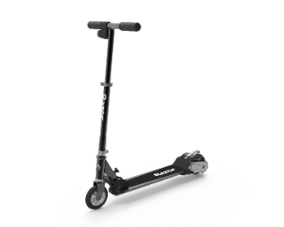
Power A is the 1st lithium-ion powered electric scooter from Razor. It brings together the combination of the Razor original A model with a high tech lithium-ion powered drivetrain delivering the lightest weight electric scooter in the Razor line. Using the kick start, high-torque motor, riders can go up to 10 mph and up to 45 minutes of continuous use. Power A is for riders ages 8 and up weighing less than 143 lbs.

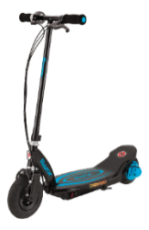
Power Core E100 sets itself apart from other electric scooters with its innovative in-wheel hub motor for more high-torque action! With a kick start and a twist of the throttle, riders can cruise up to 11 mph and, the in-hub Power Core technology allows riders up to 60 minutes of continuous use. Power Core E100 is for riders ages 8 and up and weighing less than 120 lbs.

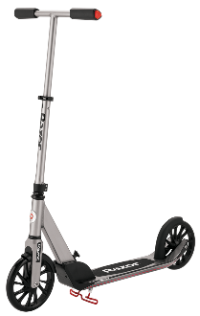
Razor has once again improved upon the classic Razor scooter. The A5 Prime premium kick scooter is a sleek, high-style, sophisticated scooter fusing modern design and craftsmanship unique to the scooter market. The A5 Prime design includes a taller easy-adjust handlebar, wider deck and larger wheels to accommodate taller riders and features Razor’s latest patent pending anti-rattle folding system. The combined spoked urethane wheel design and larger wheel build combine to make the A5 Prime the most sophisticated and modern scooter on the market. The A5 Prime is built to be the next must-own scooter and is for riders ages 8 and up weighing less than 220 lbs.

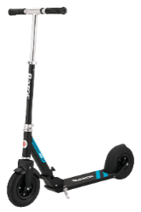
The A5 Air scooter will transform your commute – its uniquely smooth and comfortable operation and easy-fold design make it ideal for both long and short commutes. Whether you’re riding to work or running errands, the A5 Air’s super-strong construction, shock-absorbing pneumatic commuter tires, patent pending anti-rattle folding system and soft grips, make this perfect for daily commuters or those wanting to ride long distances. The A5 Air is for riders ages 8 and up weighing less than 220 lbs.

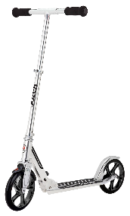
The A5 DLX joins a kick scooter line already well-known for its smooth ride, with new proprietary design features including a patent pending anti-rattle folding system and extra-large urethane wheels that create a comfortable ride like no other. Quick and easy to fold and ready to go, the A5 DLX has a super-strong aluminum t-tube and large deck to comfortably support riders up to 220 lbs. The A5 DLX is for riders ages 8 and up weighing less than 220 lbs.

Where: Power A will sell for $199.99 at mass retail outlets.
Power Core E100 sells for $159.99 at mass retail outlets.
A5 Prime sells for $179.99 at mass retail outlets.
A5 Air sells for $129.99 at mass retail outlets.
A5 DLX sells for $109.99 at mass retail outlets.

When: Power A will be available in fall of 2017.
Power Core E100 is available now.
A5 Prime is available now.
A5 Air is available now.
A5 DLX is available now.

Who: Razor has always been a leader in youth lifestyle recreational products, from the launch of the original A model scooter in 2000 to the introduction of new products in 2017. Continued support of the growing pro scooter movement has also positioned Razor as a strong leader in new categories of ride-ons and action sports – categories that they continue to help define. For more information about Razor, visit Razor.com.

# # # #

