FOR IMMEDIATE RELEASE
January 30, 2017

For further information, please contact:
George Karalias
Vice President of Marketing
george@schylling.com
Tel: 978-948-3270

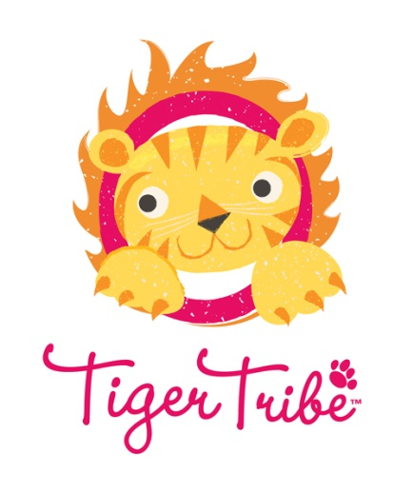
Schylling Brings Tiger Tribe Imaginative Activity Playsets and Toys to North America

North Andover, MA, January 30, 2017 – Schylling Inc. has announced that it will be the exclusive distributor for Tiger Tribe products for North America. Tiger Tribe is a world leader in creating compact and portable activity sets with quality content that encourages little ‘tigers’ to go on imaginative journeys.
“We are delighted to have Schylling as our official channel partner into North America. Our success comes from partnerships with talented and resourceful companies and people. The distribution and representation of our products should be on par with the high quality of our supplier and production partners,” said Anthony Green, Director and Co-Founder of Tiger Tribe. “Clearly, we’ve found that with Schylling. They complement us in every way, thanks to their extensive experience and reach within our target audience.”
Children are bursting with energy to create and explore. Tiger Tribe products are thoughtfully designed and packed full of creativity. Product lines include Oodle Doodles, Colouring Sets, How to Draw and Paper Doll Kits, Sticker World, Flash Cards, Magna Carry Playbooks, Magic Painting Worlds, Bath Stories, Paper Crowns, the Card Making Kit, and the Beat the Clock Stopwatch Set.
“Tiger Tribe is a perfect addition to our extensive catalog of products. The level of quality in their playsets and activity kits match our own products. They have talented artists and designers that really understand what it takes to capture the interest of a child,” said Paul Weingard, President of Schylling. “Tiger Tribe has really figured out the best way to entertain, educate and ensure kids never get bored.”
For more about Schylling’s Tiger Tribe product offering, go to www.schylling.com/tigertribe See the Tiger Tribe line of products at Schylling’s booth #411 at New York Toy Fair. To schedule a meeting with a Schylling representative, email to jaime@schylling.com Other opportunities to see Tiger Tribe products will be at the Schylling booths at Toy Fest West and the Los Angeles Toy Gift Show.

About Schylling Inc.
For over forty years, Schylling Inc. has specialized in timeless toys. We started out making delightful playthings from a bygone era. Over time we’ve built a distinctive collection of innovative gifts and traditional toys with nostalgic appeal for all ages. As an award-winning toy company located in North Andover, MA on the beautiful North Shore of Boston, Schylling works to create the future in toys by captivating new designs and intriguing refreshes and innovations of toys from the past. Schylling offers original and distributed lines of toys. Among these lines are the iconic tin toys that have been an important part of the history of the company. Schylling is the world leader in the manufacture of Jack-in-the-Box toys and tin Kaleidoscopes, among others. Toy lines include the Nanoblock, PaperNano and Terrablock family of products, the Steelworks line of construction toys, the original Lava Lamp series, Turbospoke, Crazy Foam, Fisher-Price Classics, the Zuru Bunch-o-Balloons, illooms LED balloons, the Lottie line of dolls, the Style Model line, the recently added Tiger Tribe arts and crafts playset line. Schylling’s long list of toy categories including Classics, Games, Retro Toys, Ride-Ons, Pretend Play, Just for Fun, Magic, Arts & Crafts, Great Outdoors, Tents, Die-Cast, Money Matters, Music, Sock Monkey, and BeBots tin wind-ups featuring Star Wars and Pixar characters as well as Curious George. Schylling is proud of its heritage and in offering high quality, safe and creative products that lead the toy industry. Visit the company website at www.Schylling.com or Facebook page at www.facebook.com/SchyllingToys

About Tiger Tribe
Tiger Tribe was started in 2007 by Anthony and Naomi Green, husband and wife team and parents to two tigers of their own. As busy parents, they carefully consider lifestyle in the design of the Tiger Tribe line of toys and gifts. The Tiger Tribe range is compact and portable, allowing kids to take and play every day – in cafés, travelling, at home or wherever they may be. Tiger Tribe is made up of a group of talented illustrators, graphic designers, and product innovators. Products are proudly designed and illustrated in Australia. Tiger Tribe is also proud to be the exclusive distributor of Kid O, Petit Collage, Quut, Boxsets and Casagami in Australia. Visit the company website at http://www.tigertribe.com.au/ or Facebook page at https://www.facebook.com/tigertribeau





