FOR IMMEDIATE RELEASE
February 9, 2017

For further information, please contact:
George Karalias
Vice President of Marketing
george@schylling.com
Tel: 978-948-3270

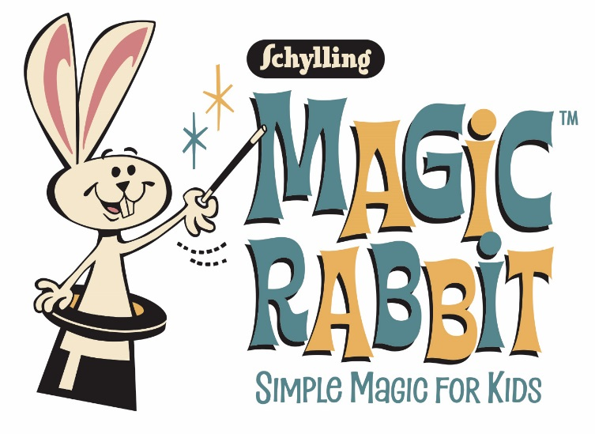
Abracadabra, presto change-o, Schylling presents “Simple Magic for Kids”…

Schylling Pulls a Magic Rabbit™ Out Of Its Hat

North Andover, MA, February 9, 2017 – Schylling Inc. announced the launch of a completely new line of magic kits, under the Magic Rabbit ™ brand. The line includes three 15 Trick Sets, a 75 Trick Jumbo Set, a 150 Trick Deluxe Magic Hat Set and, the Mysterious Levitating Wand.
Each set includes beloved, classic magic tricks that have amazed audiences for generations. A perfect starting point for the budding magician, the kits include various props and instructions to create magic shows that will dazzle friends and family.
The Mysterious Levitating Wand is the perfect stage prop for every magician. The wand enhances illusions when magicians use it to point, tap and wave over a trick. But this wand has hidden features to create a magical motion that will give an audience a surprise they won’t soon forget.
The 15 Trick Sets include traditional tricks and props like the Coin Paddle, Perplexing Beads, Puzzling Boomerangs, Crystal Coin Case, the Money Tube, and more.
The Jumbo Set of 75 Tricks includes wonderful classic illusions like the Mystical Cups and Pom-poms, the Magic Cup and Ball, Magic Coin Tricks, and many others.
The Deluxe 150 Magic Hat Set includes a wearable Magic Hat and is packed full of many magician’s favorites, like Mystic Cards, Magic Dice, Magic Rope, Levitating Wand, Magic Cloth and much, much more.
All sets include detailed instruction booklets and are beautifully packaged in nostalgic designs that will take you back to the golden days of magic.
“Our Magic Rabbit kits offer children the opportunity to create illusions and perform magic shows quickly and easily,” said Paul Weingard, President of Schylling. “Nearly every child is fascinated by magic and loves a chance to give a stage show for parents or to impress friends with slight of hand. I know all of us here at Schylling were, in fact, those kids!”
For more about the new Magic Rabbit product line go to www.schylling.com/MagicRabbit. See all the new Schylling toys at Schylling’s booth #411 at New York Toy Fair. To schedule a meeting with a Schylling representative, email to jaime@schylling.com Other opportunities to see all Schylling products will be at the Schylling booths at Toy Fest West and the Los Angeles Toy Gift Show.

About Schylling Inc.
For over forty years, Schylling Inc. has specialized in timeless toys. We started out making delightful playthings from a bygone era. Over time we’ve built a distinctive collection of innovative gifts and traditional toys with nostalgic appeal for all ages. As an award-winning toy company located in North Andover, MA on the beautiful North Shore of Boston, Schylling works to create the future in toys by captivating new designs and intriguing refreshes and innovations of toys from the past. Schylling offers original and distributed lines of toys. Among these lines are the iconic tin toys that have been an important part of the history of the company. Schylling is the world leader in the manufacture of Jack-in-the-Box toys and tin Kaleidoscopes, among others. Toy lines include the Nanoblock, PaperNano and Terrablock family of products, the Steelworks line of construction toys, the original Lava Lamp series, Turbospoke, Crazy Foam, Fisher-Price Classics, the Zuru Bunch-o-Balloons, illooms LED balloons, the Lottie line of dolls, the Style Model line, the recently added Tiger Tribe arts and crafts playset line. Schylling’s long list of toy categories including Classics, Games, Retro Toys, Ride-Ons, Pretend Play, Just for Fun, Magic, Arts & Crafts, Great Outdoors, Tents, Die-Cast, Money Matters, Music, Sock Monkey, and BeBots tin wind-ups featuring Star Wars and Pixar characters as well as Curious George. Schylling is proud of its heritage and in offering high quality, safe and creative products that lead the toy industry. Visit the company website at www.Schylling.com or Facebook page at www.facebook.com/SchyllingToys

###

