FOR IMMEDIATE RELEASE
February 14, 2017

For further information, please contact:
George Karalias
Vice President of Marketing
george@schylling.com
Tel: 978-948-3270

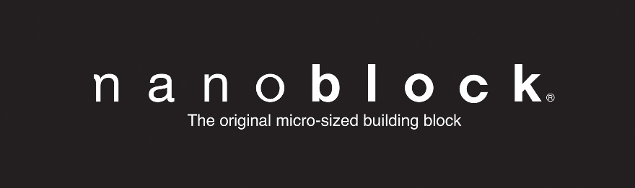

Schylling is having a ‘block party’ with new nanoblock introductions…

Schylling Introduces the Latest nanoblock™ and papernano™ Building Sets

North Andover, MA, February 14, 2017 –Schylling Inc. launches the latest from nanoblock - the original micro-sized building sets and papernano - micro-detailed, paper building sets.
nanoblock is an extremely small building block that is just half the size of a standard block. The smallest part is a mere 4x4mm! nanoblock has micro-sized precision in its building sets. The blocks have a double-ridged backing system for a perfect fit! nanoblock is a stimulating and entertaining hobby for adults, teens, as well as for children 8 and up. nanoblock’s smaller parts make it possible to create projects with more detail than with standard size blocks.
New introductions in the “Sights to See” series include the Taxi of London, the Minivan and the Kolner Dom. New to the “Mini Collection” series are the Synthesizer, the Pony, the Grizzly Bear, the Hamburger, the Birthday Cake, Sushi and Hot Dog. The “Advanced Hobby” series offers a new “Empire State Building.”
papernano has two new exciting sets. They are the Itsukushima Shrine Deluxe Edition and the Byodo-In Deluxe Edition.
“The nanoblock and papernano lines continue to grow with great building sets,” said Paul Weingard, President of Schylling. “The new challenges in building some of these sets, especially the two additions to the papernano products, will entertain construction hobby enthusiasts for hours. The intricacies and details of the models are unique and offer a high level of precision and craft. The care that has gone into the design is unmatched in the hobby world.”
The nanoblock and papernano sets can be found at http://www.schylling.com. See all the nanoblock and papernano sets at Schylling’s booth #411 at New York Toy Fair. To schedule a meeting with a Schylling representative, email to jaime@schylling.com Other opportunities to see all Schylling products will be at the Schylling booths at Toy Fest West and the Los Angeles Toy Gift Show.

About Schylling Inc.
For over forty years, Schylling Inc. has specialized in timeless toys. We started out making delightful playthings from a bygone era. Over time we’ve built a distinctive collection of innovative gifts and traditional toys with nostalgic appeal for all ages. As an award-winning toy company located in North Andover, MA on the beautiful North Shore of Boston, Schylling works to create the future in toys by captivating new designs and intriguing refreshes and innovations of toys from the past. Schylling offers original and distributed lines of toys. Among these lines are the iconic tin toys that have been an important part of the history of the company. Schylling is the world leader in the manufacture of Jack-in-the-Box toys and tin Kaleidoscopes, among others. Toy lines include the nanoblock, papernano and terablock family of products, the Steelworks line of construction toys, the original Lava Lamp series, Turbospoke, Crazy Foam, Fisher-Price Classics, the Zuru Bunch-o-Balloons, illooms LED balloons, the Lottie line of dolls, the Style Model line, the recently added Tiger Tribe arts and crafts playset line. Schylling’s long list of toy categories including Classics, Games, Retro Toys, Ride-Ons, Pretend Play, Just for Fun, Magic, Arts & Crafts, Great Outdoors, Tents, Die-Cast, Money Matters, Music, Sock Monkey, and BeBots tin wind-ups featuring Star Wars and Pixar characters as well as Curious George. Schylling is proud of its heritage and in offering high quality, safe and creative products that lead the toy industry. Visit the company website at www.Schylling.com or Facebook page at www.facebook.com/SchyllingToys

About nanoblock
nanoblock is the original micro-sized building block, developed by Kawada of Japan and distributed in the USA by Schylling Inc. For the construction set fan seeking a superior building experience, nanoblock offers a greater challenge, sophistication and detail than any other system. Create exquisite 3D works of art with amazing realism and authenticity. With bricks as small as 4mm x 4mm x 5mm and manufactured to the highest tolerances, you can build ornate and incredibly detailed sculptures that will fit in the palm of your hand. These unique bricks let you build precise models of astonishing design and quality. Each project comes with detailed, step by step instructions. Visit the company website at www.nanoblockus.com

###

