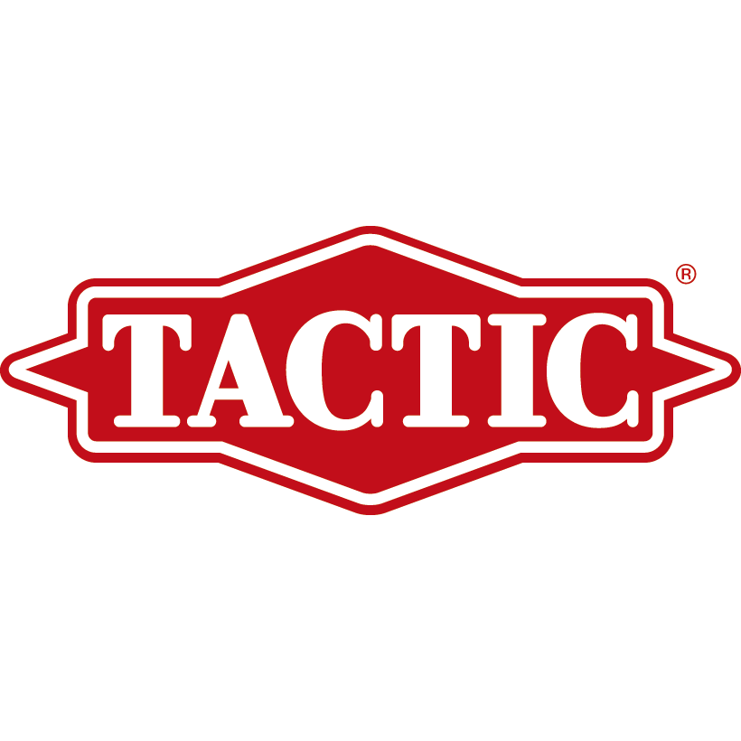

PRESS RELEASE

FOR IMMEDIATE RELEASE Media Contact: Greg Walsh, Walsh Public Relations 305 Knowlton Street, Bridgeport, CT 06608
T: (203) 292-6280; E-Mail: greg@walshpr.com

Discover Undersea Fun in Tactic's New Coral Reef Game
-Tactic Booth #6753 -

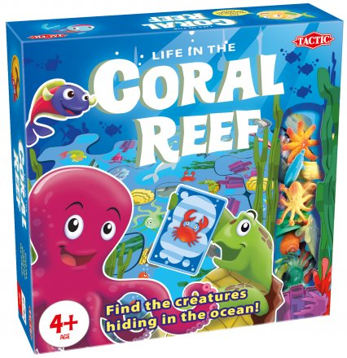
Mentor, OH - (February 2, 2018) – Young players can dive head first into a fun new game of undersea exploration when Tactic Games releases its new children's game, Life in the Coral Reef.

This this fun new game, the challenge is to find the creatures hiding in the ocean as the game expands with every turn. Life in the Coral Reef (MSRP $14.99, for 2-4 players ages 4 and up) is Tactic’s game of quick thinking that’ll trigger logic and memory skills as players identify some of the ocean’s most interesting creatures.

Jay Knox, President of Tactic Games, said, "Life In The Coral Reef is a game that combines the thrill of friendly competition with the enchantment of colorful coral reef creatures. With two levels of play and players having control over the expansion of the puzzle-like game board, the coral reef becomes a fun new challenge every time it's played."

To play Coral Reef, players first decide on which of the double-sided puzzle piece game board will be played. The pieces, each featuring multiple creatures and familiar undersea characteristics are randomly assembled. Each player takes two creature cards from the pile of 50 and then try to match the creatures on the cards to the images on the game board. Whoever successfully wins the round is rewarded with an animal figurine. The first player to acquire five figurines wins.
About Tactic Games:
Tactic Group® is an international and fast growing developer and marketer of board games all over the world. For more than 50 years, the Finnish board game company has provided consumers with innovative, high-quality products that have been warmly received by the public, including award-winning Mölkky®, Alias and iKNOW®. Their mission is to produce entertaining games that offer moments of genuine delight and entertainment to family and friends the world over. To discover more about Tactic’s wide range of games, visit www.tactic.net/USA and get all of the most up-to-date, immediate information by interacting with the company on its social media channels: Facebook, Twitter, Pinterest, Instagram and YouTube.

For product sales information, contact:
Jay Knox, Tactic Games, T: 216-288-0087; Jay.Knox@tactic.net

