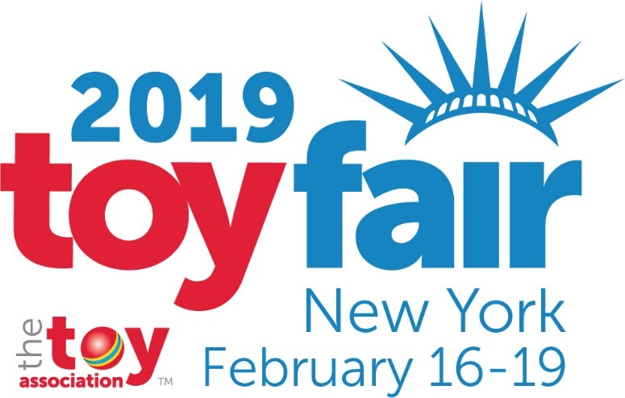 | Toy Fair 2019 Talking Points  Last update: February 13, 2019  Official Hashtag: #TFNY

General Info

EVENT: 116th North American International Toy Fair™
The largest toy, game, and youth product marketplace in the Western Hemisphere

OWNER: The Toy Association, Inc.
(www.toyassociation.org)

SHOW DATES: Saturday, February 16 9 a.m. – 6 p.m.
Sunday and Monday, February 17 and 18 9 a.m. – 6 p.m.
Tuesday, February 19 9 a.m. – 4 p.m.

WHERE: Jacob K. Javits Convention Center
655 W. 34th Street, New York, NY
11th Avenue between W. 34th and W. 40th Streets

PARTICIPATION: 1,038 total exhibitors from 30 countries
(Pre-registered as of
January 31, 2019) 190 first-time exhibitors
7,440 registered buyers representing more than 2,812 unique retail outlets
22 of the top 25 Toy Sellers* representing the $28 billion domestic U.S. toy industry *As of 2017
This year, Toy Fair is expected to attract upwards of 30,000 registrants (including more than 10,000 retailers, distributors, importers, wholesalers, and trade guests) from 100+ countries.

EXHIBIT SPACE: 447,000+ net square feet on-site at the Javits Convention Center

SHOWROOMS: Locations listed in the Exhibitor Locator Guide (available on-site)

Toy Fair Message Points

- NYC is a playground this week! At the Javits Convention Center and across the city, more than 1,000 toy companies are showcasing the products that will be under the tree this Christmas.
- As the largest toy show in the Western Hemisphere, Toy Fair is a massive celebration of play.
- This year’s marketplace is bigger than ever. The show is the equivalent to more than seven football fields filled with creative, innovative, and skill-building toys and games!
- Who comes to Toy Fair? The show is expected to attract 30,000+ attendees from over 100 countries. That includes toy inventors and designers, manufacturers, toy buyers from retailers of all sizes, wholesalers, importers, entertainment executives, and more. If someone is connected to the toy industry, they are probably in town this week!
- More than 1,000 toy companies from around the world are exhibiting at Toy Fair 2019 – nearly 200 exhibitors are here for the very first time!
- Toy Fair has a dedicated area for new exhibitors called the “Launch Pad.” It is a great place to see up-and-coming toy inventors as well as international companies looking to expand their product to the U.S. Located in Hall 1E of the Javits Center, Toy Fair first-timers represent 17 countries including Australia, Bulgaria, Canada, Chile, Denmark, India, Ireland, Italy, Japan, Russia, South Korea, Spain, and the United Kingdom.
- Toy Fair is important because play is important. Toys – which are the tools of play – promote the development of children’s cognitive, social, emotional, and fine and gross motor skills. Visit www.TheGeniusofPlay.org to learn more about how toys and play help build lifelong skills.
- Although Toy Fair is not open to the public – it is a trade event – families who want hands-on access to their favorite toys and brands are encouraged to visit one (or all!) of our three interactive consumer experiences taking place in 2019: Awesome Con Jr. at Awesome Con (April 26-28 in Washington, DC), Big Easy Con Jr. at Big Easy Con (May 31-June 1 in New Orleans, LA), and Rose City Jr. at Rose City Comic Con (September 13-15 in Portland, OR).
(RESPONSES TO INDUSTRY PERFORMANCE)
- U.S. toy and game sales declined by 2 percent in 2018 compared to 2017, according to The NPD Group. In a challenging retail environment, the results were better-than-expected.
- The U.S. toy market is estimated at $28 billion, according to NPD.
- In 2018, the following categories had sales increases: Action Figures & Accessories (+10 percent), Dolls (+7 percent), Youth Electronics (+3 percent), and Arts & Crafts (+3 percent). Categories that saw declines included: Games/Puzzles (-1 percent), Outdoor & Sports Toys (-4 percent), Building Sets (-5 percent), Infant/Toddler/Preschool Toys (-5 percent), All Other Toys (-6 percent), Vehicles (-10 percent), and Plush (-10 percent).
- In order of absolute dollar growth, Dolls had the strongest growth thanks in large part to L.O.L. Surprise!, Barbie, and Hatchimals. Action Figures followed, with sales from licensed products including Jurassic World, Marvel Universe, and Beyblade driving growth. Cool Maker, Cra-Z-Art, and Kinetic helped the gains in Arts and Crafts, while Fingerlings, Kidi, and L.O.L. Surprise! helped the Youth Electronics supercategory experience growth, according to NPD.
- From board games and dolls to outdoor toys and e-connected playthings, the toy industry is churning out an incredibly diverse array of products for kids to play with!
- A well-rounded day of play is important for families. There is room for both traditional toys and digital playthings to help balance the play experience.

Industry Sales Data
Based on data provided by The NPD Group and/or the U.S. Department of Commerce

- In the United States:
  - The average price of a toy is around $10.
  - The estimated three billion units sold across the nation each year generate approximately $28 billion in direct toy sales.
  - 2018 ended with a 2 percent decline in overall U.S. toy sales, according to The NPD Group. Growth categories included: Action Figures & Accessories (+10 percent), Dolls (+7 percent), Youth Electronics (+3 percent), and Arts & Crafts (+3 percent).
- Assorted L.O.L. Surprise products (MGA Entertainment) were named in eight of the top 10 selling traditional toy items in 2018, according to NPD. Other top licensed properties for the year based on total dollar sales included Barbie, Nerf, Marvel Universe, and Hot Wheels.

Industry Economic Impact Data*

- The toy industry’s total annual economic impact in the United States is calculated at $110.9 billion.
- From toy inventors to store clerks in every state from Alabama to Wyoming, the toy industry supports an estimated 691,263 jobs (FTE) generating more than $35.1 billion in wages for U.S. workers.
- The toy industry also generates $14.98 billion in tax revenue each year (combined state taxes of $6.3 billion; combined federal taxes of $8.6 billion).
- Up to 82 percent of retail sales dollars remain in the United States as a result of U.S. domestic operations (e.g., production plus wholesale and retail).
* Economic Impact of the Toy Industry in the United States (2017). All data cited as of May 2018.

General Statements on Toy Safety
- Safety is the toy industry’s number one priority.
- The toy industry works year-round with medical experts, consumer groups, government regulators, and others to ensure that our tough U.S. toy safety standards continue to keep children safe.
- All toys sold in the U.S., no matter where they are produced, must conform to stringent U.S. safety and environmental requirements.
- Families can visit www.PlaySafe.org to get updated information and tips on fun and safe play.
- Toys are consistently ranked among the safest of 15 consumer product categories commonly found in the home.
- Proper use and adult supervision can go a long way toward ensuring safe and fun play.

ONLINE RESOURCES

Official show releases, exhibitor releases: Online Press Room
Show information, photos, and videos: ToyFairNY.com
Toy Fair hashtag: #TFNY
Toy Fair social media: Facebook and Twitter
The Toy Association social media: Facebook and Twitter
The Toy Association: ToyAssociation.org
Additional Toy Association resources: thegeniusofplay.org / PlaySafe.org

