We at Warcradle Studios are incredibly excited to announce that we are developing an official board game based off of the “Bill and Ted’s Excellent Adventure” film franchise in partnership with Creative Licensing.

This new adventure is titled Bill & Ted’s Riff in Time. It will follow the iconic duo as they set off on another triumphant quest through time after the events of “Bill & Ted’s Bogus Journey.”
To ensure a bodacious time for players of all ages the game is based on a 'race against the clock' scenario, which immediately engages players and gets them working together towards a common goal - saving the universe! Bill S Preston Esq and Ted 'Theodore' Logan are coming to a tabletop near you soon.
Meeting old friends and a whole bunch of new ones, Bill, Ted, Elizabeth and Joanna must work together to put things right and ensure the future is most excellent!
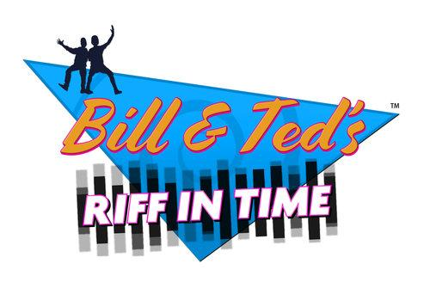
Whether you are a seasoned veteran board game player or a newcomer, Bill & Ted’s Riff in Time brings together a mix of awesomely detailed tabletop accessories plus engaging and intuitive rules to ensure a bodacious time for players of all ages. Players will take a nostalgic trip to 1990’s San Dimas and of course to time periods such as the Wild West, Napoleonic France, Ancient Greece and many more.
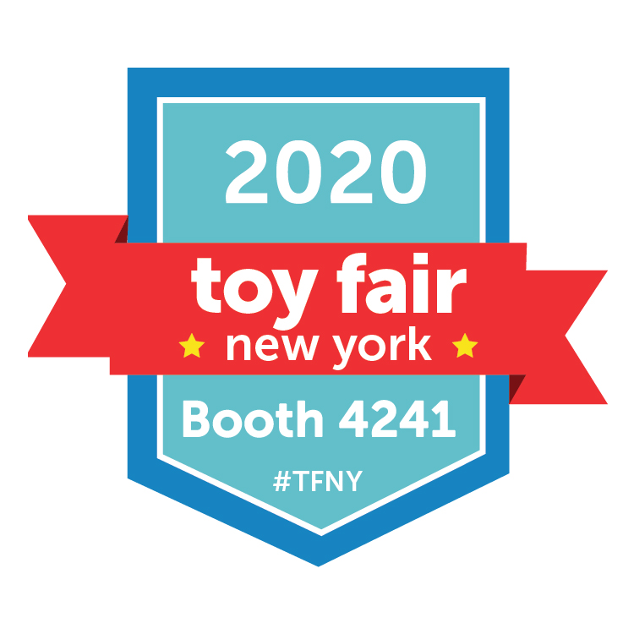
Join Warcradle Studios at the New York Toy Fair at Booth 4241 the 22nd to 25th February 2020 - it’s THE can't-miss trade-only event in the toy industry.

Warcradle Studios, established in 2016, is a UK based publisher of dynamic tabletop games including Wild West Exodus, Dystopian Wars, Fog & Friction: Western Front, and more. With several games already published, we're looking to continue producing high-quality products, that unite and excite the community, for many years to come. New York Toy Fair is one trade show that we can't miss. Find us on Facebook, Twitter and LinkedIn.

