Pop Pops™ Pets, a combination of several of the best things girls love; bright colored slime, bubble popping and the hunt for secret, cute collectable Pets, has New Features!
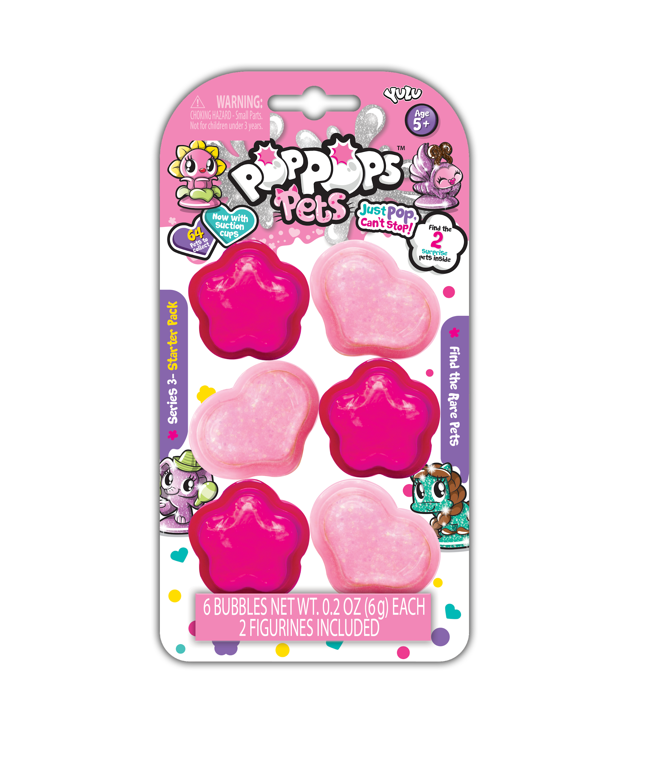

Pop Pops™ Pets Starter Pack
SRP: $4.99 | 6+ years | Available: Spring 2020
- Kids will love to pop the new heart and flower shaped Pop Pops™ with glitter slime to reveal their new collectible pet.
- Includes six bubbles and two collectible pets.

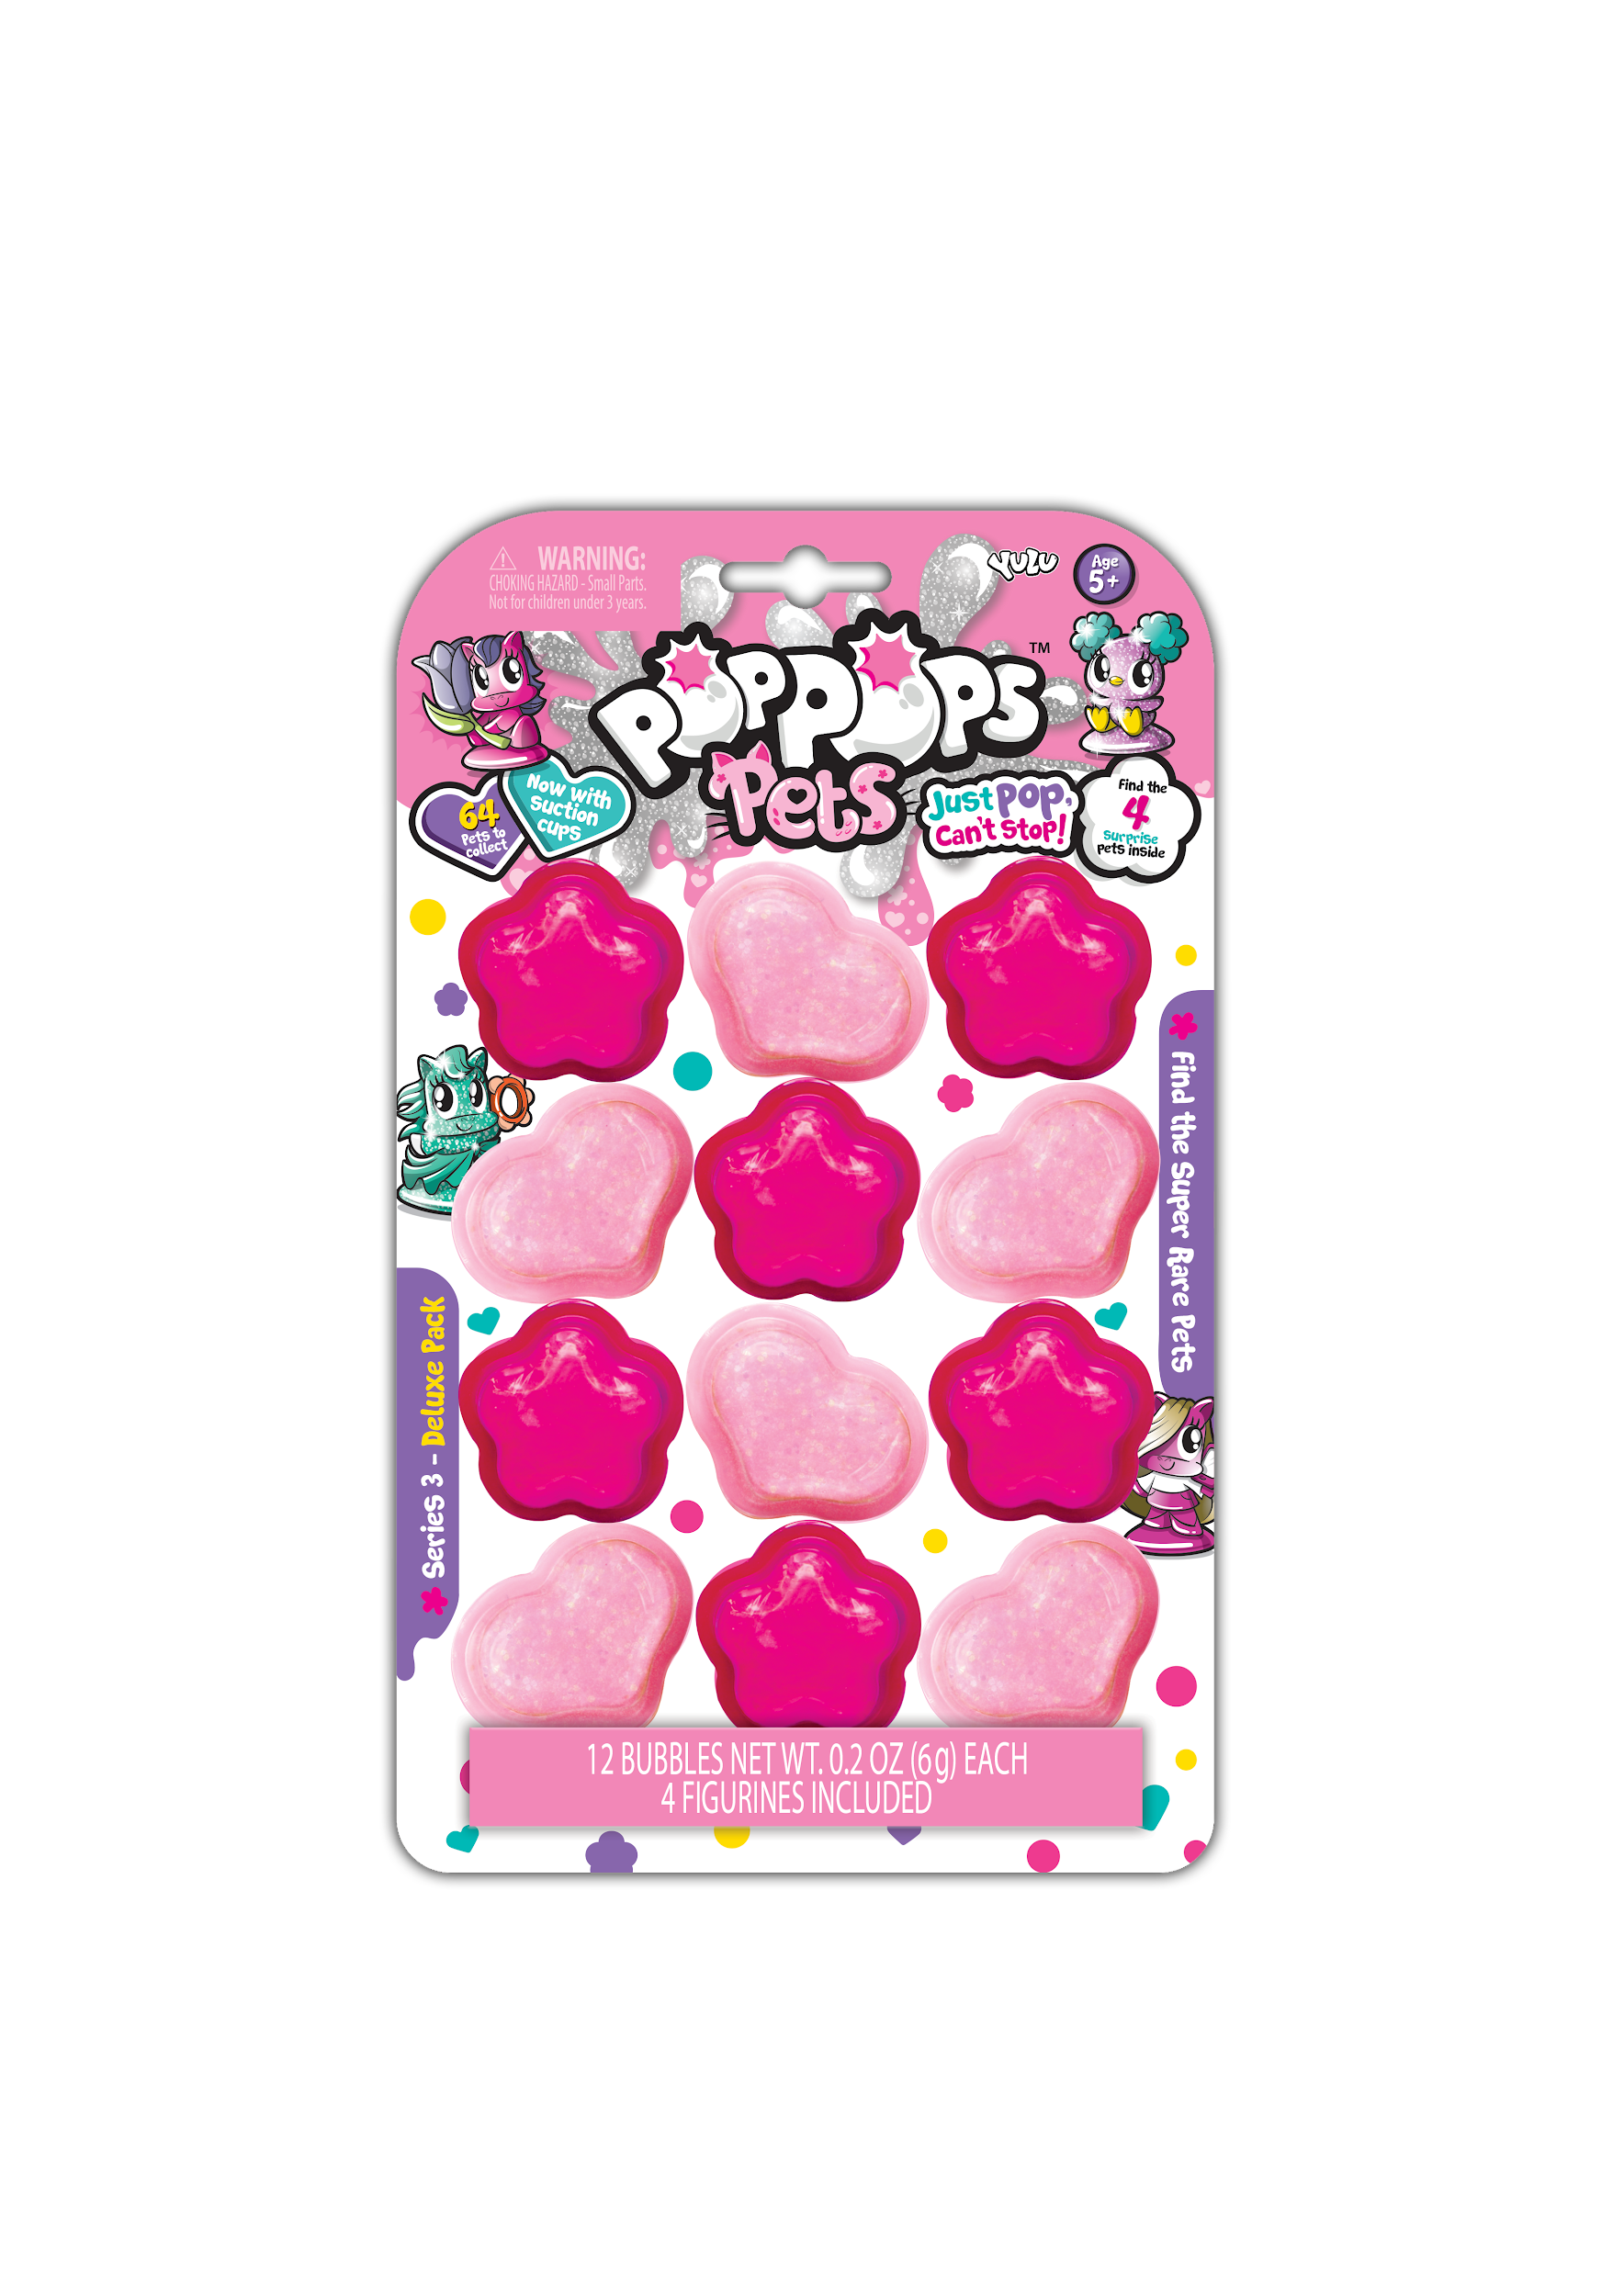

Pop Pops™ Pets Deluxe Pack
SRP: $7.99 | 6+ years | Available: Spring 2020
- Kids will love to pop the new heart and flower shaped Pop Pops™ with glitter slime to reveal their new collectible pet.
- Includes 12 bubbles and four collectible pets.
- Characters include suction cups for display.

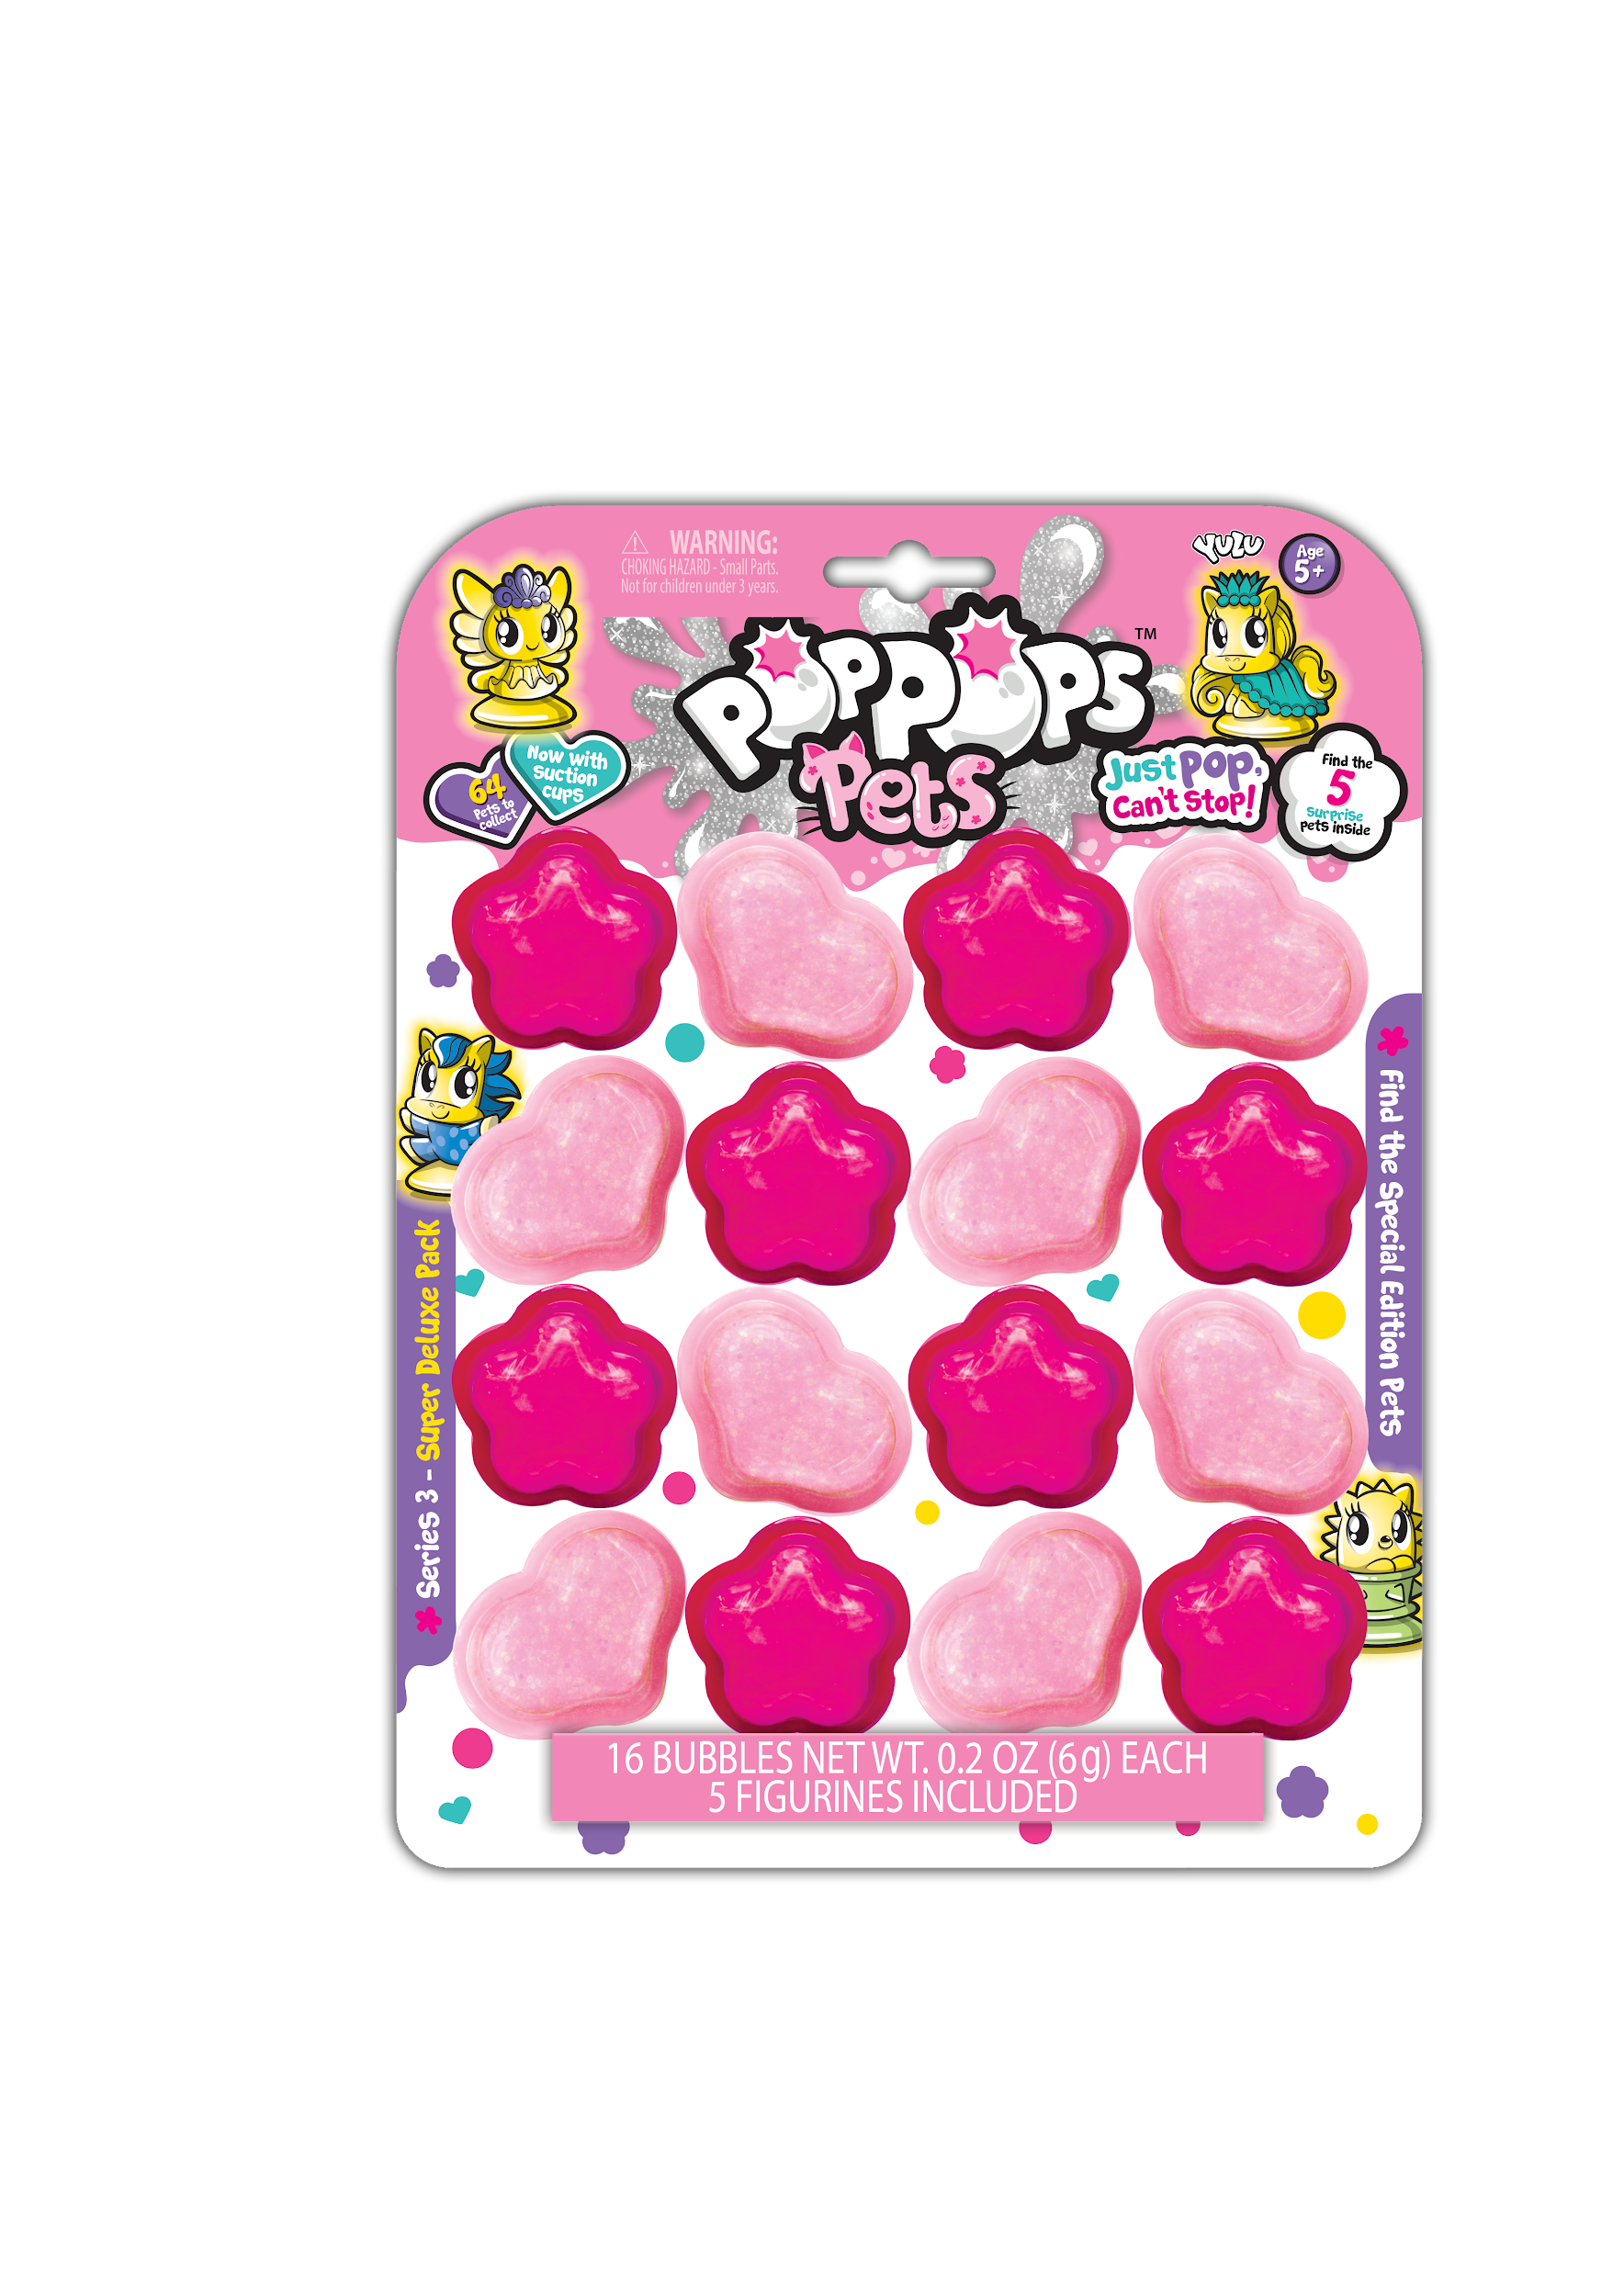

Pop Pops™ Pets Super Deluxe Pack
SRP: $9.99 | 6+ years | Available: Fall 2020
- Kids will love to pop the new heart and flower shaped Pop Pops™ with glitter slime to reveal their new collectible pet.
- Includes 16 bubbles and five collectible pets.
- Characters include suction cups for display.

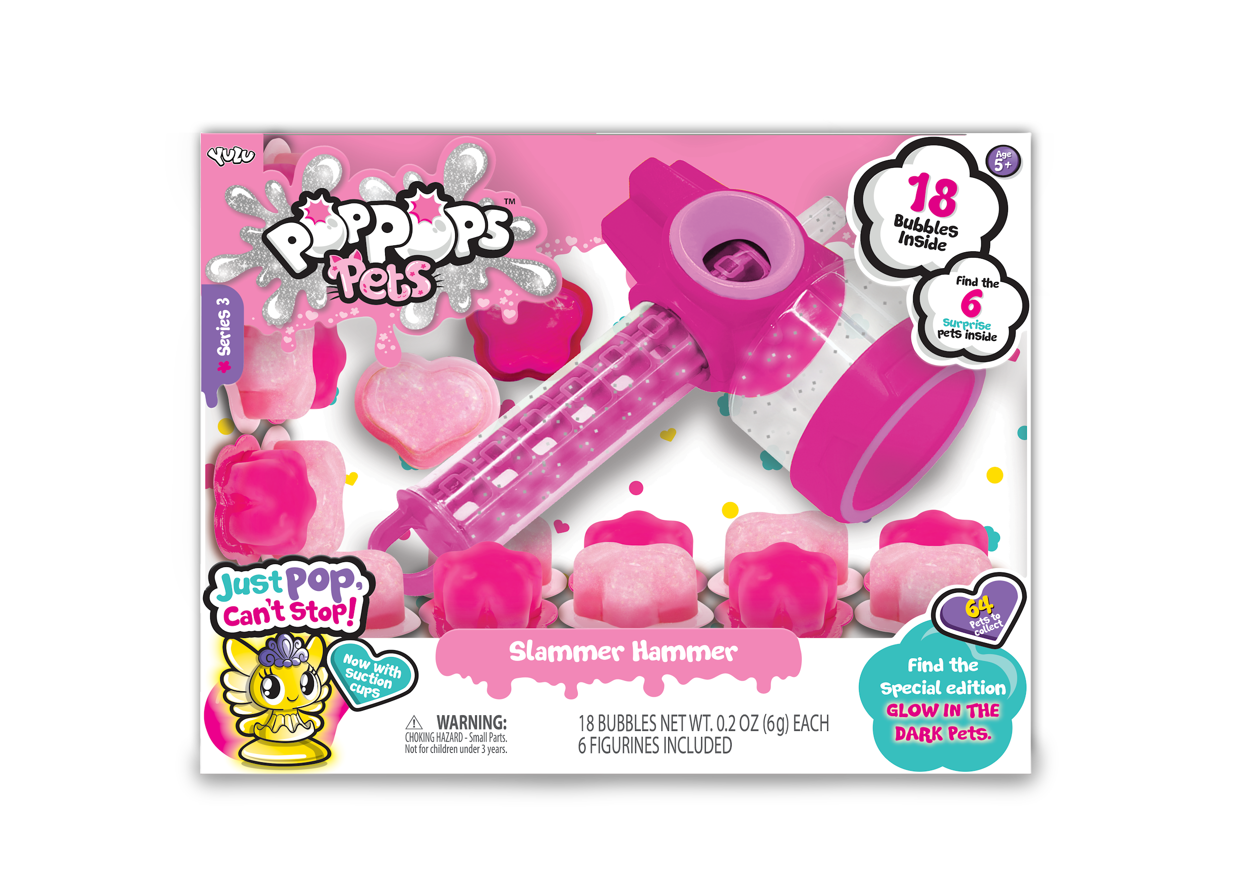
Pop Pops™ Pets Slammer Hammer
SRP: $14.99 | 6+ years | Available: Spring 2020
- Kids will love to slam the new heart and flower shaped Pop Pops™ filled with glitter slime with the Slammer Hammer to reveal their new collectible pet.
- Includes 18 bubbles and six collectible pets.
- Characters include suction cups for display.

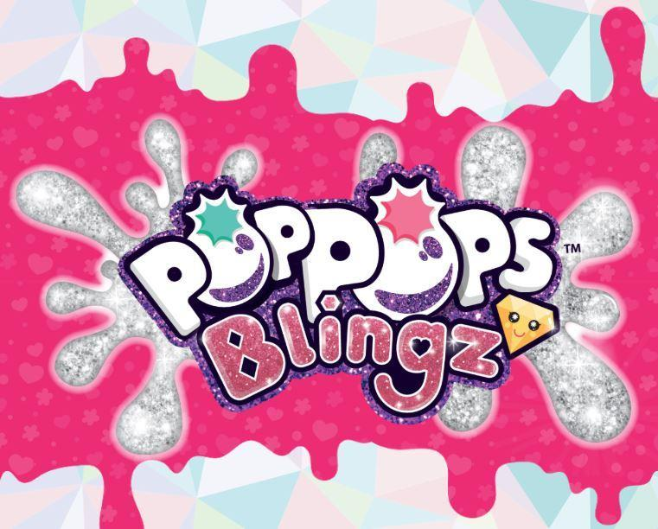

Pop Pops Blingz offers a combination of several of the best things in the world: confetti ooze, bubble popping, and the hunt for collectible charms, beads, and bracelets - all things needed to design a masterpiece jewelry!

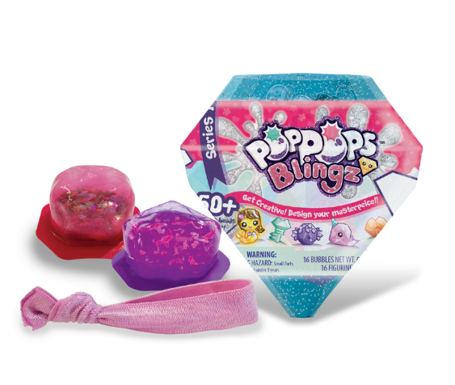
Pop Pops™ Blingz Mini Pack
SRP: $2.99 | 6+ years | Available: Fall 2020
- Kids will love to create their own jewelry!
- Simply pop the two confetti bubbles to reveal the collectible charm and bead.
- Attach to the supplied fabric bracelet.
- Get your Bling On!
- Includes two bubbles, a charm, one bead, fabric bracelet, collector’s guide, and translucent diamond container for storage.

Pop Pops™ Blingz Starter Pack
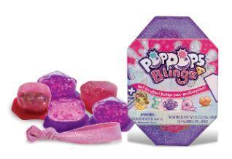
SRP: $4.99 | 6+ years | Available: Fall 2020
- Kids will love to create their own jewelry!
- Simply pop the five confetti bubbles bubble to reveal the two collectible charms and three beads.
- Attach to the supplied fabric bracelet.
- Get your Bling On!Includes five bubbles, two charms, three beads, fabric bracelet, collector’s guide, and translucent diamond container for storage.

Pop Pops™ Blingz Mega Pack
SRP: $9.99 | 6+ years | Available: Fall 2020
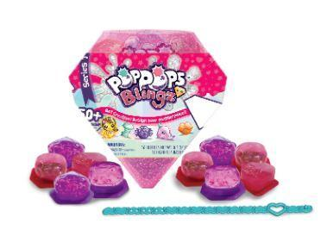
- Kids will love to create their own jewelry!
- Simply pop fourteen confetti bubbles to reveal four collectible charms and ten beads.
- Attach to the supplied premium plastic bracelet.
- Get your Bling On!
- Includes fourteen bubbles, four charms, ten beads, premium plastic bracelet, collector’s guide, and translucent diamond container for storage.

