Swirl & Style™ Tie Dye Studio Maker brings a new element of fun to tie-dying! With its unique, self-contained orb, tie-dye creations are made mess-free. Simply put dye bottles into self-sealing valves to dye, spin, wash and wear. Watch as the colors transform ordinary items to bright, colorful art!

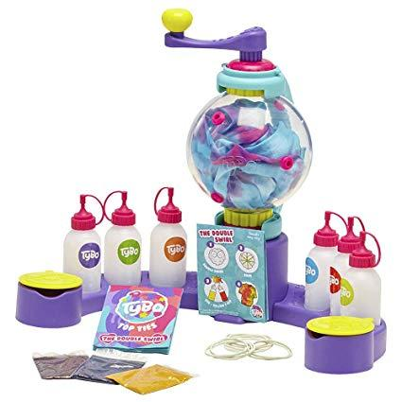
Swirl & Style™ Tie Dye Studio Maker
SRP: $19.99 | 6+ years | Available: March 2020
- Kids will love to create their own tie dye creations!
- Easy, mess free tie-dye!
- Dyes stay enclosed in self-contained orb
- Includes 6 bright colors for 12+ creations
- Includes 12 individually packaged dyes for repeatable play
- Endless creativity
- Includes instruction design booklet

