Don’t be left holding the Popcorn when it Pops! POPCORN POPPIN’™ is the fast and funny game where players must pass the popcorn bucket before the popcorn pops. While the timer counts down, players follow the instructions from the pop-up die and pass the popcorn as quickly as they can, trying not to be the one holding the bucket when the popcorn pops!

POPCORN POPPIN’™ Game
MSRP: $14.99 / Age Grade: 4+ / Available now
- Don’t be the last player holding the popcorn when it pops!
- Press down the pop-up die and follow what it says
- Time’s counting down as the popcorn gets passed around. When will it pop?
- If it pops on your turn, you’re out. Last player still in the game wins!
- For 2 or more players, ages 4 and up

DIAMOND HEIST™ is the ultimate cooperative game where you work together to win . . . or you’ll get caught! An evil organization has stolen a precious diamond and has hidden it deep within their vault. It’s up to you and your fellow spies to rappel into the vault, eliminate the alarms, retrieve the diamond and escape before the Security guards arrive. It takes teamwork, communication, and steady hands to succeed!

Spy Code Mission: Diamond Heist™ Game
MSRP: $19.99 | Age Grade: 6+ | Available Fall 2020
- Work together to rappel into the vault and retrieve the stolen diamond!
- Unique mechanism suspends the spy inside the vault. It takes sharp eyes and steady hands to direct him through the obstacles!
- There are 8 different challenges which require different skills and strategies to succeed.
- The guards are alerted when the vault is opened.
- Retrieve the diamond and get away before the Guards arrive, or you’ll be trapped!
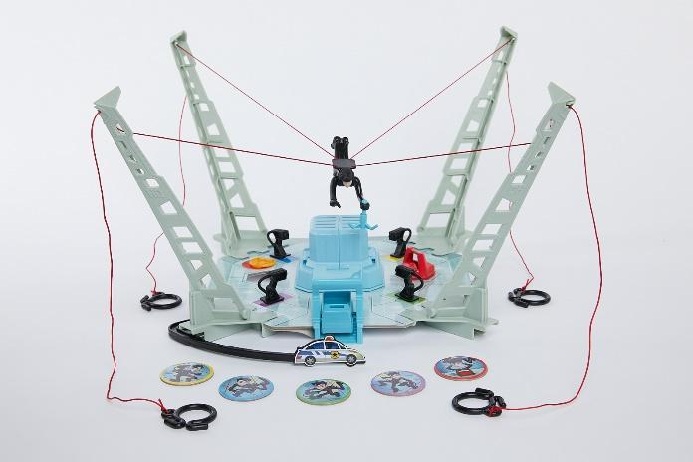
- Ideal for 2 to 4 players
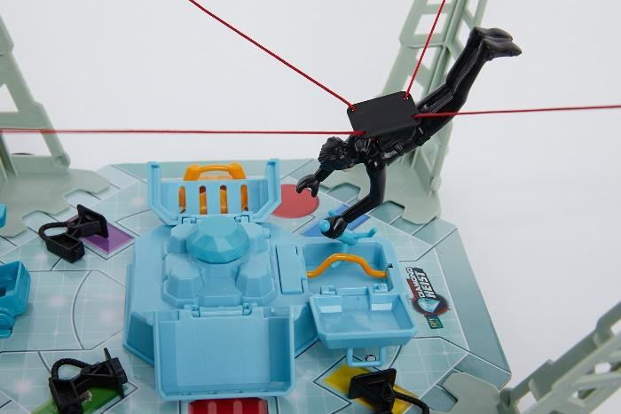

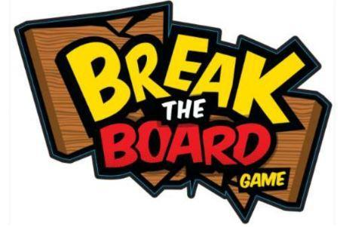

BREAK THE BOARD™ is the action-packed electronic game that takes a popular activity with kids – martial arts – and delivers the most iconic moment in the sport: breaking the wooden board! With four game modes to choose from - Level Up, Competition, Trainer, and Freestyle - players listen to the commands and master the moves to make it through increasingly challenging levels. If you’re fast and accurate, you get to Break the Board and become the ultimate martial arts master!

Break the Board™ Game
MSRP: $19.99 | Age Grade: 6+ | 3 AAA Batteries included | Available Fall 2020
- Master your moves quickly and accurately, and you get to Break the Board!
- Quickly chop, swipe, and strike through 10 challenging levels
- Compete with up to 9 other players: Who is the fastest?
- Practice your moves with Trainer mode
- Mix sounds with your moves in the Freestyle mode
