FOR IMMEDIATE RELEASE
elope, Inc. reveals 15 new designer color pieces for BRICKY BLOCKS wearable building toys
February 18, 2017

New York, NY - elope, Inc. revealed 15 new designer color additions to their line of BRICKY BLOCKS wearable building toys pieces today at Toy Fair New York. These packs of 1x1 pieces allow construction toy fans to build their own styles with custom designs on elope’s line of unisized, gender-neutral snapback caps, sunglasses, bow tie/hair bows, neckties, wristbands, and necklace pendants. Each accessory is compatible with most major brick-building systems.

“This is about wearing happiness,” said elope CEO Kevin Johnson. “We want to encourage people to express themselves and to share their passion. With these new packs of 1x1 colors, there’s a larger palette for intricate and vibrant designs—whether that’s your favorite character, cultural icon, or sporting team.”

elope manufactures all Bricky Blocks wearable build-on products with phthalate-free plastic recommended for builders ages four and up. The single-color 1x1 packages of 100 Bricky Blocks pieces retail online and in specialty toy stores at $4.95. Now available in 15 colors, the options include black, blue, green, orange, red, white, yellow, brown, lime, purple, light blue, magenta, gold, tan, and gray.

Said Creative Development Officer Marlene Lloret, “We selected these colors because they represent an entire rainbow of brick building design options. We wanted to offer up the kind of variety that makes everyone feel included and invited to create their own style, regardless of age or gender.”

“From pirates, to princesses, emojis and rainbows to sports teams, we don’t want to put anyone in a box,” added Johnson. “Bricky Blocks are a platform for gender-neutral building toys you can wear so you can ‘brick your style’ - - so you can wear what you love.”

For more information, visit http://www.elope.com/brickyblocks.
###

About elope Inc.
In 1993, elope's founders created an enterprise dedicated to a vision of happiness: everybody's laughing on planet earth (e.l.o.p.e). Still family owned and operated, elope is headquartered in Colorado Springs, USA and specializes in hats, glasses, costumes, toys, dress-up accessories and other whimsical wearables that spread joy and laughter through socially responsible business practices. The company designs, manufactures, and distributes worldwide both under their own brand and under fan-favorite licenses that include Disney, Doctor Who, Fantastic Beasts and Where To Find Them, Dr. Seuss, Hasbro, Harry Potter, and Where's Waldo.

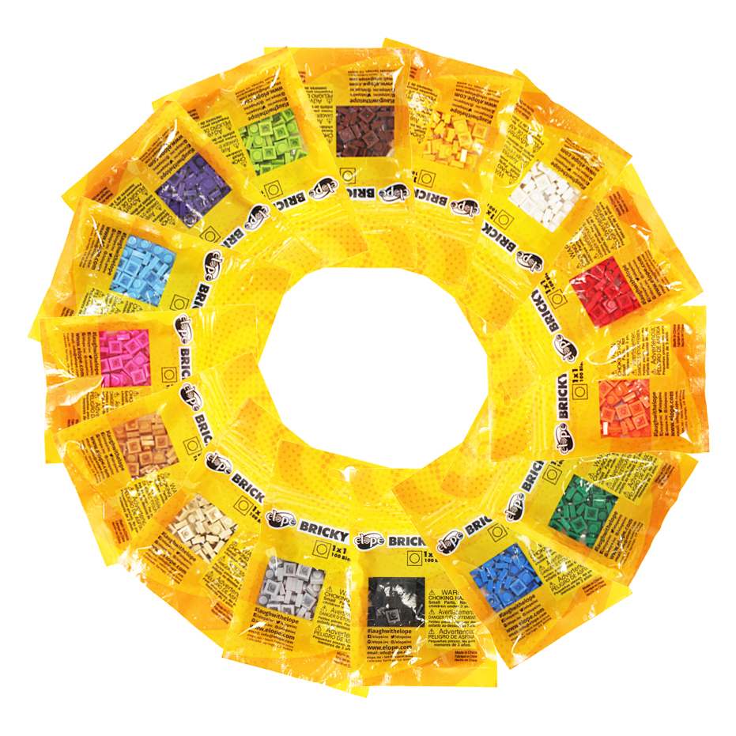

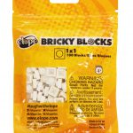
560111
Bricky Blocks 100 Pieces 1×1 White
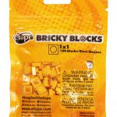
560112
Bricky Blocks 100 Pieces 1×1 Yellow

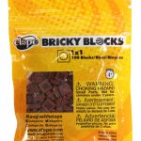
560113
Bricky Blocks 100 Pieces 1×1 Brown
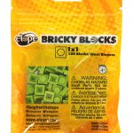
560114
Bricky Blocks 100 Pieces 1×1 Lime
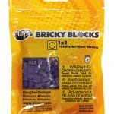
560115
Bricky Blocks 100 Pieces 1×1 Purple
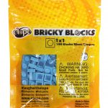
560116
Bricky Blocks 100 Pieces 1×1 Light Blue
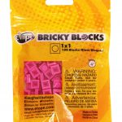
560117
Bricky Blocks 100 Pieces 1×1 Magenta
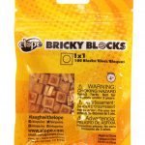
560118
Bricky Blocks 100 Pieces 1×1 Gold
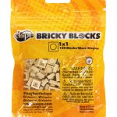
560119
Bricky Blocks 100 Pieces 1×1 Tan

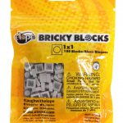
560120
Bricky Blocks 100 Pieces 1×1 Gray

